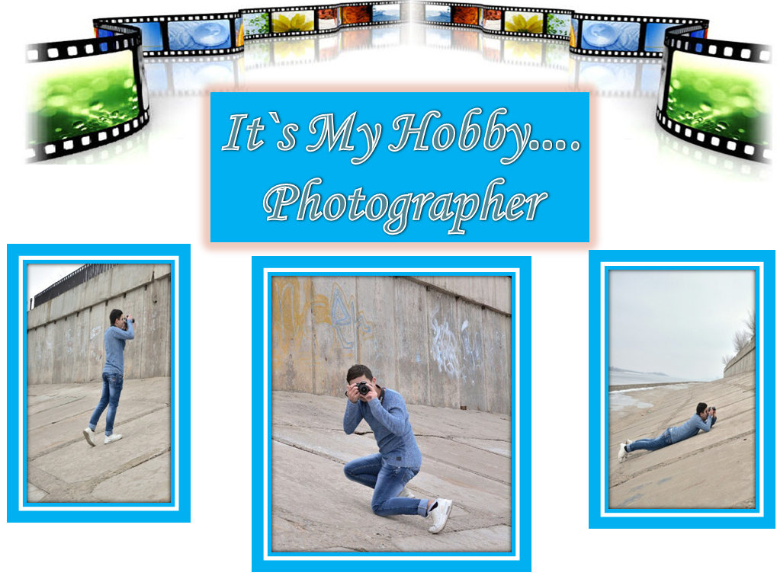



My name is Rafael. I’m 15 years old. I think that person should be developed in all areas of life. It is education and a wide range of interests. They are formed our identity. Among my interests, in addition to the learning process in a comprehensive school, there are many other useful occupations. My main hobby is photography and modeling. Photography is one of my hobbies. For my last birthday my parents an excellent camera for me parents as a present. I have taken photos everything what I see around. I took a series of good pictures during my school trip. I think photography is a form of art, which helps us depict nice places, people and moments for a long time. The word “photography” comes from Greek. It means the combination of words “light” and “drawing”.

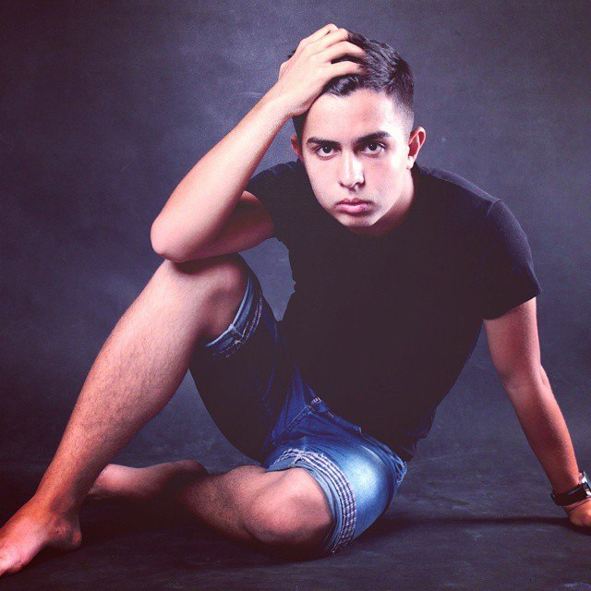
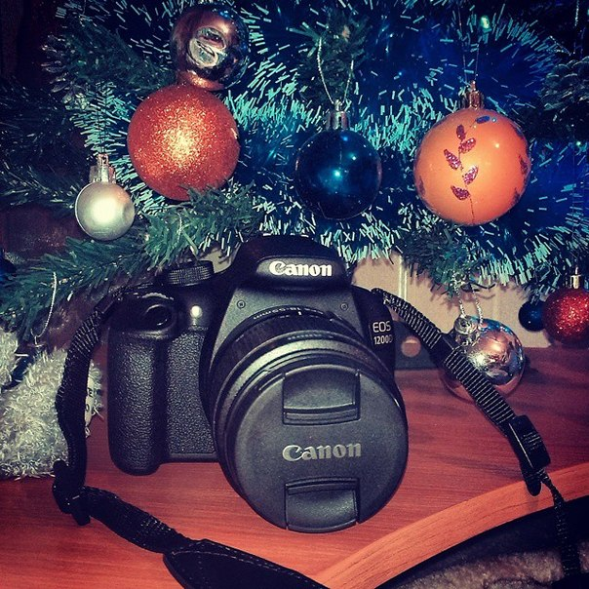

It seems to me that the modern person has been comprehensively developed. The direction of hobby depends on the person, on his temperament, tendencies, character. Hobby of each person must bring a joy and also can bring material benefit. My interest in photography always brings me a joy and a pleasure. I am fond of my hobby a lot of time. The photo is a part of my life. To take photo is it to hold breath when all our abilities work in common before the reality. Then the capture of the image becomes big physical and intellectual pleasure. I became one of the famous photographers in the city. I am proud of it very much. Will taking pictures become my hobby? Time will show because there are many interests for each person. I don't know what occupation will seem to me fascinating in the future. But the main thing it is to continue "to look for himself".

We can create long-term images and videos with the help of modern cameras. In my opinion, photography has great uses. It used for business, for manufacturing, for art, for science, for tours, and for mass communication, for example. I think that taking photos is an engaging activity. I can create and present new ideas, show and realize my fantasy or thoughts in real life. I like to share my photos with my friends. They are my best critics and appraisers. They say that I’m really good photographer, so perhaps in the future photography will become my main occupation.

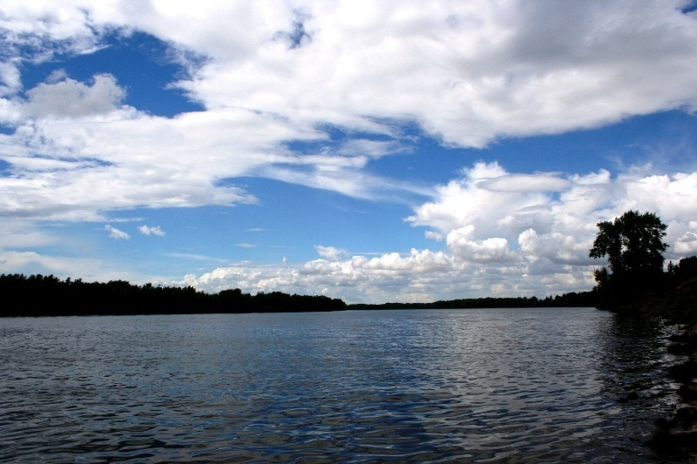

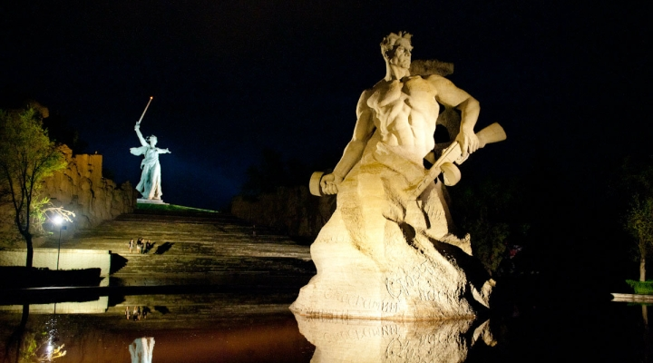

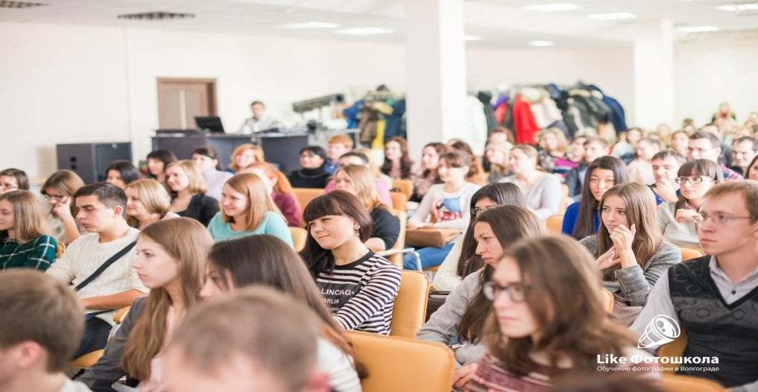

Today there are also lots of clubs and organizations where photographers meet and discuss their works, share new ideas and give advice to the beginners. I think it is rather useful for professional development. One of my favorite photographers is going to visiting our city and he will hold seminar about experiments with light and color. My favorite photography is Adele Butsman. He opened his own school in Volgograd – The title of this school is «Likе photo school .»

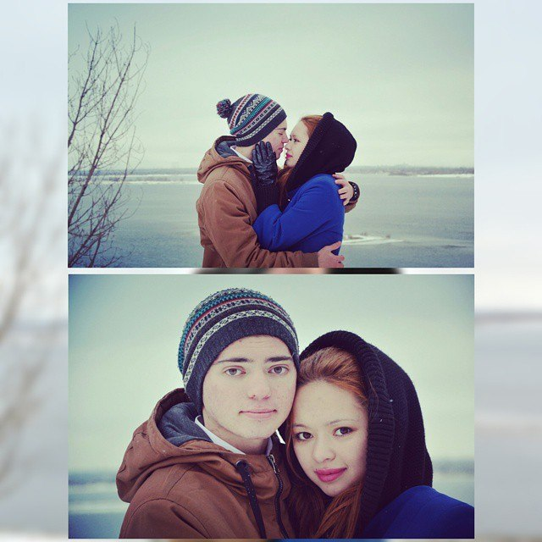
I took part in a seminar and learned a lot. I learned a lot of portrait and wedding stories
Now my pictures are so good. But sometimes I want to learn how to take pictures as the great American photographers such as Jay Manuel, John William, and many others. My photos:

Photographer IS Rafael Zayn
ModelS ARE Samanta and Denis

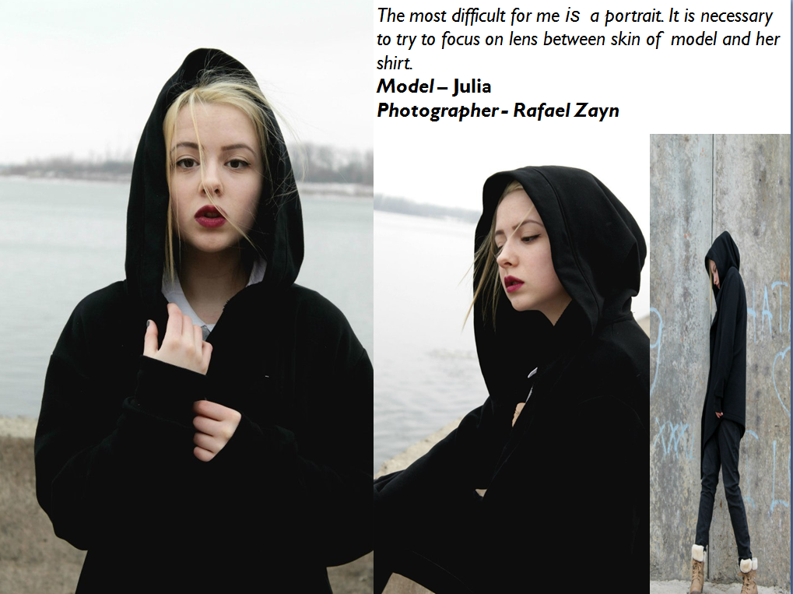
The most difficulty for me is a portrait. It is necessary to try to focus on lens between skin of model and her shirt.
Model is Julia
Photographer is Rafael Zayn

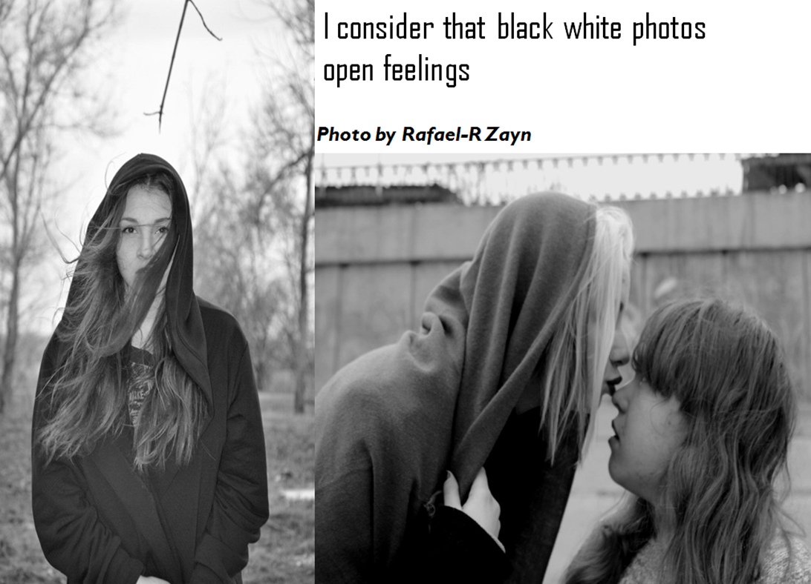

Whether there will be a photographer serious and will become my "hobby" for long time, the time will show, after all occupations as a hobby a huge number. For example earlier I was model of agency the set of shootings was V.G.models. В of my life and even there were shootings when I was on other party of the camera. Here, the best-known shootings.

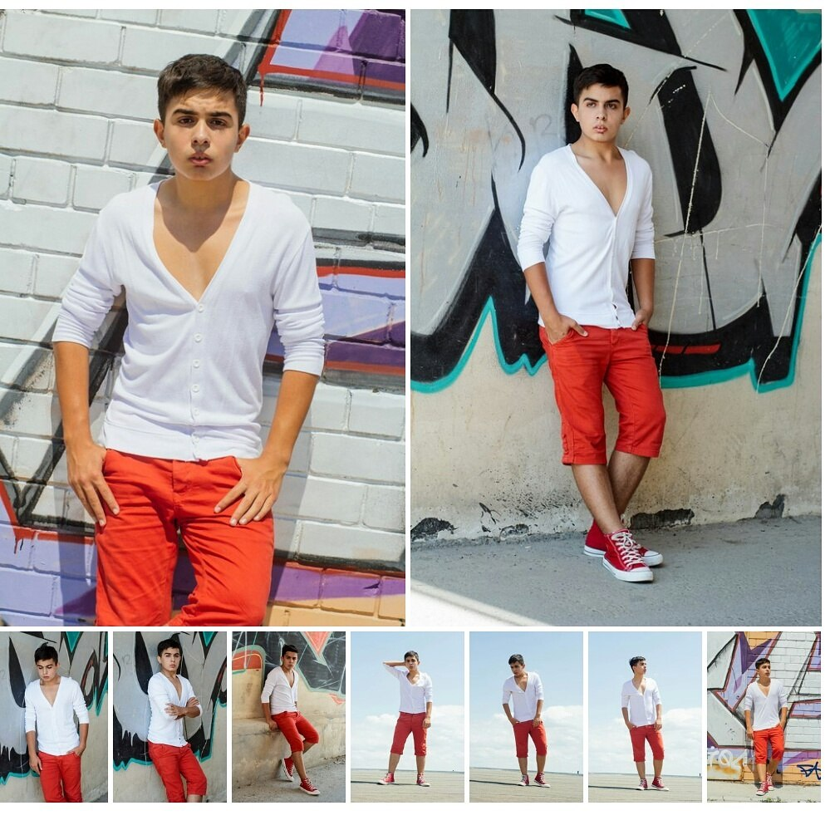
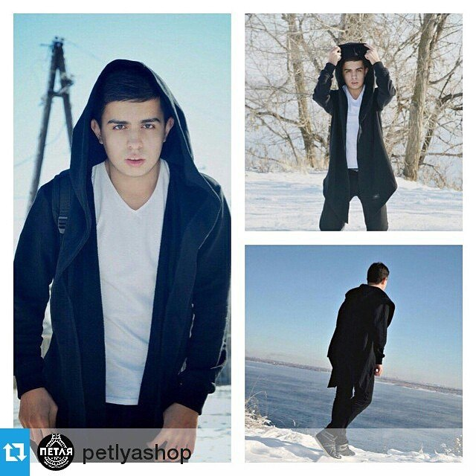
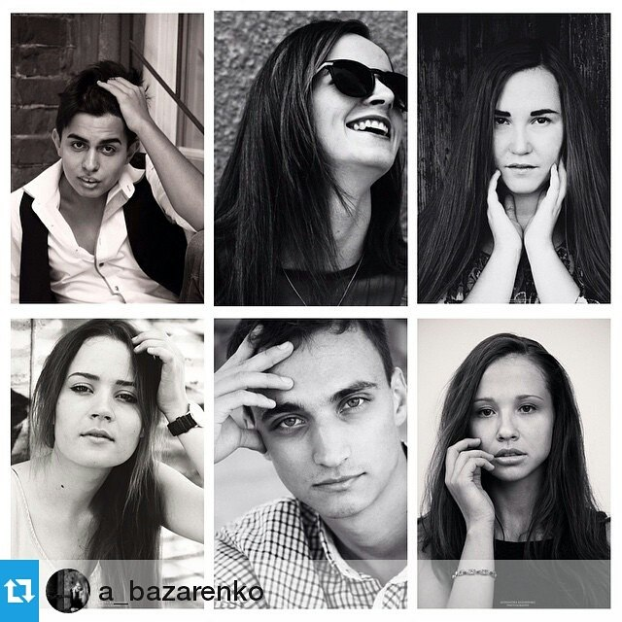

Shooting for shop – the petlyashop
4 best models in Volgograd
V.G.models – «the fase»

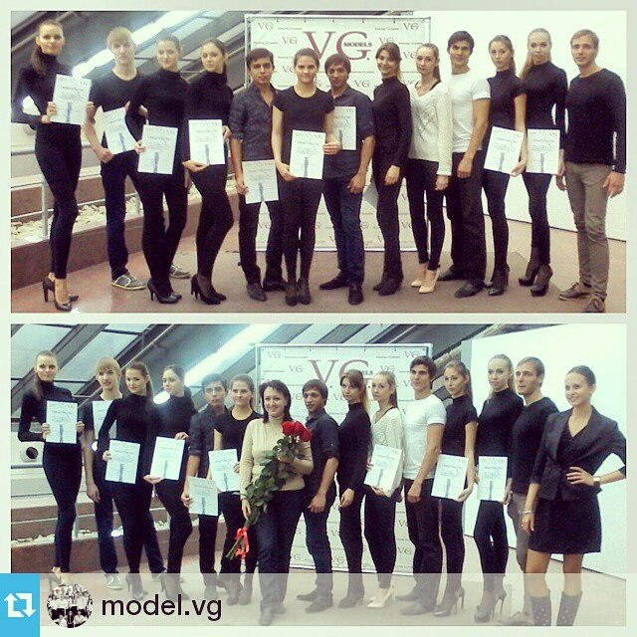

Examination in a model school – V.G.MODELS

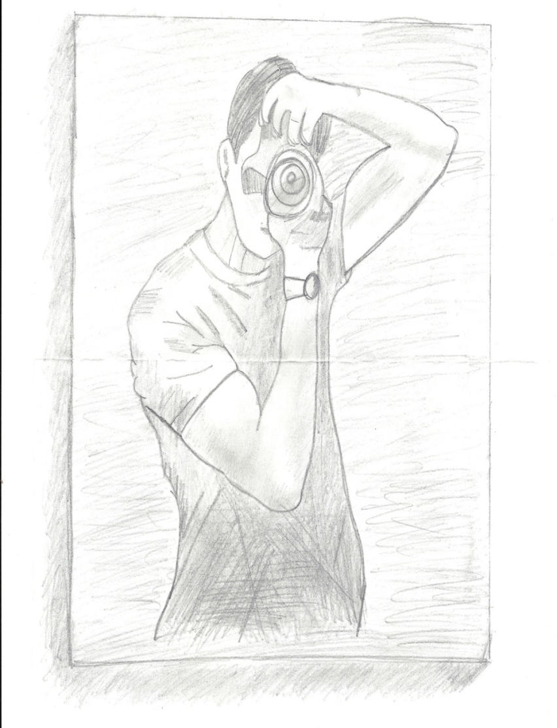
I became better to take photos. My clients decide to give a present. This is my portrait.

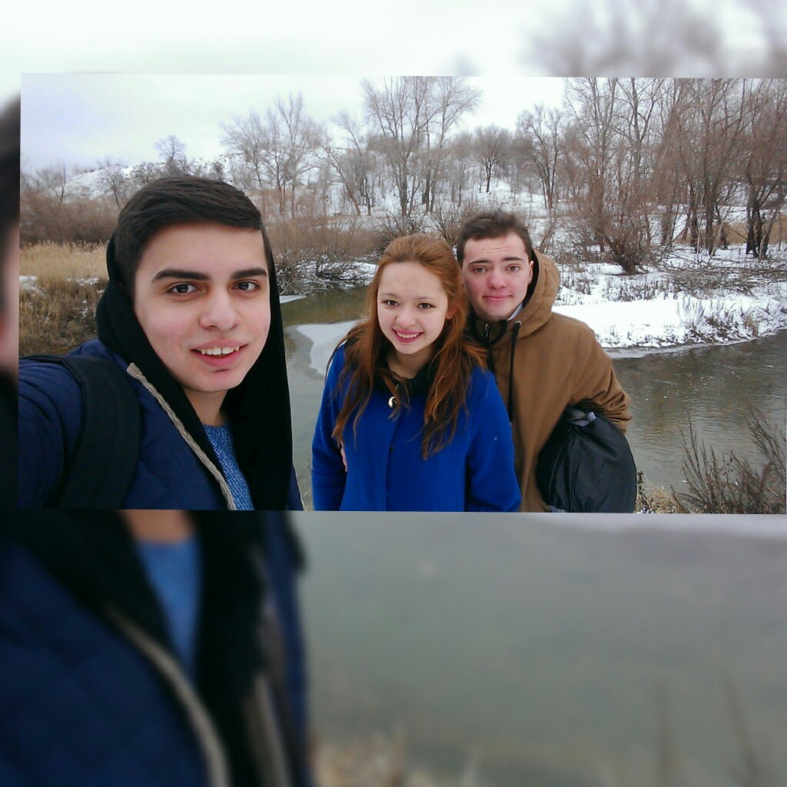

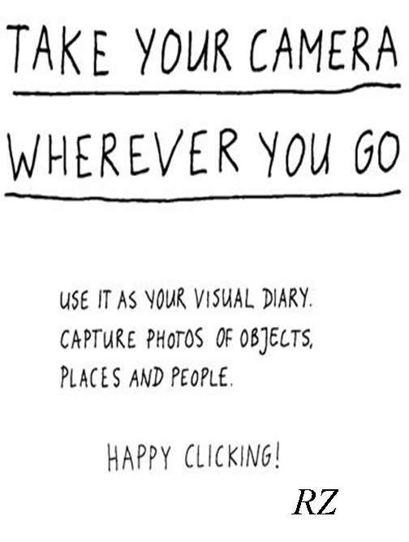
It`s my motto

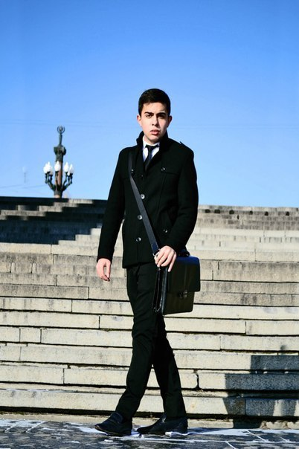

In conclusion of the project I want to tell that the person must go always forward.
I was the student of secondary school then I became a model of agency “ V.G.models”. But now I enter the best young photographers of Volgograd!
To follow always dream. All that seemed not possible, will be open before you!

