LESSON: Reading for Pleasure |  |  | School: 44
Date: 25.10.17. |  |  | Teachername: Suleimenova A.
CLASS: 5 “V” |  |  | Number present: | absent:
Learning objectives(s) that this lesson is contributing to |  | 5.R4 read with some support a limited range of short fiction and non-fiction texts  5.W7 use with some support appropriate layout at text level for a limited range of written genres on familiar general topics and some curricular topics
Lessonobjectives |  | All learners will be able to:
- understand the main events in the story
- say thank you and give reasons
 |  | Most learners will be able to:
- read the story without support
- understand the moral of the story
- make some questions on the given story
 |  | Some learners will be able to:
- understand most of the language in the story
- answer the questions and give examples from the text
Languageobjectives |  | Use vocabulary from the story to answer the questions
Valuelinks |  | Respect for self and others, academic honesty, Cooperation
Crosscurricularlinkslink |  | Literature
ICT skills |  | Projector or Smart board for presenting pictures
Previouslearning |  | Creativity
Plan
Plannedtimings | Plannedactivities |  |  | Resources
Beginning  0-3  Middle  3-8  8-20 | Warm up:  In order to create friendly atmosphere in class Teacher asks Students to make a circle and say thank you to each other. (W)  - Reflecting on the previous lesson  Teacher shows some questions on the first part of the short story. Students discuss the questions in pairs.(P)  - Setting the aims of the lesson  - Reading skills:  Learners start reading the short story“Goldilocks and the Three Bears” (Part 2). (I,G)  Differentiation: More motivated learners sit individually and read the story with no Teacher support. Less motivated learners make a circle and read the text with teacher together.  Scaffolding: Learners have a vocabulary/pictionary of unknown words. |  |  | PPP (1 slide)  PPP (2 slide)  Appendix 1  Appendix 2
20-35 | After reading: Teacher distributes short story quiz templates to each Student. They need to make questions on the short story and swap them with their classmates in order to answer them.  Peer assessment: Once Learners finished the task they swap their cards in order to assess each other.  Assessment criteria:  -Student answers to questions correctly  -Student justifies his/her answers by showing the number of the page |  |  | Appendix 3  PPP (slide 3)
End  35-40 | - Teacher asks learners 1) how do you feel when a friend doesn’t say thank you for your help?e.g. unhappy, sad, lonely 2) why should people say sorry?  - Teacher encourages Learners to reflect on the lesson “Two stars one wish” |  |  | Stickers
Summary evaluation

What two things went really well (consider both teaching and learning)?

1:

2:

What two things would have improved the lesson (consider both teaching and learning)?

1:
2:

2:

What have I learned from this lesson about the class or individuals that will inform my next lesson?

Goldilocks and the Three Bears
Part 1
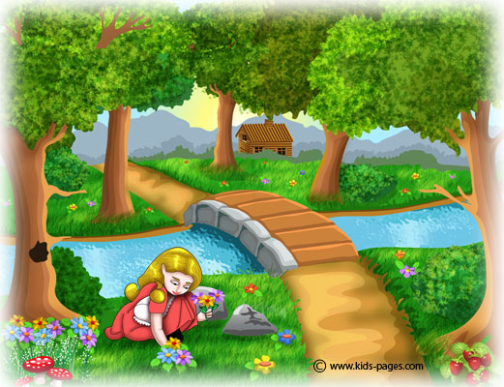
Once upon a time, there was a little girl named Goldilocks. She lived at the edge of the forest with her family. One morning, while she was picking flowers, Goldilocks wandered into the forest and lost her way. She was very frightened, but then she saw a friendly little cottage in the distance.
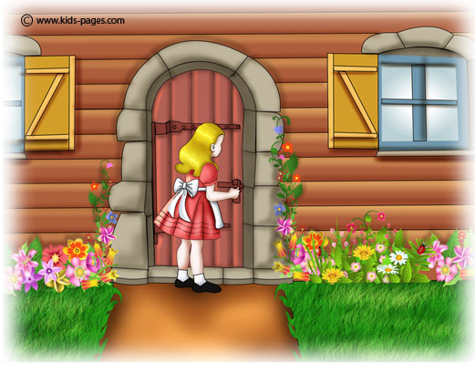
The friendly little cottage belonged to three bears. One was a great big Papa Bear, one was a middle-sized Mama Bear, and one was a tiny little Baby Bear. That morning, the three bears decided to take a walk while their porridge – which tastes like oatmeal – was cooling. It was too hot to eat! Right as they left through the back door, Goldilocks came in through the front door very quietly.
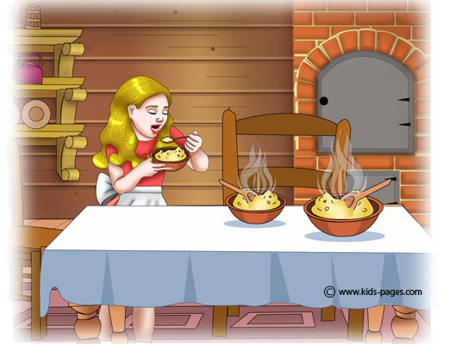
The first thing she saw and smelled was the sweet, steamy porridge. “I sure am hungry,” Goldilocks said. “I’ll just have one bite.”First, she tried a spoonful from Papa Bear’s great big bowl. “OW!” she yelled, “TOO HOT!” Next, she tried a spoonful from Mama Bear’s medium-sized bowl. “Brrrrr! TOO COLD!” she complained. Finally, Goldilocks tried a spoonful from Baby Bear’s tiny little bowl. “YUMMY!” she cried. “THIS IS JUST RIGHT!” Goldilocks ate the entire bowlful.
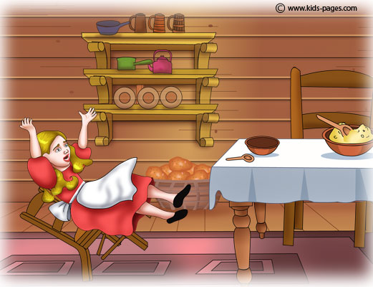
After running around the forest all day, Goldilocks’ feet were sore. “I need to sit down for a little while to rest my sore feet!” she thought. First, she sat in Papa Bear’s great big armchair. “TOO HARD!” she screamed. Goldilocks stomped to the next chair. Next she sat in Mama Bear’s medium-sized chair. It was so soft that she sunk in! “TOO SOFT!” she complained, as she pulled herself out of the cushions. Finally, she sat in Baby Bear’s tiny little rocking chair. “JUST RIGHT!” She laughed, but the chair soon broke.
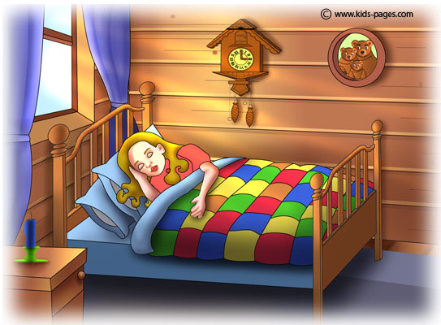
With nowhere to sit, Goldilocks climbed up the stairs to find somewhere to sleep. She was still very tired. First, she tried Papa Bear’s great big bed. “TOO HIGH!” she yelled. Then, she tried Mama Bear’s medium-sized bed. “TOO LOW!” she screamed.
Finally, she tried Baby Bear’s tiny little bed. “JUST RIGHT!” she sighed. Then Goldilocks fell asleep and dreamed dreams of flowers and warm cookies.
Part 2
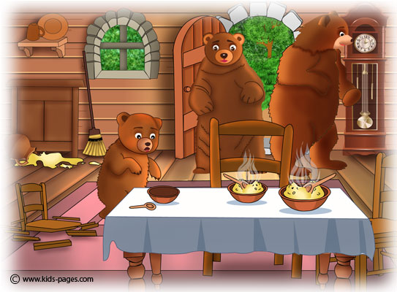

Just then, the three bears returned home from their walk. They saw spoons in their porridge, and were very surprised. “Who’s been eating my porridge?” asked Papa Bear. “Who’s been eating my porridge?” asked Mama Bear. “Who’s been eating my porridge and eaten it all up?” cried Baby Bear. Then, the three bears saw that their chairs had been used. “Who’s been sitting in my chair?” Papa Bear howled.“Who’s been sitting in my chair?” wondered Mama Bear. “Who’s been sitting in my chair and BROKEN it?” squeaked Baby Bear.
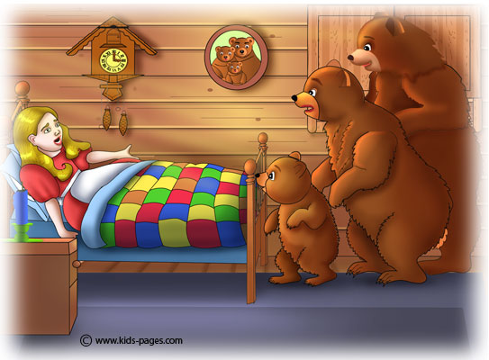
The three Bears ran upstairs to check their bedrooms. “Who’s been sleeping in my bed?” Papa Bear roared. “Who’s been sleeping in my bed?” growled Mama Bear. She was a little angry and a little worried.“Who’s been sleeping in my bed and is STILL HERE?” Baby Bear screamed. He said it so loudly that he woke Goldilocks up.
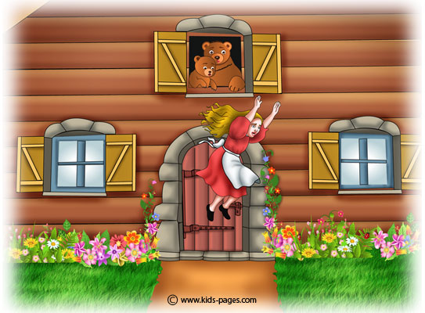

She was so frightened that she jumped out of bed, then jumped out the window, and raced through the forest until she heard her mother’s voice. Goldilocks was so happy to see her mother that she promised to never wander through the forest alone again.
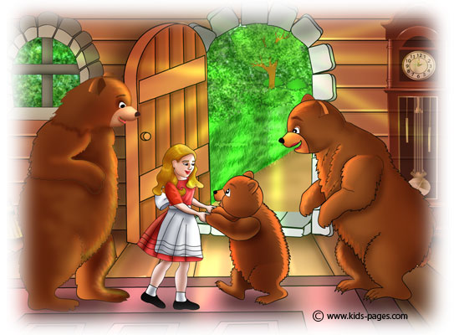

The next day, though, she realised she did something wrong by trespassing the bears’ house and using their stuff without permission, so she felt sorry and went back to apologize to them. She knocked at the door politely this time, and Mama Bear appeared before her right away: “Hello", Goldilocks said frightened, "I am very sorry about yesterday, what I did was wrong. I ran away because I was scared.”
“It’s, ok, dear, don’t worry, come inside to meet the rest of the family.” Mama Bear told the other two bears about Goldilock’s apology and they were glad to have her company. They became very good friends from then on and Goldilocks kept visiting them as often as she could.

Vocabulary list/pictionary on the story Goldilocks and the Three Bears
№ | WORD |  | TRANSALTION/PICTURE
1 | once upon a time |  | жили-были
2 | forest | n | 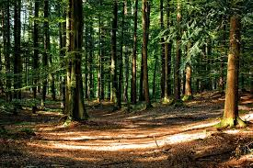
3 | pick | v | собирать
4 | wander into | v | бродить
5 | lose way | v | заблудиться
6 | cottage | n | 
7 | porridge | n | 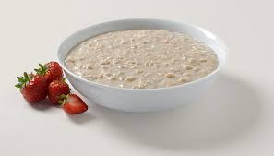
8 | oatmeal | n | 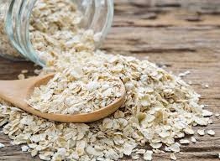
9 | spoonful | n | 
10 | bowl | n | 
11 | yell | v | 
12 | complain | v | жаловаться
13 | Yummy! |  | Объедение!
14 | sore | v | болеть
15 | rest | v | отдыхать
16 | armchair | n | 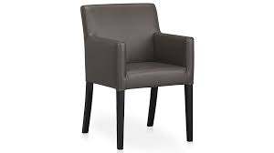
17 | stomp | v | топать
18 | cushion | n | 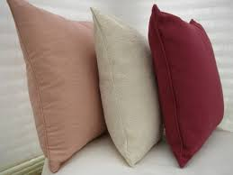
19 | rocking chair | n | 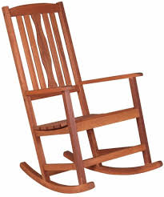
20 | stairs | n | 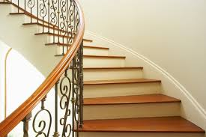
21 | squeak | v | пищать
22 | growl | v | рычать
23 | trespassing | n | самовольный вход в чужие владения

