Bostandik secondary school

6 form

We learn English
(intellectual show)

\\

English teacher: Zhalmukhanbetova Zh.S

2017-2018 academic year
Aims:
- to develop pupil’s interest in the subject of English, to widen pupils scope (country knowing) according to the intercommunication by subjects: Russian, Kazakh.
- to develop communicative skills and abilities through extracurricular work, to cultivate the feeling of love and responsibility to Motherland.
Visual aids: presentation, cards, picture, placard.
Teacher:
Dear our guests, We very glad to see you in our intellectual show “We learn English”. Welcome to our show!
They do not all use it as their first language. English is spoken practically all over the world. It is spoken as the mother tongue in Great Britain, the United States of America, Canada, Australia and New Zealand. A lot of people speak English in China, Japan, India, Africa and other countries. It is one of 6 official languages of the United Nations. It is studied as a foreign language in many schools. English is the first language in the United Kingdom, the United States of America, Australia and New Zealand. It is one of the official languages in Canada, the Irish Republic and the Republic of South Africa.
Today English is the language of the world. Over 350 million people speak it as a mother tongue. The native speakers of English live in Great Britain, the United States of America, Australia and New Zealand. English is one of the official languages in the Irish Republic, Canada, the South African Republic. As a second language it is used in the former British and US colonies.
First of all let me introduce to you our members of jury.
And the 3 teams: “Colour”, “Subjects” and “Time”
- Let's begin our game. I think our game will be interesting for us.
I competition
Do you know the missing letters? І сайысымыз түсіп қалған әріпті таба аламыз ба?

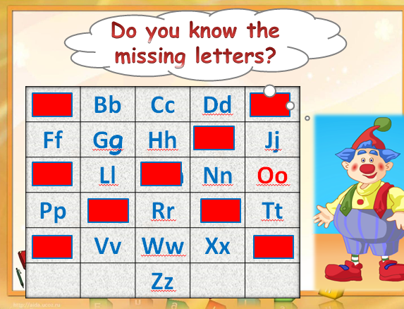

II. The second competition is called “Answer the question”. You must answer the questions.
For each correct answer you will get 1 points. Listen to me… Екінші сайысымыз “Сұрақ - жауап”
1st team:
What is your name?
What is your surname?
Do you know me?
Have you got a friend?
The capital of Kazakhstan?
How many fingers have you got? (10)
What’s your nationality? (Kazakh)
2nd team:
How old are you?
How are you?
Who is the first President of Kazakhstan? (N. A. Nazarbaev)
What are you favourite subject?
What holiday is celebrated on 22 of March (Nauryz holiday)
Where is the Big Ben? (in London)
3rd team:
What is your teacher name?
What’s your nationality? (Kazakh)
Where are you from?
Have you got a cat or dog at home?
How many lessons have you got today?
What is it?
How are you?
IІІ. - Ok! Thank you very much! So, let’s start third competition “Name the colours”. You must call me the colours in English, Russian and kazakh.s. Үшінші сайыс “Түстерді тап”
Black-----------қызыл
Yellow---------қоңыр
Red-------------қара
Green----------ақ
Orange---------көк
Blue-------------қара
Brown----------сәбіз түстес
White-----------сары
ІV. Fourth competition “Piktogramma”. 3 сайыс “Пиктограмма”. Командаларға берілген сөздерге сурет салуы тиіс.
1st team:autumn, pupils, flower, pencils
2nd team: sky, tree, sun, birds.
3rd team: book, table, pens, school.
V. 4 сайыс өздерді алфавит бойынша жазып шығуы тиіс.
Put the words in the alphabetical words. Nine, five, paper, сat, ill, dog, apple, letter, mother, vegetable, seven, book, umbrella, zebra, window, jam, happy, tiger, eleven, give, yacht, kind, rabbit, one.
V. Fifth competition “What’s the word?” Қандай сөз
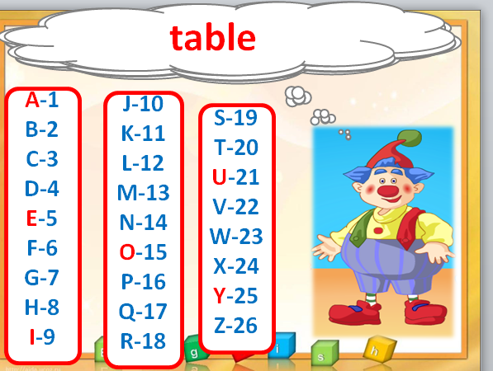

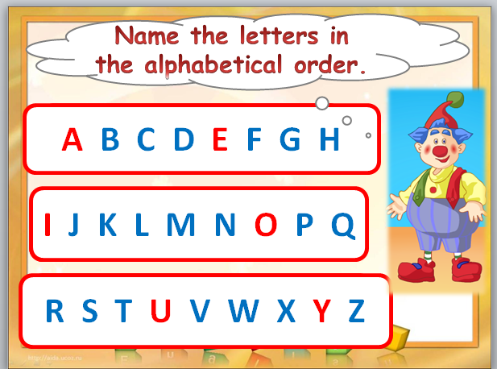
VI competition Last our competition is called “Name the letters in the alphabetical order” соңғы сайысымыз әріптерді ретімен айт

Now let’s see which group has more cards.
- And now let’s listen the speech of our jury.
Dear our guests the intellectual show “We learn English” is over! Thank you very much for your visit!!!

