Class: 1 D
Learning objectives:
1.S3 pronounce basic words and expressions intelligibly
1.S5 produce words in response to basic prompts
1.UE9 use basic present simple forms [positive and negative] to give basic personal information
1.L2 recognize with considerable support a few basic personal questions spoken slowly and distinctly
Anticipated problems:
All learners will be able to
- Recognize simple greetings
- Listen to the song, sing it and act
Most learners will be able to
- Recognize transport vocabulary
- Demonstrate and name the actions
Some learners will be able to
- Answer the questions with a new structure intelligibly

STAGE AND ITS OBJECTIVES | PROCEDURE | INTERACTION | TIME
Greeting  Ss are able to greet | T: Good morning, children! | Ss: Good morning, good morning, good morning to you… | 1 min
Warm up  Ss are able to say how they feel at the beginning of the lesson | T: How are you? | Ss: I’m super. I’m sad…  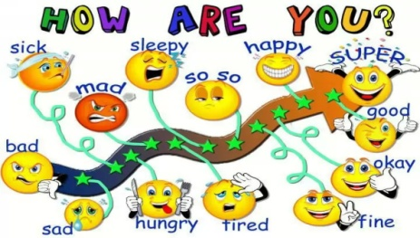 | 2 min
Physical drill  Ss are able to use and act out the verbs describing daily routine | T: I get up, wash my face and hands, clean my teeth… | Ss repeat in chorus and act | 3 min
Lead in  Ss are able to name the types of transport | - T shows the pictures of transport  - Guessing game  - A game “Go to the ....” instead of dots T names a word  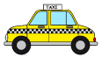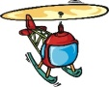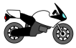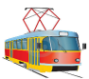  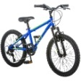  - T hides some pictures  of transport and asks What is missing?  - T asks a student “Show me a...” | Ss name the transport  A S acts out words of Transports, the others guess and say the word in English.  Ss find the picture of a named transport and go there.  - Train  - Bus  - Bicycle  - Motorbike  - Tram  - Helicopter  - Car  - Boat  - Foot/ on foot  - Ship  - Taxi  Ss close their eyes  Ss open their eyes and answer  Ss show the picture of mentioned transport | 20 min
Physical drill “Hockey Pockey”  Ss are able to understand the words, sing and act out | T turns on a song  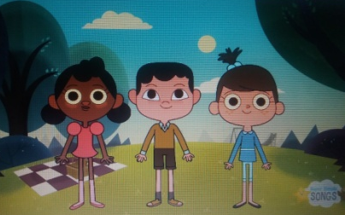 | Ss sing and act out | 3 min
Presentation  Ss will be able to say how they go to some places | - T says the structure “How do you go to…? I go to …by/on…”  - T asks questions using studied vocabulary “go to school/park/shopping/friend’s house” | Ss drill it repeating in chorus or individually being an echo of the teacher  Ss answer the questions then do the tasks in the Pupil’s Book  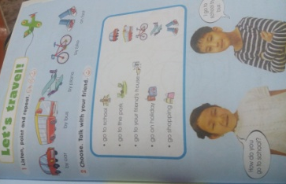 | 14 min
Feedback  Ss are able to self-assess the achievement they gain to the end of the lesson | T asks students “How do you feel?” to find out their mood and achievement at the end of the lesson. | Ss look at the “Blob tree” and say. 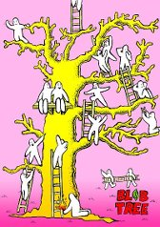 | 2 min

