Муниципальное автономное общеобразовательное учреждение Селятинская средняя общеобразовательная школа № 2


РАЗРАБОТКА
ОТКРЫТОГО УРОКА
ПО АНГЛИЙСКОМУ ЯЗЫКУ
для 6-7 класса
«Easter / Пасха»
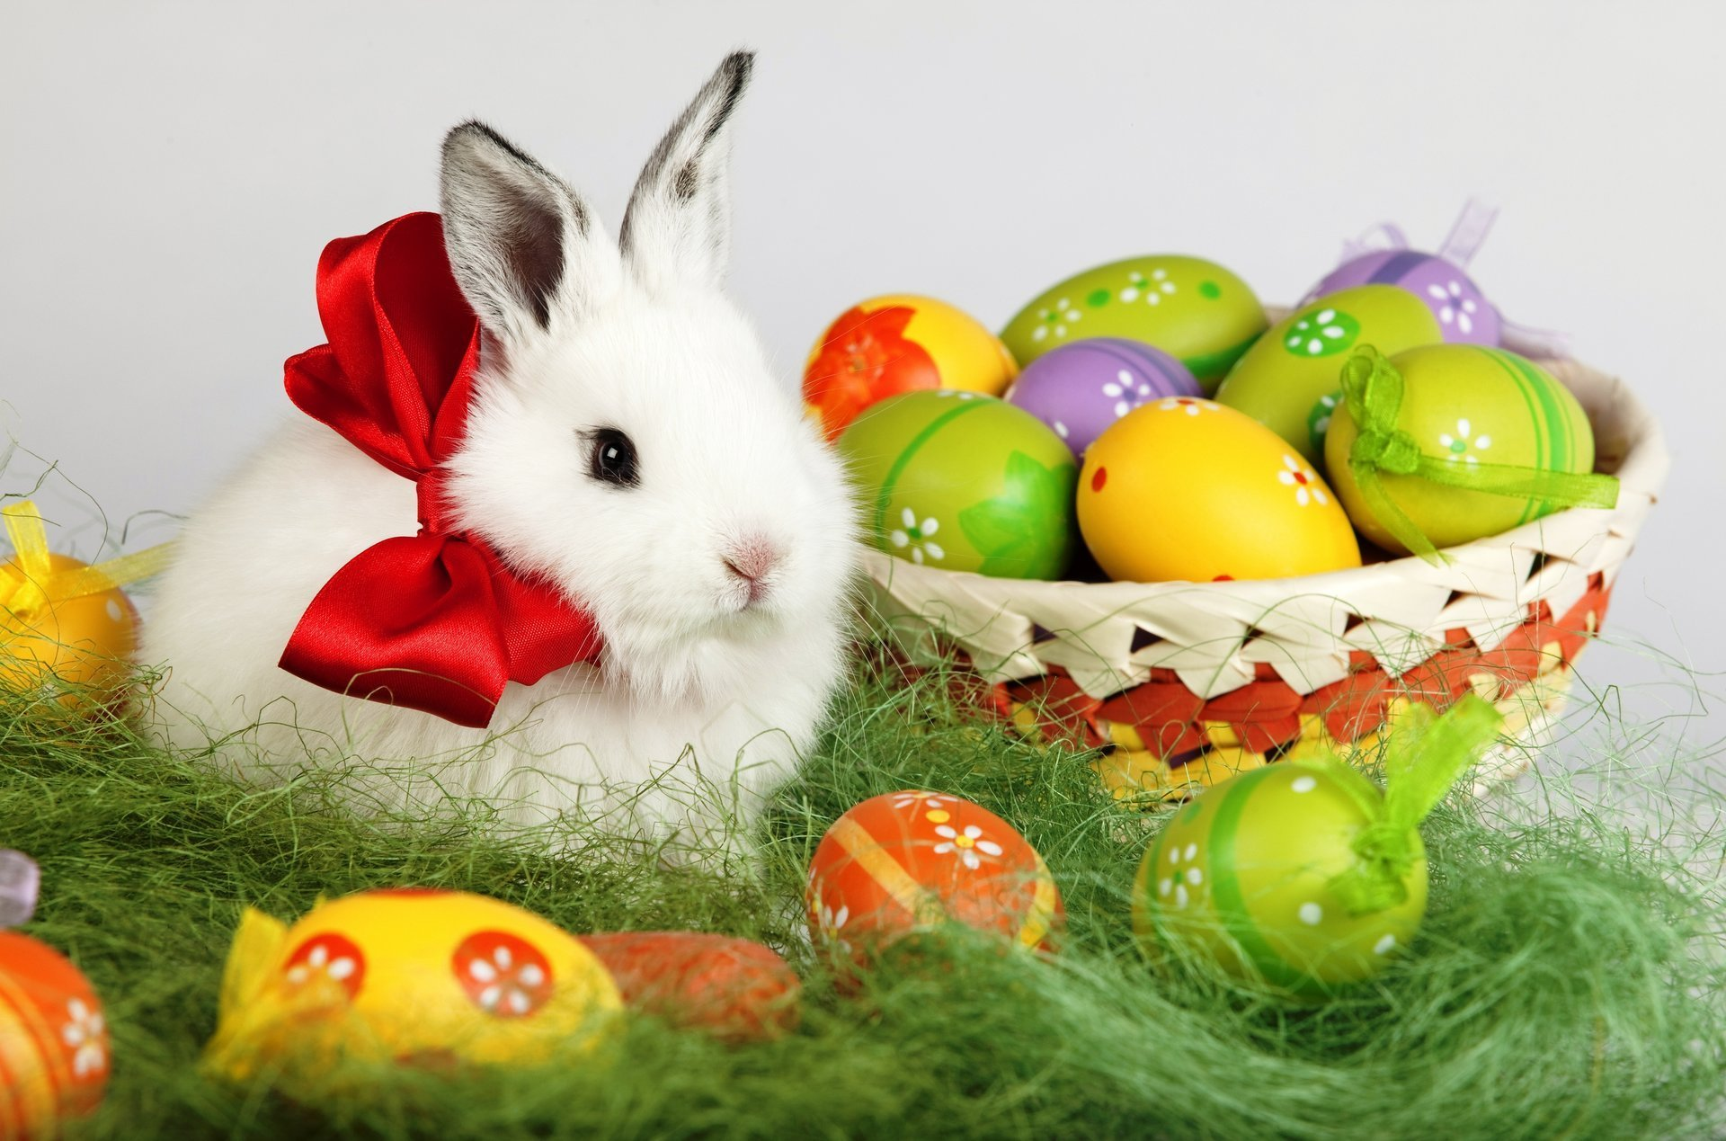

ВЫПОЛНИЛА И ПРОВЕЛА:
учитель английского языка
ПРИЛИПКО И.В.

2016/17 учебный год

Цели:
- Развитие коммуникативных навыков учащихся.
- Развитие творческих и креативных способностей.
- Активизация изученных лексических единиц.
- Пополнение словарного запаса.
- Развитие социокультурных навыков.

Задачи:
- Развивать лексические навыки, умения и языковую догадку.
- Развивать навыки аудирования и говорения (коммуникативных универсальных учебных действий).
- Познакомить с обычаями празднования Пасхи в Великобритании и Америке (развивать социокультурную осведомленность).
- Развивать творческие способности учащихся.
- Развитие памяти, внимания, мышления;
- Развивать умение работать в коллективе и принимать совместные решения;
- Развивать положительные личностные качества (ответственность, доброжелательность, чувство взаимопомощи)
- Воспитывать уважение к культуре своей страны и стран изучаемого языка.

Оборудование:
Компьютер, интерактивная доска, раздаточный материал, картинки, карточки

Ход урока.

На доске вывешены картинки с изображением символов и атрибутов праздника и словами их обозначающими (картинки и слова прилагаются). Приложение № 1.
Учитель приветствует детей, сообщает им цель урока и рассказывает о празднике или показывает свою презентацию. Приложение № 2.

- Good morning! Today I'm going to tell you about Spring Holiday - Easter! It's a moveable feast. Usually it is celebrated in April! People celebrate the resurrection Of Jesus Christ. Easter starts on Good Friday in Britain. But before it people keep Lent, it’s a time of fasting! It lasts 40 days! The last day of Lent is called Maundy Thursday! It’s a day of charity, tolerance and kindness! The Queen goes to Westminster Abbey and gives Maundy money to poor people. Number of people chosen depends on the Queen’s age. The Queen gives each person a red purse and a white purse. The white purse contains coins which have been specially made for the occasion. The number of coins also depends on the Queen’s age. The red purse contains money for food; usually about 5 pounds. This custom based on the washing of the Disciples’ feet in the Bible, goes back to the 13th century. At that time, the kings and queens of England used to wash the feet of the poor and then give them money. Today they only give them money!
On Easter children like to decorate eggs, eat chocolate bunnies and hot cross buns. Girls like wearing bonnets with flowers and colourful ribbons. The symbol of Easter is Easter Bunny. It carries eggs in a basket. The traditional dish is roasted lamb. Children enjoy playing Egg Hunt or Eggs Racing. They love this holiday very much as it is a family feast and it’s time for two weeks spring holidays!

Далее учитель предлагает задание для проверки понимания презентации – Easter Quiz
(раздаточный материал)

How much do you know about…


Easter is …  - A moveable feast.  - Always on the same date.  - Always in April. | Easter is connected to the Jewish….    - Yom Kippur.  - Passover.  - Pentecost. | Easter is always celebrated on a…  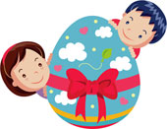  - Friday.  - Saturday.  - Sunday.
The Friday before Easter is known as…    - Easter Friday.  - Lent Friday.  - Good Friday. | 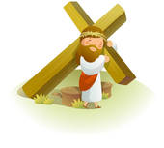  Easter day is commemorated as the day…  - that Jesus was born.  - that Jesus died.  - that Jesus was resurrected. | 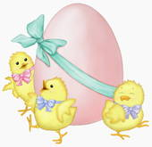  Which animal is considered a symbol of Easter?  - The chick.  - The rabbit.  - The duck.
When will Easter be celebrated in 2012    - On April 8th.  - On March 31st.  - On April 20th. |   The week before Easter is known as…  - Resurrection week..  - Holy week.  - Easter week. |   What is Lent?  - It’s a celebration.  - It’s an Easter bunny.  - It’s a time of fasting.
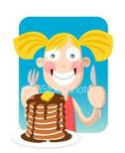  What is Shrove Tuesday?  - It’s the last day before Lent.  - It’s the first day of Lent.  - It’s the last day of Lent. |   What is usually done to eggs at Easter?  - They are eaten.  - They are decorated.  - They are broken. | 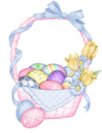  How many days does Lent last for?  - 15.  - 30.  - 40.
What kind of hunt is usually done at Easter?  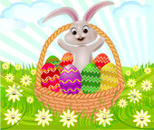  - Rabbit hunt.  - Chick hunt.  - Egg hunt. | The Easter bunny carries the eggs in a…    - basket.  - box.  - bag. | 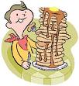  In the U. K. Shrove Tuesday is also known as…  - Egg Day.  - Rabbit Day..  - Pancake Day.


И для закрепления лексики учитель предлагает провести небольшое соревнование – «Кто лучше запомнил тематическую лексику?». Класс делится на три команды и предлагается выполнить на время следующие задания: (с опорой на картинки и карточки на доске) приложение № 1.
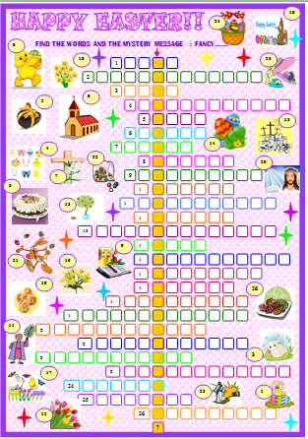
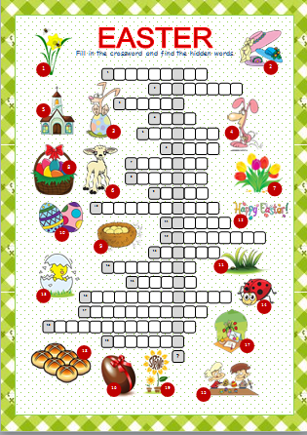

(раздаточный материал) (раздаточный материал)
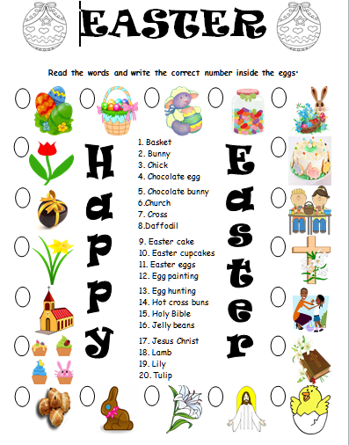
После выполнения задания ребята зачитывают слова и получившиеся секретные послания – Поздравления с Праздником!
Кто быстрее и правильнее всех выполнит задание – получает 5 баллов!

Затем учитель предлагает ученикам прочитать текст о том, как их сверстники в Великобритании празднуют Пасху и выполнить ряд заданий к тексту!



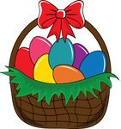






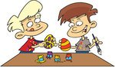




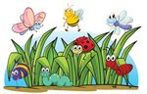
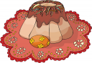
Are the statements true (), false () or doesn’t it say (∅)?
1 Easter is in summer.
2 Easter starts two days before Sunday.
3 Everybody eats hot cross buns on Good Friday in Britain.
4 Jack’s family eats hot cross buns on Good Friday morning.
5 Children make Easter bonnets this year at school.
6 Jack likes doing Easter projects.
7 Easter egg hunting means that children eat chocolate eggs.
8 Jack gets three chocolate eggs.
9 On Sunday afternoon two cousins come over.
10 Unfortunately, children have to go to school at Easter in Britain.
Answer the questions.

1 When is Easter?
_________________________________
2 What do people celebrate at Easter? _________________________________
3 Who gets chocolate eggs in Britain? _________________________________
4 What are the traditional food at Easter?
_________________________________
5 Why does Jack like Easter?
_________________________________

Complete the sentences.
1 This year the Easter project will be a ____________________ full of painted eggs.
2 After ______________ Jack’s family goes to church.
3 Emily and Jack ______________ Easter eggs in the garden.
4 In the __________ all his family have tea.
5 At Easter _________________ no school in Britain.
What about you? How do you celebrate Easter? What do you do at Easter? What do you eat? Do you have Easter holidays in you country?

Hello Friends! My name’s Jack.
I’m 12 years old and I live
in a small town in the south of
Britain with my mum, dad and
my sister, Emily.
Spring is here now and I’m very happy because of it. But now, I would like to tell you what we do in Britain at Easter.
Easter is in spring and people celebrate the resurrection of Jesus Christ. Easter starts on Good Friday in Britain. My mum makes hot cross buns and we eat them for tea. We usually have Easter-projects at school. Last year we made colourful hats, called Easter bonnets. This year we are going to design a basket full of painted Easter eggs. It will be a great fun!
On Easter Sunday morning we have a big breakfast. After breakfast we all go to church. When we get home, we give each other chocolate eggs. (Kids get the biggest ones!) Then we play ‘Easter egg hunt”. My parents hide some Easter eggs in the garden and Emily and I look for them. We love playing it.
We have roasted lamb with veggies for lunch.
In the afternoon my cousins, aunts and uncles come over for tea. We have Easter cupcakes, cakes and delicious tea. After tea we usually go for a walk together.
I like Easter because it is a great family festival and there is no school for two weeks!:)
OUR EASTER
Match the words to the pictures.
1 church
2 egg hunting
3 spring
4 hot cross buns
5 chocolate egg
6 garden
7 cupcake
8 chick
9 bunny
10 roasted lamb
11 egg painting
12 basket
13 Easter eggs
14 cake
15 bonnets

И в заключение урока учащимся предлагается логическая игра – Logic Game “Easter”
Five boys went to sprinkle their relatives this Easter. Each boy became different presents from different relatives, and the number of the visited ‘girls’ are different, as well. If you want to know which information belongs to which boy, look at the clues and fill in the tables. Then write full sentences using the solution.
To solve this logic game put an 'X' where there is a relation and '-' where there isn't.
 |  | FROM WHOM? |  |  |  |  | WHAT? |  |  |  |  | HOW MANY PLACES?
 |  | aunt | cousin | grandma | mother | sister | chocolate bunny | chocolate egg | chocolate sheep | money | painted egg | 2 | 3 | 4 | 5 | 6
NAME | Adam
NAME | Allan
NAME | Doug
NAME | Elliot
NAME | Hugh
HOW MANY PLACES? | 2 |  |  |  |  |  |  |  |  |  |  | Clue 1: Adam got a chocolate animal from his aunt’s daughter. He sprinkled in five places.  Clue 2: The boy who got a chocolate egg was in more places than the boy who got money but less than Elliot.  Clue 3: The grandma gave some money to her grandson. He isn’t Hugh or Doug.
HOW MANY PLACES? | 3
HOW MANY PLACES? | 4
HOW MANY PLACES? | 5
HOW MANY PLACES? | 6
WHAT? | chocolate bunny |  |  |  |  |  | Clue 4: The boy who is neither Doug nor Elliot was in four places. He got a painted egg but not from his mother.  Clue 5: The chocolate sheep was from an aunt.
WHAT? | chocolate egg
WHAT? | chocolate sheep
WHAT? | money
WHAT? | painted egg

Now summarize your answers.
NAME | FROM WHOM? | WHAT? | HOW MANY PLACES?
Adam
Allan
Doug
Elliot
Hugh
Now write sentences. Look at the example.
e.g.: Dave was only in one place. He sprinkled his mother and got a chocolate chicken.
1) ______________________________________________________________________________________
2) ______________________________________________________________________________________
3) ______________________________________________________________________________________
4) _______________________________________________________________________________________
5) _______________________________________________________________________________________

В конце урока подводятся итоги, объявляются победители, вручаются памятные призы!
Использованы материалы с:
      - Приложения Pinterest
      - сайт BBC Learning English

Приложение № 1.

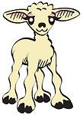










basket

bunny
Easter eggs
chick

lamb

egg hunting
egg painting

c
greeting

Easter card

decoration
Easter set
Easter bonnets

chocolate egg

chocolate rabbit
Easter cake
Easter cupcake

bee

butterfly

e
ladybug
Easter egg boy


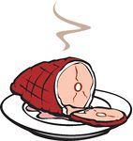













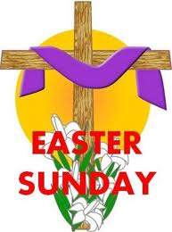

hot cross buns

jelly beans
ham
roasted lamb

catkin

daffodil
lily

c
tulip

Jesus Christ

Holy Bible
cross
church

nest

sprout
grass
spring

Good Friday

Easter Sunday

e
March
April

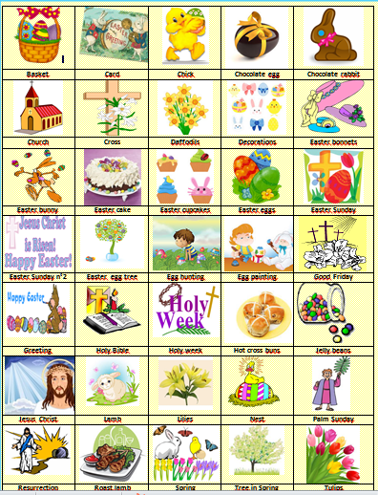

Приложение №2
(смотреть презентацию - на персональном сайте Прилипко Ирины Владимировны)
