№ | Что делаем | Время | Примечания
 | - Организационный момент. Погружение.  Видео «How are you?»  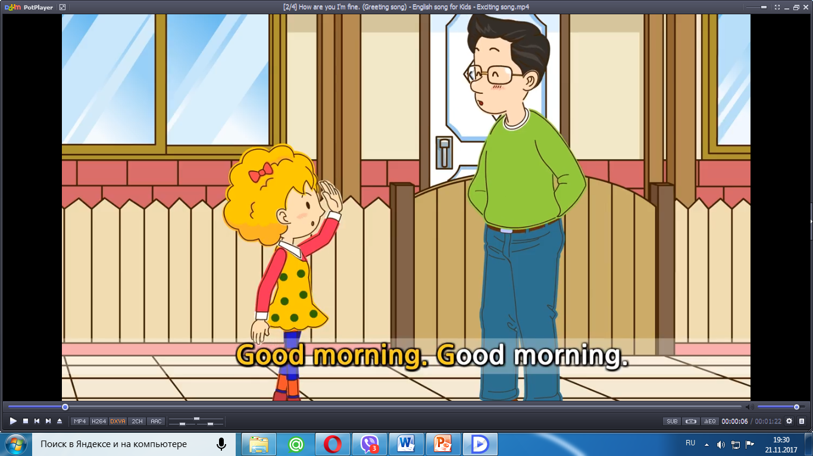  Дети смотрят видео и поют песню «How are you?».  Good afternoon! Sit down, please. Thank you for your beautiful singing. I like it very much. So how are you today? -- -- I’m fine, thanks. I’m great too. Don’t be nervous. Just relax and enjoy English.  - Целеполагание.  Слайд 1    Let’s start our lesson. What will it be about? I don’t know. But I have some pictures. Look, please.  Доска:  Фотографии известных людей (Пелагея, Александр Пушкин, Мать Тереза, Билан, Дракула и обычного мальчика).  Подпись: IN/FAMOUS/UNKNOWN/ORDINARY  Do you know these people? And this boy?  I don’t know and nobody knows. So these people are FAMOUS. And it is INFAMOUS. And this boy is UNKNOWN/ORDINARY. Maybe in the future he will be famous but not yet. Look here. Can you guess the topic of our lesson now?  Слайд 2    Доска:  People famous (вырезать из бумаги).  Correct me please. Thanks. You are right. Put down please the right version.  (Пока записывают тему)Would you like to be famous?  Проектор прикрыть  So famous people is our topic/theme and what will we do in the lesson?  Записываем цели на листочке (доска)  - We will talk/read/listen about famous people.  - We will find out something new.  You are right. We will work a lot.  - Фонетическая разминка.  We will start with our reading.  There are a lot of good words with letter f. For example, family, friends. There is not a good sentence about friends. Let’s read it and correct.  Прочитать слова по отдельности и собрать из них предложение.  Five furiuos friends fought for the phone.  Try to read it. Now I’ll show you some faces and you’ll read according to these faces.    Let’s correct it: NEVER (вырезать из бумаги.)  4 . Проверка д/з.  Монологические высказывания.  Tell me please about your best frinds. (1 - 2 students from each group.)  Крепят фото сових друзей на доску.  Задаём вопросы:  Can your friend swim/sing/play football?  - Применение полученных знаний на практике. Повторение вопросов.  Доска: фото моего друга.  And here is my best friend. Ask me some questions about her.  - Is it she or he?  - What’s her/his name?  - How old is she?  - Can she sing/draw/play hocky?  Ok. Look. It is my best friend. Can you tell about her?  - Систематизация и обобщение лексики по теме «Семья»  Is it my sister or my daughter or my aunt?  Самоконтроль письменной речи.  Can you guess who is who?  My mother’s mother is my …  My parent’s daughter is my…  My father’s father is …  My parent’s sun is my …  My aunt’s children are my…  My father’s brother is my…  My mother’s sister is my …  Write answers and then we’ll check it.  Слайд 3  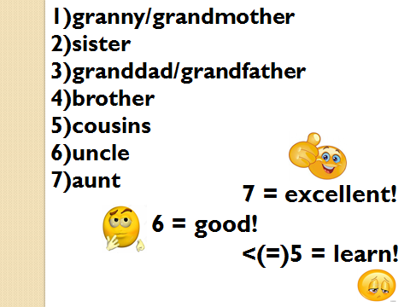  - Физкультминутка.  We’ve written a lot. I’m tired. And you? Let’s rest a bit. Listen dance and tell me whose song is it?  Видео Me Enamore Shakira  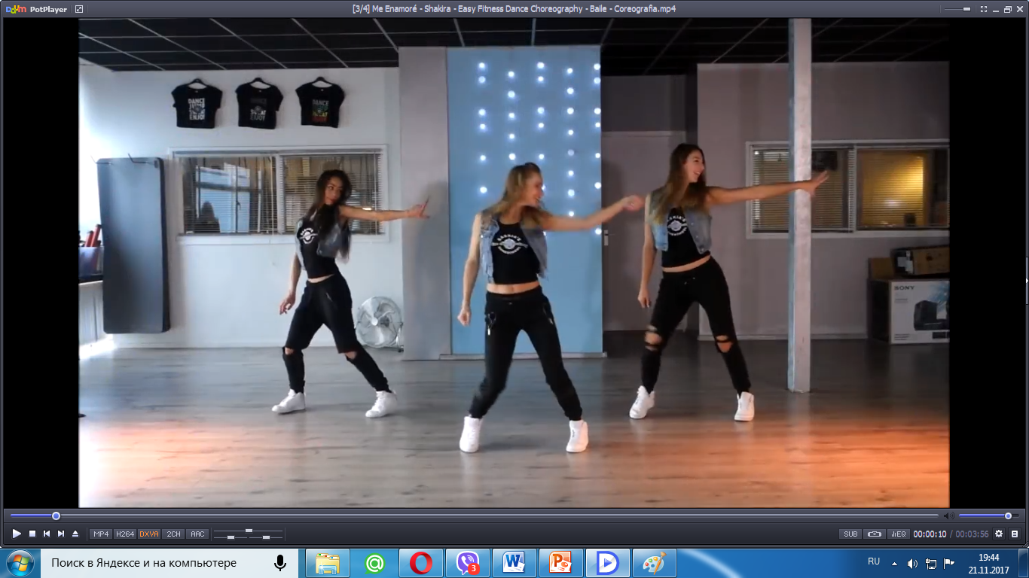  - Reading  Yes, it’s a famous singer, dancer Shakira.  Слайд 4    Is she a beautiful woman? Why do you think so?  Слайд 5    Open your books p. 60 Ex. 2  Read the article and complete the profile.  Слайд 6  You have 3-4 minutes. Then we’ll listen and check. Аудио 03  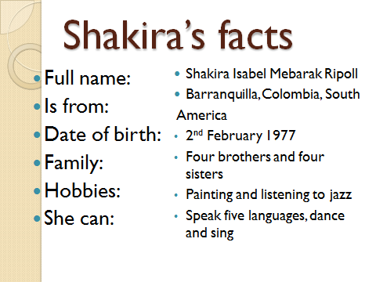  Try to remember as many facts as you can about Shakira.  Слайд 7  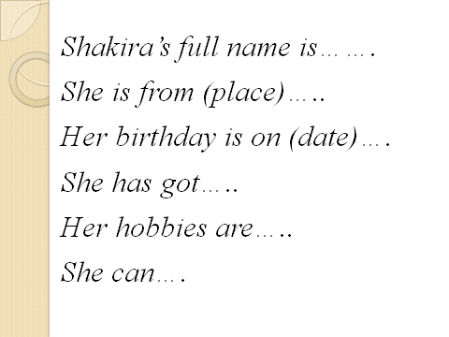  - Tell me some facts about this person.  Доска.  - Homework  You can see with this plan you can describe any famous person.  Open your diaries and put down your homework.  Слайд 8  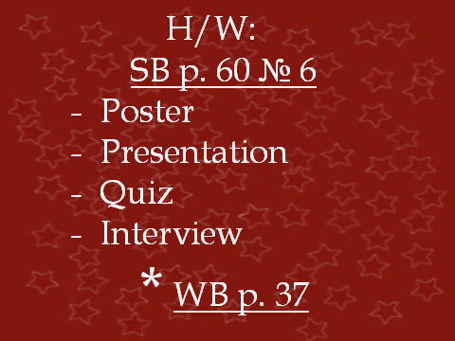  - Listening.  What can we tell about famous pople’s hobbies? Do you know them? So can say they like what they do. Their hobbies and hard work of course often help them to become famous. And what are your hobbies? What hobbies do British and American teenagers have?  P. 60 Ex. 5 Аудио 04  Listen and match the people and their hobbies.  Ann’s hobby is … .  - Подведение итогов урока.  Оценки.  Famous – hobby, family, friends, hard work  Mother Teresa – everyone is talented in his own way. So everyone can be famous.  But more important is to have good friends and family.  - Рефлексия.  Your hard work .  Choose a smile.  Good bye and good luck.  Song «Goodbye» | 2  3  3  5  2  4  1  2  3  2  2  5  1  2  1  1 | 14.00  14.02  14.05  14.08  14.13  14.15  14.19  14.20  14.22  14.25  14.27  14.29  14.34  14.35  14.37  14.38  14.39

