1. Choose the country to complete the rhyme.
A) Russia B) Spain C) France D) UK

2. Match the flag with the country and choose the right variant.
A) 1c, 2a, 3d, 4b B) 1c, 2a, 3b, 4d
C) 1d, 2c, 3b, 4a D) 1b, 2d, 3a, 4c
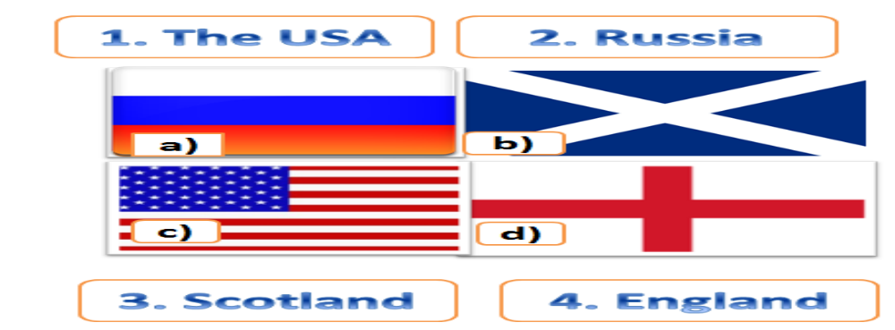
3. Max doesn`t know English very well. It is difficult for him to converse (общаться). Help him to fill in the correct sentence.
1. A: ………. . What time is it, please?
B: Half past four.
2. A: Could you tell me the time, please?
B: Certainly. ………… .
3. A: Thank you very much.
B: ……………………. .
4. A: ……………..?
B: It`s a dog.
5. A: …………………..?
B: It`s got a big body, long legs and a long tail.
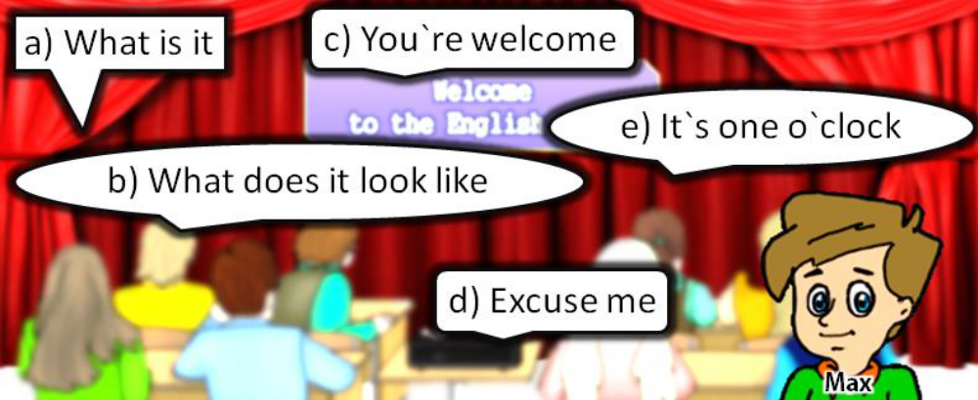
A) 1e, 2a, 3d, 4b, 5c B) 1c, 2a, 3e, 4d, 5e
C) 1d, 2e, 3c, 4a, 5b D) 1b, 2d, 3a, 4c, 5e
4. Max is speaking about himself. Help him to make his story correct. Choose the correct variant.
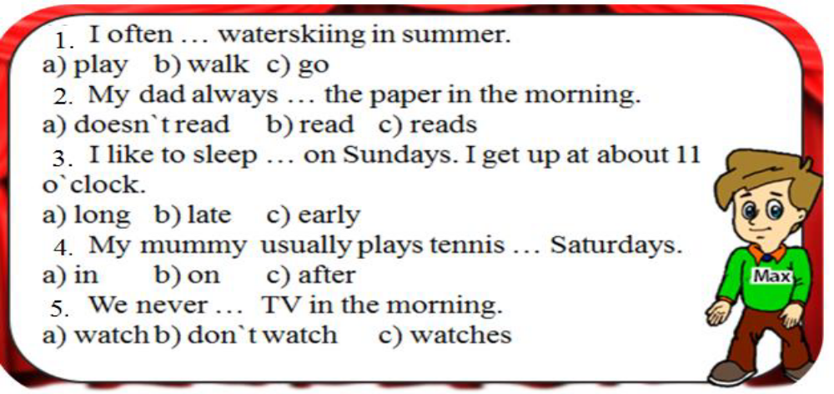
A) 1a, 2 а, 3b, 4b, 5a B) 1a, 2b, 3b, 4a, 5b
C) 1a, 2a, 3b, 4b, 5c D) 1c, 2c, 3b, 4b, 5a
5. Choose the right variant.
1. She likes watching TV ___ the evening.
2. I get up ____ seven o’clock every day.
3. My father works ___ a bank.
4. I didn’t go __ school last week.
5.Cathy was __ home.
A) 1 on, 2 in, 3 at, 4 in, 5 in B) 1 in, 2 at,3 in, 4 to, 5 at
C) 1 in, 2 at, 3 on, 4 to, 5 in D) 1 in, 2 on, 3 in, 4 to, 5 at
6. Read the jumbled up conversation. Put it in the correct order.
1. Hello, Sarah.
2. Why not?
3. It’s Sally. We are having a party on Saturday.
4. I am going to visit my grandparents.
5. Sorry, I can’t come.
6. Who is speaking?
A) 1, 6, 3, 5, 2, 4 B) 6, 3, 1, 5, 2, 4 C) 1, 3, 6, 4, 5, 2 D) 1, 2, 4, 5, 6, 3
7. Look at the pictures and match them with the sentences
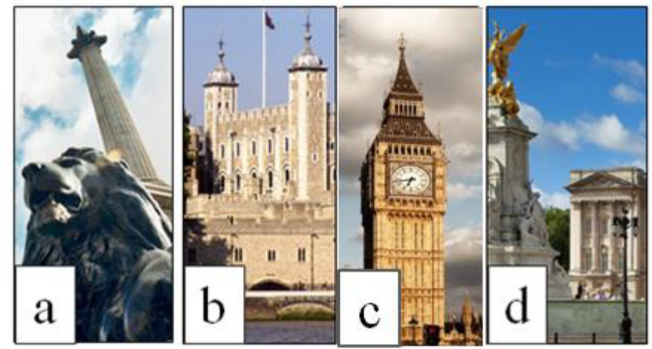
1 The Tower of London was founded (быть основанным) in the 11th century by William the Conqueror.
2. The queen of England lives in Buckingham Palace.
3. There is a statue of Admiral Nelson in the center of Trafalgar Square.
4. Big Ben is the largest and the most famous clock in the world.
A)1c, 2a, 3d, 4b B)1c, 2a, 3b, 4d C) 1d, 2c, 3b, 4a D) 1b, 2d, 3a, 4c
8. Solve the riddle
What is that you cannot see, but which is always before you?
A) your future B) your relatives C) your family D) your legs
9. Find the mistake.
Tina is listen to music now.
1 2 3 4
A) 1 B) 2 C) 3 D) 4
10. Put the words in the correct order to get a questions.
favourite / subject / is / your / at/ school / what?
1 2 3 4 5 6 7
A) 7, 4, 3, 1, 2, 5, 6 B) 7, 6, 3, 4, 1, 2, 5 C) 7, 3, 4, 1, 2, 5, 6 D) 3, 4, 6, 1, 2, 7, 5

