- Choose the right word to complete the statement.
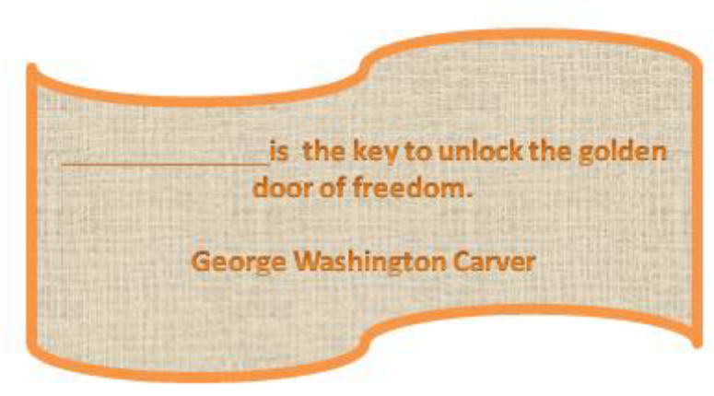
A) a book B) education C) family D) future
2. Solve the riddle.
What is that, over the head and under the hat?
A) eyes B) forehead C) cap D) hair
3. Match the two halves of the sentence. 1. The tea is too hot a) to buy 2.The jacket is too expensive b) to catch the bus 3.It’s too late c) to climb a tree 4.He is too old d) to drink
A) 1b, 2c, 3a, 4d B) 1d, 2b, 3a, 4c
C) 1d, 2a, 3b, 4c D) 1a, 2d, 3c, 4b
4. Choose the right variant.
1. My mum has studied English language at school ________7 years.
a) for b) since
2. “Let’s go for a walk”. “I’m afraid I haven’t done my homework _________”.
a) still b) yet
3. I met my best friend Lucy in summer camp ten years_________.
a) ago b) since
4. I’m sure I’ve ________seen this film.
a) yet b) already
5. She has been to England once_________.
a) before b) ago
A) 1a, 2b, 3a, 4b, 5a B) 1b, 2b, 3a, 4a, 5b
C) 1a, 2b, 3a, 4a, 5b D) 1b, 2a, 3a, 4b, 5a
5. Read the idioms and their meaning. Fill in the correct idiom.
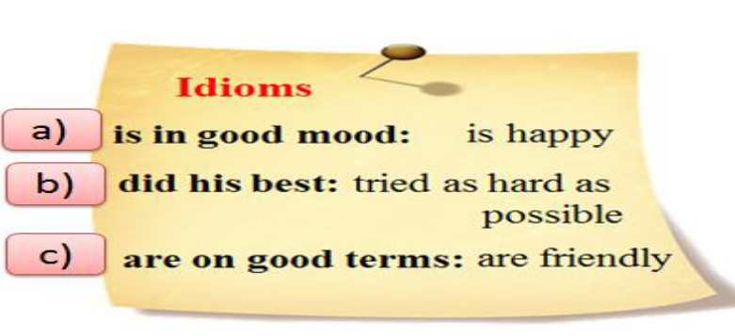
1. We ____________________with our English teacher. She is very friendly.
2. Mike ___________________to win the trip to England.
3. Look! Nick is smiling. He _______________________ today.
A) 1b, 2c, 3a B) 1c, 2b, 3a
C) 1c, 2a, 3b D) 1a, 2b, 3c
6. Read the text. Choose the correct variant.
1. A young lady was ___ for a concert.
a) late b) lately
2. The curtain was ___ up.
a) already b) still
3. The conductor was just ___ his hand.
a) raising b) rising
4. The attendant (билетер) did not want to let the young lady ___
the concert-hall during the performance.
a) enter b) leave
5. “But I`ll stand at ___ back and not make any noise,” she said.
a) a b) the
6. “I want to ___ to the new symphony of this composer.”
a) hear b) listen
7. Open the door ___ little, please.” – “That`s the trouble, madam,” said the attendant.
a) a b) –
“If I open the door now, half the audience will run out.”
A) 1a, 2b, 3a, 4b, 5a, 6b, 7a B) 1b, 2b, 3a, 4a, 5b, 6b, 7a
C) 1a, 2a, 3a, 4a, 5b, 6b, 7a D) 1b, 2a, 3a, 4b, 5a, 6a, 7b
7. Put the verbs in brackets into the correct tense form.
– I usually don`t have breakfast before I (1)____________ (go) to work.
– When the doorbell (2) ____________ (ring) he (3) ____________ (stand) up and (4)
____________ (go) to the door.
– Are you the boy whose dog was barking all night long? – I`m sorry, but you (5) ____________
(be) mistaken, sir. I never (6) ____________ (have) a dog.
– If it (7)____________(not to stop) raining we won`t be able to go boating tomorrow.
A) 1 go, 2 rang, 3 was standing, 4 went, 5 are, 6 have, 7 don’t stop
B) 1 go, 2 is ringing, 3 am standing, 4 went, 5 are, 6 have had, 7 doesn’t stop
C) 1 go, 2 rang, 3 stood, 4 went, 5 is, 6 have had, 7 don’t stop
D) 1 go, 2 rang, 3 stood, 4 went, 5 are, 6 have had, 7 doesn’t stop
8. Choose the right word to complete the sentence
1. _________ I failed my driving test and have to take some more lessons.
a) fortune b) unfortunately c) misfortune
2. There are very few polar bears left on our planet. They are _______ animals.
a) dangerous b) danger c) endangered
3. Sam likes________ kinds of sport: football, tennis, ice-hockey and others.
a) indifferent b) differ c) different
A) 1b, 2c, 3c B) 1c, 2a, 3c
C) 1c, 2a, 3b D) 1a, 2b, 3c
9. How well do you know Britain? Choose the correct variant.

1. How many countries does the UK consist of?
a) 3 b) 4 c) 5
2. What plant is the symbol of England?
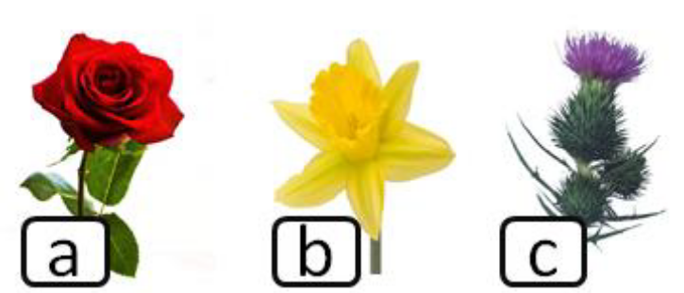

3. When was the Great Fire of London?
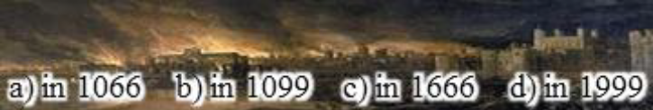
A) 1b, 2c, 3c B) 1b, 2a, 3c C) 1b, 2a, 3b D) 1a, 2b, 3b
10. Make up the question from the given words.
you / to / Christmas / are / send / going / cards?
1 2 3 4 5 6 7
A) 4, 1, 6, 2, 5, 3, 7 B) 4, 1, 6, 2, 5, 7, 3 C) 1, 5, 3, 7, 4, 6, 2 D) 1, 4, 6, 2, 5, 3, 7

