1. Choose the topic to which the following words belong.
Soap opera, quiz show, channel, news
A) internet B) television C) newspaper D) magazine
2. Choose the word to complete the sentence.
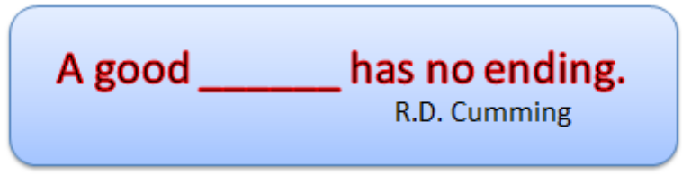
A) film B) life C) book D) conversation
3. Match the type of program with its definition.
1. A talk show is
a) is a form of game or mind sport in which the players (as individuals or in teams) attempt to answer questions correctly.
2. A soap opera
b) is a program, which gives facts and information about a particular subject.
3. A documentary
c) is a program o in which one person (or group of people) discusses various topics put forth by a talk show host.[
4. A quiz
d) is a serial drama on television which features related story lines about the lives of many characters. The stories usually focus on emotional relationships to the point of melodrama
A) 1c, 2d, 3a, 4b B) 1a, 2b, 3c, 4d
C) 1d, 2c, 3b, 4a D) 1c, 2d, 3b, 4a
4. Solve the riddle.
What runs but never walks?
A) a film B) a life C) a river D) time
5. Where can you see these notices? Choose the correct answer.
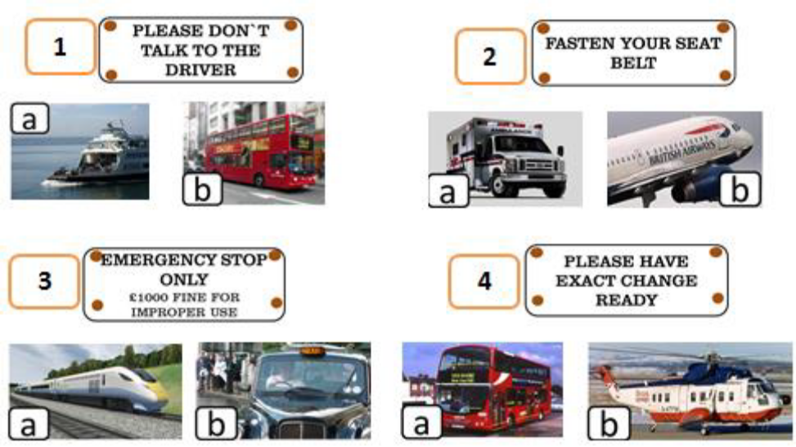
A) 1b, 2a, 3b, 4a, B) 1a, 2a, 3b, 4b,
C) 1b, 2b, 3a, 4a, D) 1b, 2b, 3b, 4a,

6. Choose the correct variant.
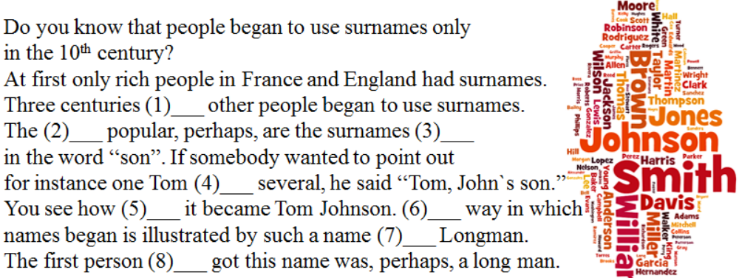
A) 1b, 2a, 3a, 4a, 5b,6b, 7b, 8b B) 1b, 2b, 3b, 4a, 5b, 6b, 7b, 8b
C) 1b, 2a, 3a, 4a, 5b, 6a, 7a, 8a D) 1b, 2b, 3b, 4a, 5a, 6a, 7b, 8a
1. a) late b) later
2. a) more b) most
3. a) end b) ending
4. a) among b) between
5. a) late b) later
6. a) other b) another
7. a) like b) as
8. a) which b) who
7. Complete each sentence with the correct participle.
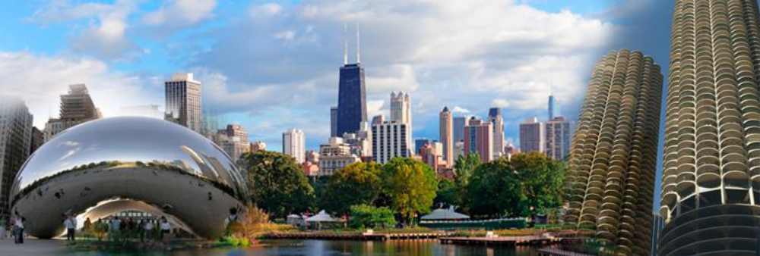
Lira: You must be (1)
____________(thrill). Chicago is an
(2)____________(amaze) city.
There are so many (3)
____________(interest) things to do.
You can`t get (4)
____________(bore) in this city!
Natalie: Honestly, I`m a little bit (5) ____________(scare) because my English is very poor.
I think that people will find it even (6) ____________(amuse).
Lira: Don`t worry! I`m sure your trip will be really (7) ____________(excite).
A) 1 thrilled, 2 amazing, 3 interesting, 4 bored, 5 scared, 6 amusing, 7 exciting
B) 1 thrilled, 2 amazing, 3 interesting, 4 boring, 5 scaring, 6 amused, 7 exciting
C) 1 thrilled, 2 amazing, 3 interested, 4 boring, 5 scared, 6 amusing, 7 exciting
D) 1 thrilled, 2 amazed, 3 interesting, 4 bored, 5 scared, 6 amusing, 7 excited
8. Put the verbs in brackets into the correct tense form.

Ellie is a fashion designer. She (1)_______________(make)
clothes ever since she (2)_______________(be) a little girl.
She (3)_______________ (get) her first job in a small
clothes workshop when she was seventeen. She
(4)_______________ (sew) zips (молния) onto a skirt one
day when she (5)_______________ (have) a brilliant idea
for a design. She (6)_______________ (speak) to her bank manager, got a loan (получила
кредит), and (7)_______________ (open) her own workshop. Since then she
(8)_______________ (earn) a lot of money. Many famous film stars and singers often
(9)_______________ (buy) her clothes nowadays.
A) 1 has been making, 2 is, 3 got, 4 sew, 5 had, 6 spoke, 7 opened, 8 has earned, 9 buy
B) 1 has been making, 2 was, 3 got, 4 was sewing, 5 has had, 6 was speaking, 7 opened, 8
has earned, 9 buy
C) 1 made, 2 was, 3 got, 4 was sewing, 5 had, 6 spoke, 7 opened, 8 earned, 9 bought
D) 1 has been making, 2 was, 3 got, 4 was sewing, 5 had, 6 spoke, 7 opened, 8 has earned, 9
buy
9. How well do you know Britain? Choose the correct variant.
1. What is the capital of Wales?
a) London b) Cardiff c) Edinburgh
2. Where were the Beatles from?
a) Liverpool b) Manchester c) London
3. Where did Sherlock Holmes Live?
a) Buckingham Palace b) 10 Downing Street c) 221b Baker Street
4. Where is Stonehenge situated?
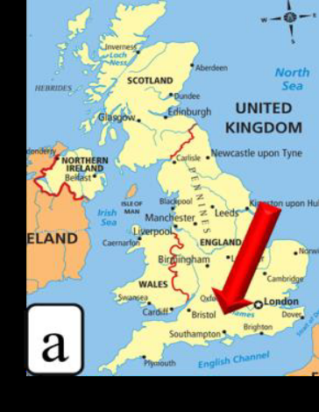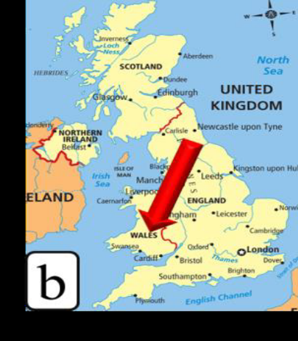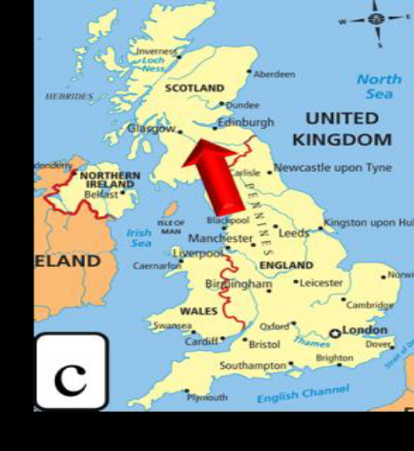
5. What plant is the symbol of Wales?
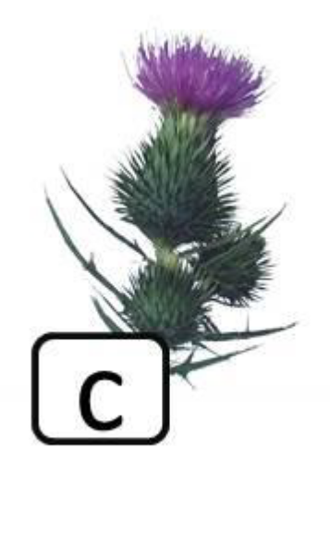
A) 1b, 2a, 3c, 4a, 5b B) 1c, 2a, 3b, 4b, 5b
C) 1b, 2a, 3c, 4a, 5c D) 1b, 2b, 3b, 4a, 5c
10. Make up the question from the given words.
designed / first / who / helicopter / world’s / the?
1 2 3 4 5 6
A) 6, 5, 2, 4, 3, 1 B) 3, 1, 6, 5, 2, 4
C) 6, 5, 4, 2, 3, 1 D) 3, 6, 5, 2, 4, 1

