Материал для подготовки к устному этапу итоговой аттестации по английскому языку.

Пособие: Exam Success by Wayne Rimmer and Olga Vinogradova with Ludmila Kozhevnikova, Course Consultant: Maria Verbitskaya

Тема: сравнение двух картинок

Хочу поделиться материалом, взятым из данного пособия и переработанным под формат задания устной части ЕГЭ, где ставится задача сравнить две фотографии на основе предложенного плана.

Task 4. Study the photographs. In 1.5 minutes be ready to compare and contrast the photographs:
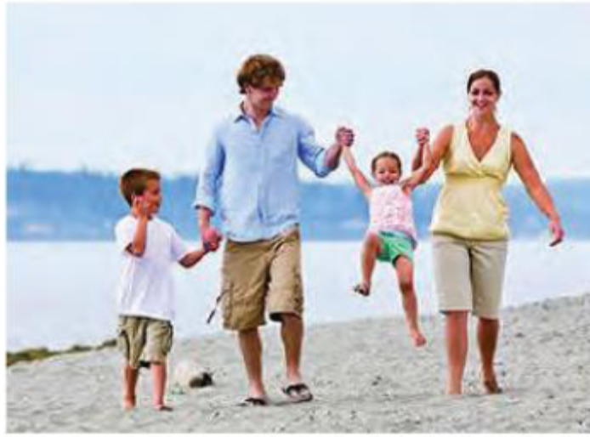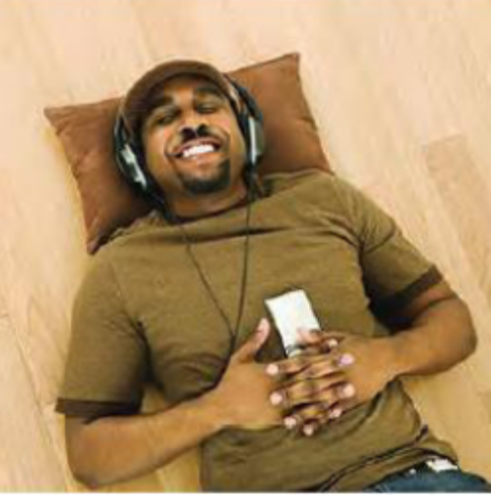
- give a brief description of the photos (action, location)
- say what the pictures have in common
- say in what way the pictures are different
- say which of the concerts presented in the pictures you'd prefer
- explain why

- I’d like to describe two photographs of people enjoying themselves. In the first picture you can see a family walking by the sea. It is a lovely day and it is, obviously, great to be together. The second picture shows a man lying on his back and listening to music indoors. He is very pleased because it is, probably, his favourite music and he loves listening to it.

- These photos are quite similar as they both show nice ways to pass you time. Moreover, the people in the pictures are smiling. They seem to be happy on their holidays.

- However, there are some differences between the photos. The left one is taken outside while the right one is inside and there is contrast between activity and pure relaxing. There is also a difference between doing things together and individually.

- As for me, I would choose a seaside holiday shown in the first picture.

- There are several reasons for it. Firstly, I love my family and prefer to spend my free time with them. Secondly, I’m fond of active holidays where I can swim, run or play sports games.
Well, I’ve come up to the end of my talk, the pictures look similar but they are different and I’d prefer the left one.

