The English

The subject of the lesson:Almaty is the largest city of Kazakhstan.
The aims of the lesson: 1) Educational-to acquaint students with a new vocabulary and expressions on a theme:Almaty is the largest city of Kazakhstan.
2) Developing-Bringing up-to develop a culture of behavior during the meal.
3) Bringing up-to bring love to the English language.

The type of the lesson:Аралас
Methods:Түсіндірмелі иллюстративтік
Interobjects connection:Kazakh language, Russian language, Geography
The visual aids: Ғаламтор қолдану. Ноутбук

The procedure of the lesson:
- Organization moment:(3 мин)
- Greeting
Good day, students! Sit down! I am glad to see you!
We begin our English Lesson!
- Conversation with on duty:
Who is on duty today?
What date is it today?
What day is it today?
Who is absent?
Thank you, very much! Sit down!
- Check up the educational accessories.
- Creation the language atmosphere
What is the weather like today?
What season is it now?
Is it raining today?
- Phonetic drill:(3 мин)
structure
struggle
student
study
stuff
stupid
style
subcontract

- Repetition of the lesson.
- Checking the home task.
What was your home task for today?
- Presentation of the new material:(25 мин)

New words.
subject
swift
swim
swimmer
swing
Swiss
switch
sword
syllable
symbol
sympathetic
sympathize
sympathy
symptom
synthetic
system
table
tablet
tag
tail
tailor
take
take steps
takeoff
takeover
tale
talent
talk
tall
tame
tank
tap
tape
target
tariff
task

taste
tax
taxation
taxi
taxpayer
tea
teach
teacher
teaching
team
teamwork
tear
technical
technician
technique
technology
tedious
teenager
telegram
telegraph
telephone
telescope
television
tell
teller
temper
temperature
temple
temporary
tempt
temptation
ten
tend
tendency
Almaty City
Almaty is the largest financial, economic and cultural city of Kazakhstan. Almaty was the capital of Kazakhstan from 1929 to 1997. It is one of the most beautiful cities in Kazakhcstan with a population of of 1,348,500 (as of 1 September 2008), which represents 9% of the population of the country, situated in the foothills of the ZailiskyAlatau Mountains. It accommodates numerous business centers, theaters, museums, art galleries, exhibition halls and countless modern entertainment complexes. The name “Almaty” derives from the Kazakh word for “apple” (alma), by which the surrounding region is rich; the region that is thought to be the ancestral home of the apple, and the wild Malussieversii, is considered a likely candidate for the ancestor of the modern domestic apple.
Residents and guests of the southern capital have at their disposal 5 stadiums, a hippodrome, and the high-altitude Medeo sport complex, featuring a unique ice skating rink located at 1700 m above sea level.
This is where world records have been set many times by the world’s top skaters. Medeo is a popular skating area for residents and guests of Almaty. Almaty Central Stadium accommodates 32,000 people. Nearby is a venue for track and field athletes and a perfectly equipped winter swimming pool.
Mountainous areas the visiting card of Almaty. You can begin your acquaintance with them on a ride by cable car to the city’s highest point, Kok-Tyobe (Blue Hill), 1130 m above sea level.
From here you can view a splendid panorama of the mountain ranges and the city. It is especially beautiful at night when Almaty is illuminated by glimmering lights. The cableway soars over the old part of the city, buried in gardens called Compote by locals. This area is so called because of the fruit names of streets located here: Cherry, Pear, Grape, etc. While riding the cablecar up the hill you can watch the lifestyle of local people almost as in an ethnographic museum. The Kok-Tyube hillside is topped by a350 m TV tower. It’s built in a seismically active area.
The new 2030 General Plan of Almaty was developed in 1998 and aims at forming ecologically safe, secure and socially comfortable living conditions. The main objective is to promote Almaty’s image as a garden-city. One of the components of the General Plan is to continue multi-stored and individual construction, reorganize industrial territories, improve transport infrastructure and launch Almaty Metro (Almaty Subway). At the same time, some officials and Almaty city dwellers actively opposed metropolitan construction in seismically active zone. Some scientists said that in case of strong earthquake, the city will immediately fall under ground. However, constructors state that metropolitan is constructed taking in consideration Almaty city seismic situation. In fact, metropolitan construction started in 1989, hardly any of the project initiators could suppose that construction time would have lasted for 20 years. The total length of Almaty metropolitan is planned to be equal to 45 kilometers.
Saint-Voznesenskiy is an Orthodox Cathedral designed by the local architect A. Zenkov, was built without the use of any nails in 1940 and is one of the nine most unique wooden buildings in the world. Its wall paintings and interior decoration boggle the imagination of the visitors with its beauty and magnificence. The remarkable fact is that the Cathedral outstood a very strong earthquake of 9 points by Richter scale in 1911.
It is an inimitable construction that decorates the Republic Square. It was erected by a creative group under the supervision of Shota Valikhanov. This god-like image floats in the glaring sky of the Southern capital while the “Golden” Man tames the snow leopard. Around this monument there is the history of the ancient Kazakh land. Original of the Golden Man artifacts said to be kept in Kazakhstan President Nazarbayev’s presidential palace.
Central (Gorky) Park
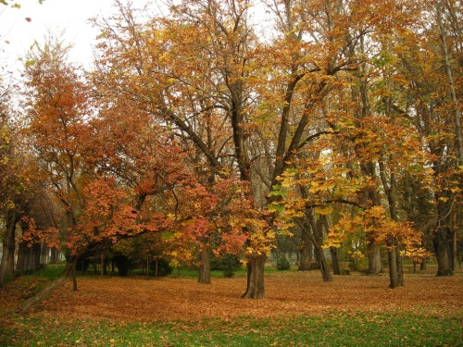
Almaty’s biggest recreational area (admission 25T; 24hr), at the eastern end of Gogol, is still known as Gorky Park. It has lakes, funfair rides, an Aquapark (Jun-Sep), a zoo, and several cafés, and shashlyk stands.
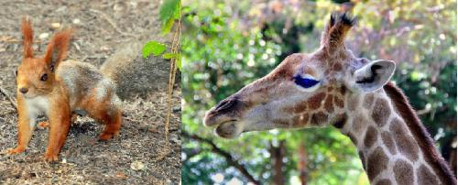
Some lovely species at Gorky Park zoo
This large and popular rectangle of greenery, first laid out in the in the 1870, is focused on the candy-col our end Zenkov Cathedral. The park is named for the Panfilov Herous, commemorated at the fearsome war memorial. This represents the 28 soldiers of an Almaty infantry unit who died fighting off 50 Nazi tanks in a village outside Moskow in 1941. An eternal flame commemorating the fallen of 1941-45 (WWII), flickers in front of the giant black monument of soldiers.
There are many museums in Almaty worth to visit like the uniquely Museum of Kazakh musical Instruments, Geology Museum, there displayed the country’s mineral wealth, city’s best Central State Museum, that takes you through Kazakhstan’s history from bronze-age burial mounds to telecommunications and the transfer of the capital to Astana, with more than 200,000 beautiful artifacts. The first exhibit hall has historical costumes including replica of Golden Man, while other exhibits include clothing, objects and even a yurt!

- Consolidation of the new lesson: (12 мин)
- Conclusion of the lesson:(2 мин)
1. The result of the lesson
2. Home task: Revision. Retell the text

