Short term plan  Term 3  Unit 8: Where is my toy?  Vocabulary practice |  | School: № 176 school-gymnasium
Date: 15.02.2018 |  |  | Teachers‘ name: MoldabayevaG.M
Grade 1 D |  |  | Number present: | absent:
Learning objectives(s) that this lesson is contributing to |  | 1.S3 pronounce basic words and expressions intelligibly  1.S5 produce words in response to basic prompts  1.S5 use words in short exchanges  1.L9 recognise the names of toys
L Lesson objectives |  | All learners will be able to:
- Pronounce and identify the topic vocabulary with considerable support
- Identify words.
 |  | Most learners will be able to:
- Pronounce and identify the topic vocabulary with minimal support
- Identify new words
- Identify letters from the alphabet
Some learners will be able to:
- Pronounce and identify the topic vocabulary without teachers` or classmates` support
- Identify transport, animals and toys words
- Identify and read letters in words
Language objective
  Revision of vocabulary.
Value links: |  | Respect, Cooperation
Previous learning |  | Students learned the words for transport
Cross-Curricular Link |  | Science
Use of ICT |  | PPT, video
Intercultural awareness |  | The student will understand and investigate…and the relationship among Earth cycles and change and their effect on living things.
Kazakh culture |  | Time in Kazakhstan
Pastoral Care |  | Assure you met all learners’ emotional, mental and physical needs
Health and Safety |  | Make sure power cords/outlets are not a tripping hazard  Everyday classroom precautions
Planned timings | Planned activities |  |  |  | Resources
2 min  Start  4 min  Group division | Greeting  Good morning children!  Start the lesson with the song “Hello” How are you? “What is the weather like today? Is it sunny? Is it cold? Is it snowy? encourage learners to give full answers.  Divide into 3 groups.  Teacher gives the cards and according to the cards divide pupils into three groups. 1st - group is Car. 2nd - group is Train. 3rd group is Plane. Then teacher asks what are they and how can we call them.  Cartoon. Dora explorer . Teacher turn on the video then introduce the pupils with Dora explorer.  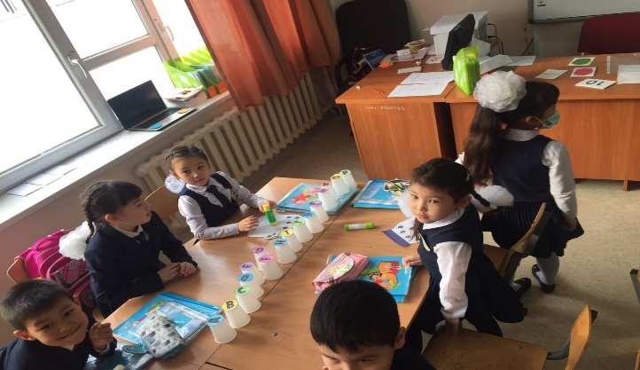 |  |  |  | Song “Hello”  Dora explorer (video)
7 min  Magic box  5 min  Scrambled letters  7 min  Going to Disneyland  3 min  Memory game  5 min  Writing  2 min  Physical exercise  5 min | The main part  Travelling.  They travel around the world . At first they choose the city then they go to the London Zoo. Children look at the map of UK.  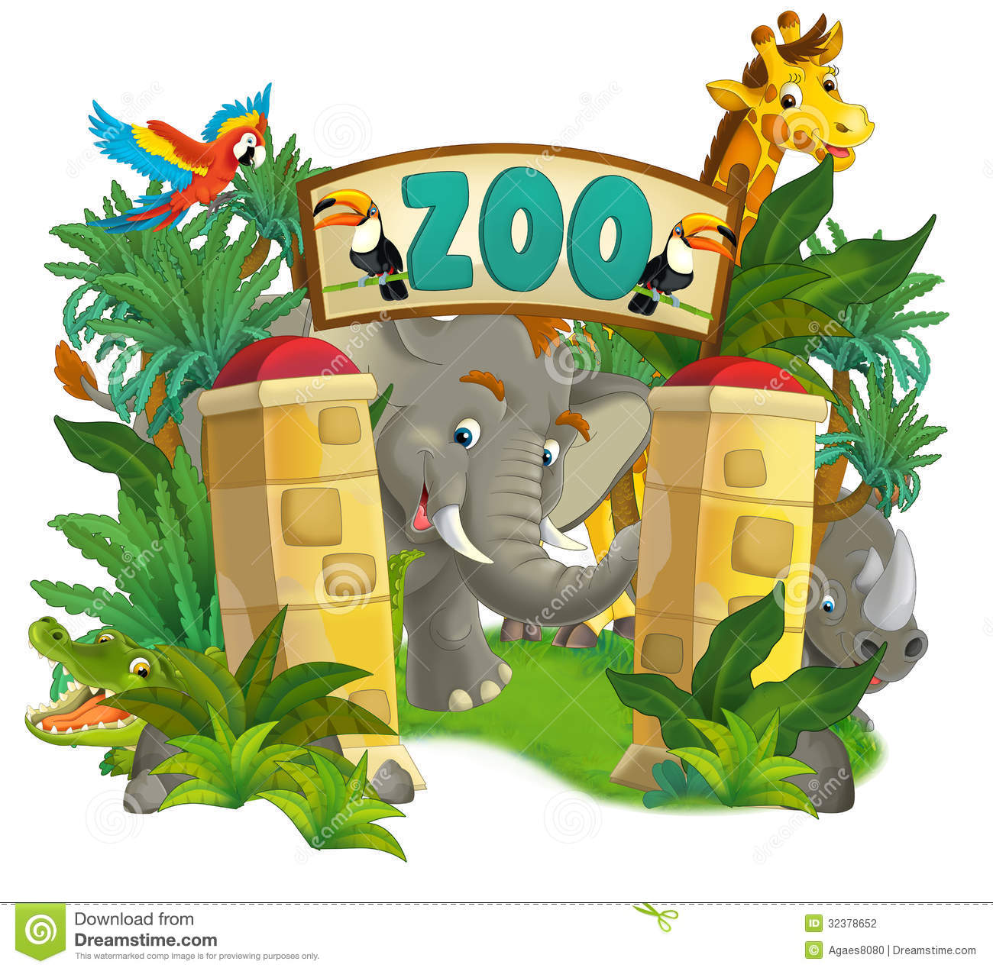  On this task children should choose one of the toy and tell what animal is it?  A O E I  Words :  C_ T D_ _G B_ _ K  F_SH P_G P_N  P_NCIL R_BB_T M_USE  Children look at the map of the USA. Teacher introduces the poster of Disneyland . Then they go to the Toyshop .  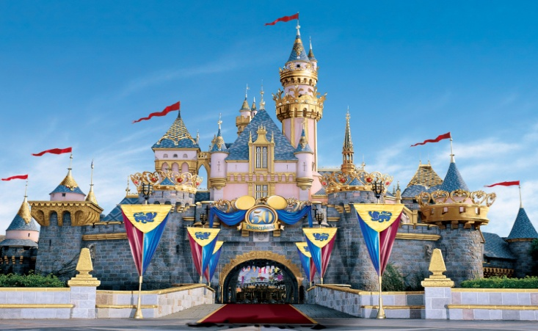  What’s missing?  Checking memory of students Teacher uses flashcards.  Teacher gives sheets of papers for writing.  One one one  I can run  Two two two  I can jump too  Three three three  Look at me  Game. Dora’s monkey wants a toy. Let’s choose a toy for monkey. For choosing a toy for monkey at first you should scramble the letters.  Example: ball- llab |  |  |  | Globe  Globe
Formative assessment
Task. Look at the picture on the board . you should color pictures according to my command.
Descriptor.
A learner:- colors papers by teachers command
- names toys

End  1min | Feedback: Teacher asks students what task was difficult to them and which pair worked well.
Additional information
Differentiation – how do you plan to give more support? How do you plan to challenge the more able learners? |  |  |  | Assessment – how are you planning to check learners’ learning?
More support:  - These students may work with a stronger student to support them during the vocab activities.  - These students may answer in a single word  More-able learners:  - Encourage very strong students to model answers  - Encourage these students to ask and answer using complete and correct structures  - These students could also ask the number of the birthdate, or, give their own |  |  |  | - Students will be assessed for their speaking skills during the survey activity and their writing skills during the writing practice.
Summary evaluation
What two things went really well (consider both teaching and learning)?
1:
2:
What two things would have improved the lesson (consider both teaching and learning)?
1:
2:
What have I learned from this lesson about the class or individuals that will inform my next lesson?

