LESSON: Module 3  Theme: My School |  | School: Asenkritovskaya secondary school  Taranovskiy region, Kostanai oblast
Date: |  | Teacher’s name: Bakhitzhamal Akhmetovna Artykbaeva
CLASS: 2 |  | Number present: | absent:
Learning objectives(s) that this lesson is contributing to | 2.L1 understand a range of short basic supported classroom instructions  2.L3 understand the main points of short, slow and carefully articulated talk on routine and familiar topics features such as colour and number  2.L5 identify missing phonemes in incomplete words  2.S4 respond to basic supported questions giving personal and factual information  2.R4 begin to use with support a simple picture dictionary  2.UE2 use numbers 1 -20 to count  2.UE11 use there is/there are to describe and ask about school objects
Lesson objectives | All learners will be able to:
Lesson objectives | respond correctly to some prompts about classroom objects, identify some words in reading and listening tasks and spell some words correctly
Lesson objectives | Most learners will be able to:
Lesson objectives | respond correctly to most prompts about classroom objects, identify most words in reading and listening tasks and spell most words correctly
Lesson objectives | Some learners will be able to:
Lesson objectives | ask and answer questions correctly, with correct word stress and identify all words in reading and listening tasks and spell most words correctly with very little support
Previous learning | What’s …. This …. It’s a ….. pen pencil bag
Plan
Planned timings | Planned activities |  | Resources
Beginning the lesson | Lesson Opening & Warm-Up  Teacher greet learners: Good morning, children! Салеметсиз бе! Доброе утро!  T: -Children come to me and stand in circle. Greet each other in English, Kazakh and Russian languages: Hello! Салем! Привет!  T:Take the hands and wish to each other “Good luck!”  - Teacher introduces lesson objectives to the students.

Middle | Main  T: Let’s divide our class into 2 teams by gathering puzzles of school things.  Step 1 Game “Flower” (read and answer the questions)  Questions  - What is your name?  - What is your surname?  - How are you?  - Where are you from?  - How old are you?  - Which class are you in?  - What is your address?  - What is your hobby?  - Have you got a friend?  - Can you speak English?  Step 2 Game “Guess the word”  Colour rhymes (Pupil-1 team- to pupil 2- nd team )  - Учить цвета я стала. Цвет по-английски … color.  - На светофоре красный цвет вам скажет: «Стойте!» - красный … red.  - Везде гуляет смело, цыпленок желтый … yellow.  - Я море синее люблю, а синий по-английски … blue.  - Вот в черной шляпе человек, запомни черный это … black.  - Утром встает очень рано, мишка коричневый… brown.  - Цвет листьев и травы один, зеленый по-английски … green.  - Забыл слово белый не унывай, оно по-английски будет …white.  - Мышонок серый, убегай быстрей! Серый по-английски … grey.  Step 3 Name the picture ( It is a blue book and so on ...)  Pupil-1 team- to pupil 2- nd team  What’s this?  - It is a 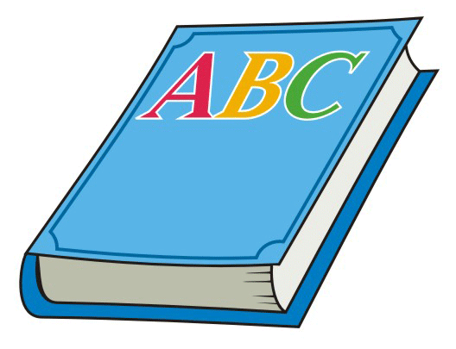  - It is a   - It is a 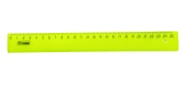  - It is a   And so on.  DYNAMIC PAUSE  T: Look, listen and do it.  Step 4 Count me (pictures of school things ) Use the structure: There is/There are ...  Ls of the 1-st team count. There is/ There are  -   - 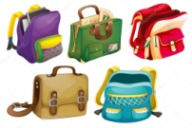  - 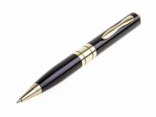  - 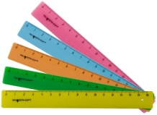  - 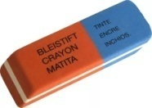  Ls of the 2-nd team count. There is/ There are  - 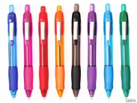  - 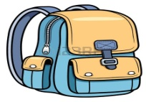  - 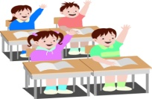  - 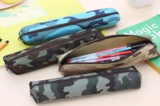  5.   Step 5 Board racing game:  Ask 2 teams to come in the middle of the classroom. Learners stand in 2 rows.  Rule: Teacher shows a picture of a classroom object on the PPT . Learners should look at the picture and touch the word which is on the board. Who touches the more words is the winner. This should be a quick and exciting game.  Formative Assessment:  T. Task: Listen and do it.  Stand up, please  Hands up, please  Hands down, please  Hands on the hips, please  Turn left, please  Turn right, please  Stand still, please  Sit down, please.  Step 6. “The best translator”  (One pupil from each team.)  Text. Hello! My name is Boris. My surname is Sidorov. I’m from Russia. I’m a pupil. I’m 10. I’m O’key. I can speak and read English.  Step 7“My schoolbag” (choose only the school things)  Teacher put many different things on 2 desks. Pupils must choose only school things and put it in the school bag. |  | puzzles of school things  red flower  Colour pictures of school things  Video material  Song “Hoppy-Poppy”  Colour pictures of school things
Ending the lesson | Homework & Reflection  Reflection: Magic Hat - L’s glue stickers;  –red colour - if you understand everything  -yellow colour- if you understand  something  - green colour- if you don’t understand everything  Homework: words
Additional information
Differentiation – how do you plan to give more support? How do you plan to challenge the more able learners? |  | Assessment – how are you planning to check learners’ learning? |  | Cross-curricular links  Health and safety check  ICT links  Values links
- provide extra modelling and drilling to pairs of learners in pair work task  - ask stronger learners to check spellings in a picture dictionary |  | - monitoring pair work activity to check question formation and pronunciation |  | - ICT links: use an interactive picture dictionary to check spellings

Reflection  Were the lesson objectives/learning objectives realistic?  Did I stick to timings?  What changes did I make from my plan and why? | Answer the most relevant questions from the box on the left about your lesson.

