


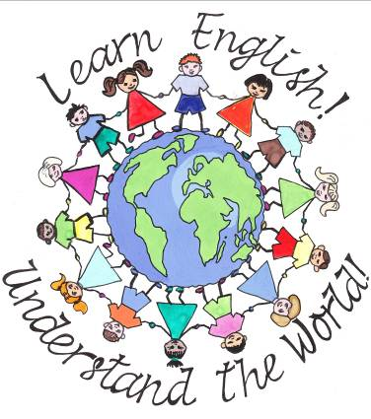

Подготовила:
Учитель английского языка
Абдулгапова Эмилия Курманалиевна

Цель: мотивировать учащихся изучать английский язик и правильно пользоваться им при живом общении; подвести к осознанию необходимости и важности изучения английского языка, как одного из самих распространённых языков в мире; пополнять словарный запас, тренировать в диалогической и монологической речи. Развивать логическое мышление, внимание, воображение, творческие, актёрские способности и познавательный интересю Воспитывать взаимопонимание и совершенствовать умение работать в коллективе, прививать интерес к изучению английского языка.
Тип мероприятия: внеклассное мероприятие с элементами инсценизации и использованием мультимедийных технологий
Оборудование: ширма, декорации и реквизити для инсценирования (автобус дабл-декер, Биг Бен, таблички ‘’Police station’’,’’Hospital’’,’’Souvenir shop’’, бейджики для экскурсовода, полисмена, доктора, кошелёк, книги, колпак для доктора, маски поросят и волка, перчатки, презентаия у PowerPoint, музыкальное оформление, мультимедийное оборудование.
Ход мероприятия
Stage 1 «At school»
*Школьный звонок
Вчитель Good morning, pupils. Sit down, please. Today we are going to speak about …
Учень I’m sorry. May I sit down?
Вчитель Why are you late, Bob?
Учень I dislike English. It’s boring subject. In my opinion it’s waste of time
Вчитель You are wrong. English is very useful and important. And now I’ll try to prove it you.
If you don’t know English you can faced with some funny situations. Let's look some of them.

Stage 2 «Situations»

Учень 1 Как переводится "I don't know" ?
Учень 2 Я не знаю.
Учень 1 Ох,никто не знает!
Автор: Evening. Hotel. Reception. The telephone is ringing
Учень 1 - Reception, Kate speaking. Can I help you?
Учень 2 - Ту-ти-ту-ту-ту!
Учень 1 - Reception, Kate speaking. Can I help you?
Учень 2 - Ту-ти-ту-ту-ту.

Учень 2 - Ты что? Английский не понимаешь?! Я ж тебе говорю: два чая в двести двадцять второй!
Учень 1 "Иван, переведи на английский лово «дверь»
Учень 2 "Dwear"
Учень 1 "What eto da!"
Учень 1 Ok. Let’s translate some words into English: Ольга, как по-английски будет парта?
Учень 2 Desk
Учень 1 Very well. Маша, как по-английски будет окно?
Учень 3 Window.
Учень 1 Максиме, как по-английски будет подоконник?
Учень 4 - ...... ПодWindows
Автор: At the Music lesson.
Учень 1 Есть только миг между прошлым и будущим, именно он называется… (під фонограму).
Учень 2 Present Simple Tense.
Автор:
The couple arrived at the resort. They move into the room.
Wife sees the mouse and starts yelling,
Учень 1 "A-a-a-a! Мышь! Позвони администратору отеля!
Учень 2 Но я плохо говорю по-английски!
Учень 1 А я в английском полный ноль!!!
Учень 2 -Hеllo.
Учень 3 -Hеllo. Reсeption, Kate speaking. Can I help you?
Учень 2 -Do you know "Tom and Jerry"?
Учень 3 -Yes, I do.
Учень 2 -So... Jerry is here.

«English exam»

Учитель Сome in, please
Учень -Здрасте, какой камин? Тепло вроде бы…
Учитель -Sit down.
Учень -Чё сразу «даун»? Не успел прийти…
Учитель -Take a ticket, please
Учень -Что-что?
Учитель -Берите уже билет, Сидоров!
Учень -А какой брать?
Учитель -Да берите любой, мне всё равно
(берёт билет)
Учитель -And what is the topic?
Учень -Не понял?
Учитель - What is the topic?
Учень -Да не ношу я никакие топики! Это женская одежда.
Учитель -Тема вашого билета «Аэропорт» Airport. Airport…
Учень - Airport…
Учитель -Consists of… состоит из…ну что есть в аэропорте?
Учень - Ну холл
Учитель -OK. Hall. What else? Что ещё?
Учень -Ресторан
Учитель - A restaurant. A на улице?
Учень -ВПП
Учитель -Что?
Учень -Взлётно-посадочная полоса, на которой самолёт взлетейшн, а потом приземлейшн.
Учитель -Если самолёт будет так резко приземляться, то пассажиры погибнут.
- Учень А спорим не погибнут? На пятёрку
Учитель -На тройку
Учень -Ни вам, ни нам, на Четыре
Учитель -ОК
Учень -А самолёт грузовой был..
Учитель -Сидоров!

Stage 3 «Screen work»
Вчитель: And now I would like to show you some photos. Be very attentive
СЛАЙД 1 We very often we use on-line translator. But remember it’s only machine which couldn’t think

For example: Our cat gave birth to three kittens – two whites and one black.
Translation:
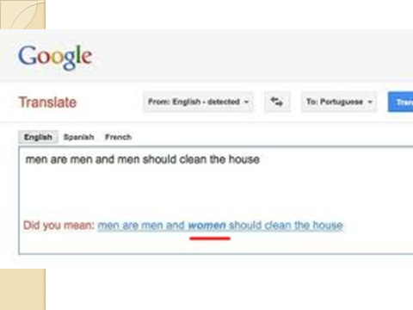
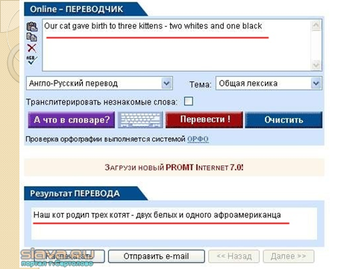

СЛАЙД 2 From the other side this machines can think too much
For example: Men are men and men should clean the house
But computer has another idea: Men are men and women should clean the house
СЛАЙД 3, 4 - Тell me please, how you will prepare for the English exam.
I don’t think about it. May be I will take some extra classes.
- And which teacher will help you.
- I don’t know. May be I’ll find some teacher through the internet.
- I can help you. I have some advertisement.
It’s the first one (показує)and the second one (показує)
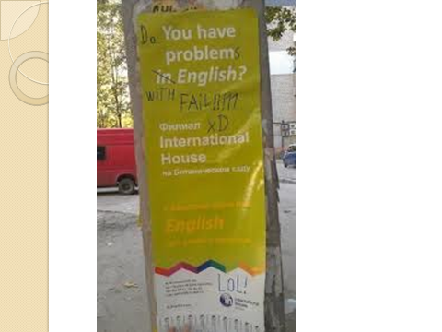
- Oh, thank you, very much. You are really good friend
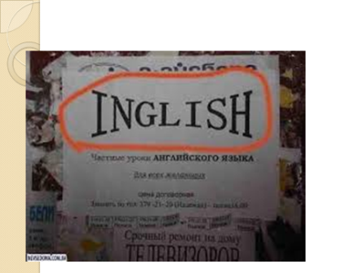
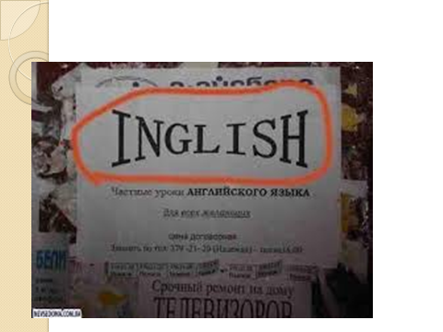

СЛАЙД 5, 6, 7, Masha, I know that your family are going to Lviv next week.
Yes. It’s true.
Please, pay your attention to the road signs. Some of them can be so funny
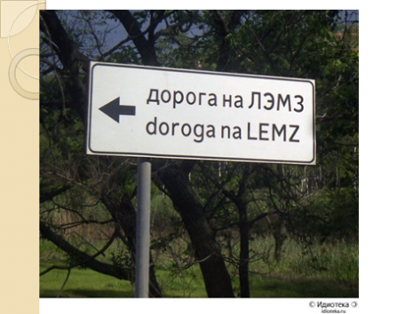
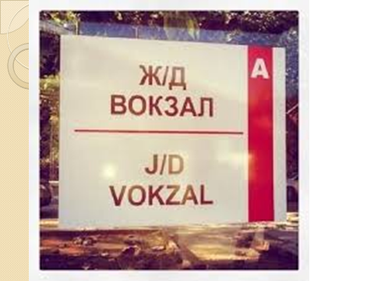
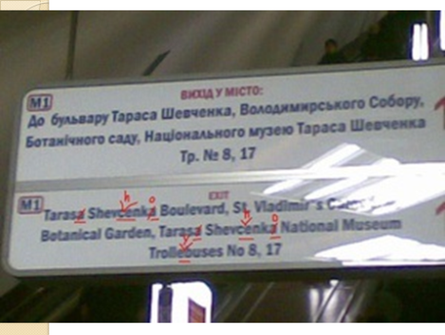

СЛАЙД 8, 9, 10, 11
Do you like go to a restaurant?
Yes, I do.
Do you have some problems when you go to the restaurant?
No, I don’t. and what about you.
Last time I have some problems with menu!!!
What you mean?
Oh, I have some examples.

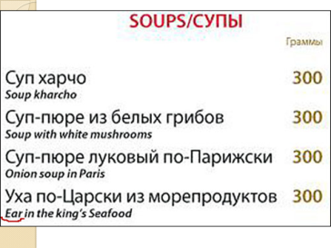
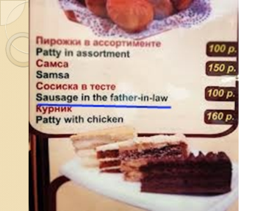

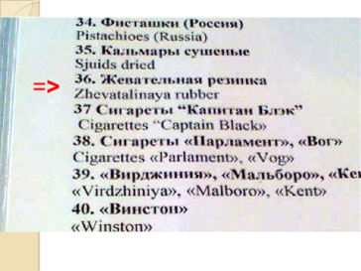

СЛАЙД 12
And now I would like to show you a label,
which I find on the father’s shirt.
Oh, it’s very funny!



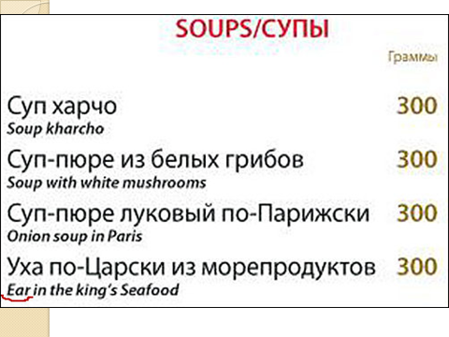

Stage 4 “One day in London”
T. London is famous for its sightseeings. The guide-interpreter is going to make the excursion around the city. He will show and tell about the most interesting places of London.
SIGHTSEEING TOUR.
G.-I. Now, I think, you want to have a sightseeing tour around London.
Sam. With pleasure.
G.-I. Meet your guide around London.
Tom. And what places will we visit?
Guide. Oh, the most wonderful places in London, I promise. It will be unforgettable tour, believe me.
( The guide shows and tells about the most interesting places of London ).
T. But something has happened . Sam can’t find his purse. That’s why he has to go to the police station where he’ll have a conversation with the policeman. Listen to it, please.
Sam. Tom, it’s a pity, but I can’t find my purse.
G.-I. We have to go to the police station.

AT THE POLICE STATION.
Sam. Good afternoon. We have a problem.
Policeman. How can I help you?
Sam. I have lost my purse.
Policeman. No problem. We’ll help you to look for it.
Sam. Thanks.
Policeman. What colour is it?
Sam. It’s black.
P. When and where did you lose it?
Sam. I think, it was when we were in Trafalgar square.
P. OK. We’ll find it. Come to us tonight.
Sam. Well. Good bye
T. Really, the day is full of surprises. Headache. Tom is not well and the doctor is ready to help him.
Tom. Oh, my head.
Sam. What has happened?
Tom. I have a bad headache.
Sam. Let’s see the doctor then.
G.-I. I’ll help you to find a good doctor.
AT THE DOCTOR.
G.-I. Hello, doctor.
Doctor. How can I help you?
G.-I. This man is a tourist. He has a bad headache.
Doctor. Do you have any other symptoms? A temperature, for example?
Tom. No.
Doctor. Then I’ll give you a pill and in 30 minutes you’ll be well.
Tom. Thank you, doctor.
T. Our travellers can’t come back home without souvenirs. It is the last place Tom and Sam visit in London.
AT THE SOUVENIR SHOP.
Tom. Hello. Can you help me to choose an interesting souvenir for my family?
Seller. What do you want?
Tom. Something which will remind me about your wonderful city.
Seller. You may take this book. There are many pictures of interesting places of London in it.
Tom. How much is it?
Seller. It costs 20 pounds.
Tom. It is very expensive.
Seller. But it is worth of it.
Tom. All right. Write out a bill. I’ll take it.

Stage 5 «Dreams»
Вчитель: Petro, if you know English and if you have a magic cap you can know what people think
Учень: Are you really?
Вчитель: Yes, I’m
- Which question teaches repeat very often at the lessons? (Tell me why…)
- The main reason why peoples looking for a job (Money, money, money…)
- How teachers feel when they get a salary? (Life is good)
- How teachers feel when they get a reword (I feel good)
- What our headmaster think about our pupils and teachers? (We are the champions…)
- Which timetable pupils like best of all? (Monday – party…)
- What pupils think during the control lesson? (S.O.S…)
- How our teachers will be feeling after this conference? (I need a doctor..)
- What teachers think about their profession? (It’s my life…)
- And what our guests think about this performance? (Show must go on…)
*(Tell me why…)
*(Money, money, money…)
*(Life is good)
* (I feel good)
*(We are the champions…)
*(Monday – party…)
*(S.O.S…)
*(I need a doctor..)
*(It’s my life…)
*(Show must go on…)
Stage 6 «Fairy tales»
(pupils of 5th form)

Characters: Author, Mother Cat, 1st Kitten, 2nd Kitten, 3rd Kitten.
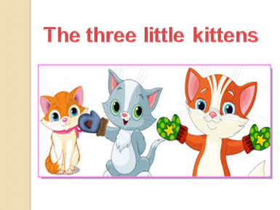
SCENE
Author: The three little kittens
Lost their mittens,
And they began to cry.
1st Kitten: Oh, Mother dear,
2nd Kitten: We very much fear.
3rd Kitten(crying): That we have lost our mittens!
Cat: Lost your mittens,
You naughty kittens!
Then you will have no pie. (The Kittens run away)
Author: The three little kittens
Found their mittens,
And they began to cry. (The Kittens run in)
Three little Kittens(together):Oh, Mother Dear,
1st Kitten: (showing the mittens): See here,
2nd Kitten (showing the mittens): See here,
3rd Kitten (showing the mittens): See , we have found our mittens.
Cat: Oh, you’re good kittens!
Put on your mittens,
And you will have some pie. (Gives them pies)
But I smell a mouse close by.
(All together):We smell a mouse close by. Good- bye. (The Cat and Kittens leave the stage)

1: Well done! You all understand that family is very important for everybody
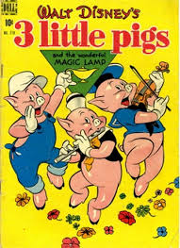
2. Now you’ll see it in a play which the pupils of the 3rd form prepared
It is also about the family of three little Piglets.

I am Niff-Niff
I am Naff-Naff
I am Nuff-Nuff

Pig1: I have a house of grass
Pig2: I have a stick house.
Pig3: I have a brick house.
*Who’s afraid of big bad wolf
*Мелодія Wolf
Wolf: My name is Wolf.
Niff-Niff let me come in.
Niff-Niff: Go away ,bad Wolf.
Wolf: Let me in Naff-Naff.
Naff-Naff: Go away, bad Wolf
Wolf: Nuff-Nuff let me in.
All: Go away
Вовк дмухає, проте даремно
*The more we are together

Stage 7 «Wax museum»

А сей час мы с вами находимся в музее восковых фигур Мадам Тюссо.Здесь много известных звёзд
1.Rihanna “Umbrella”
2.Bob Marley “Don’t worry”
3.Boney M “Sunny”
4.Eagles “Hotel California”
5.No doubt “Don’t speak”
6.Status QWO “You’re in the army now”
7.Eurythmics “Sweet dreams”
8.Modern talking “Cheri Cheri lady”
9.Spice girls “Spice up your life”
10.We will rock you

Итак, мы хотели показать этим мероприятием, что английский язик-это важный предмет. Если знать английский язик, то можно:
-понимать содержание песен, стихав, сказок
-общаться с иностранцами
-путешествовать
-не попадать в смешные и неловкие ситуации
-хорошо учится
-в будущем помогать своим детям
-получить современную профессию
-свободно пользоваться компьютером
Вчитель: And now what would you say
Учень: Ok. I was wrong. Now I understand that English is very useful and important.
Let's learn English!!! Everybody come on
*Good-bye song

The end

