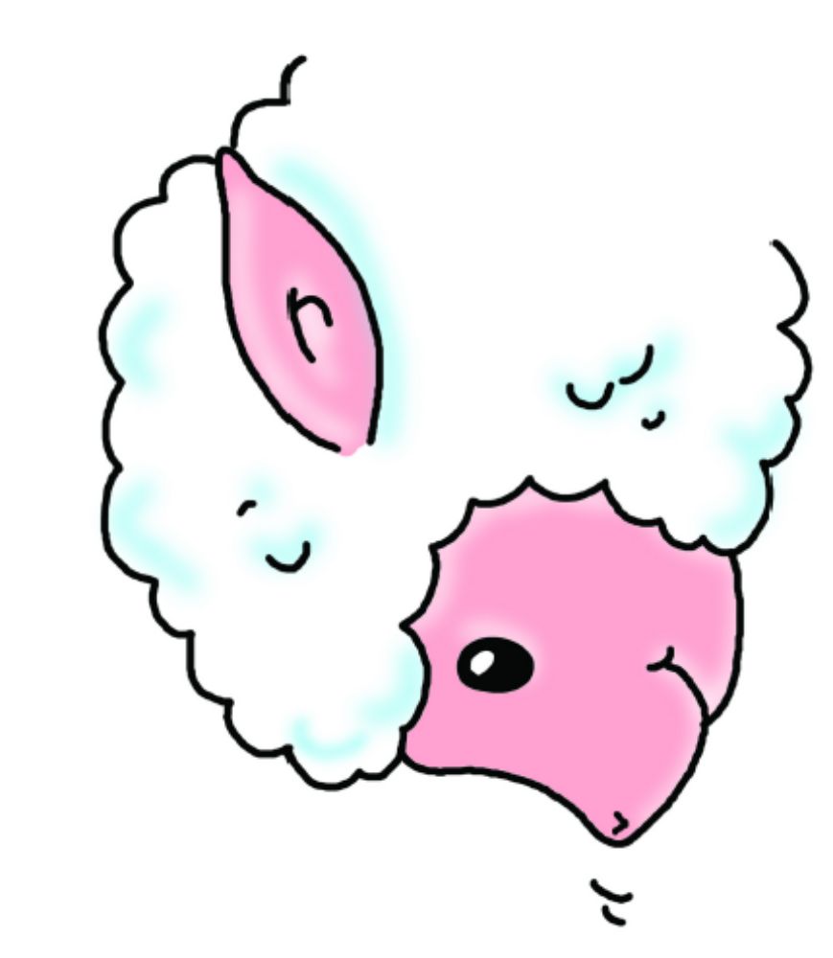
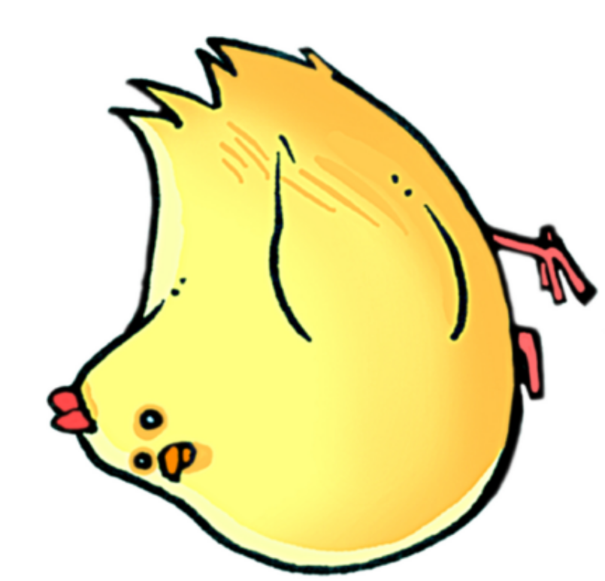

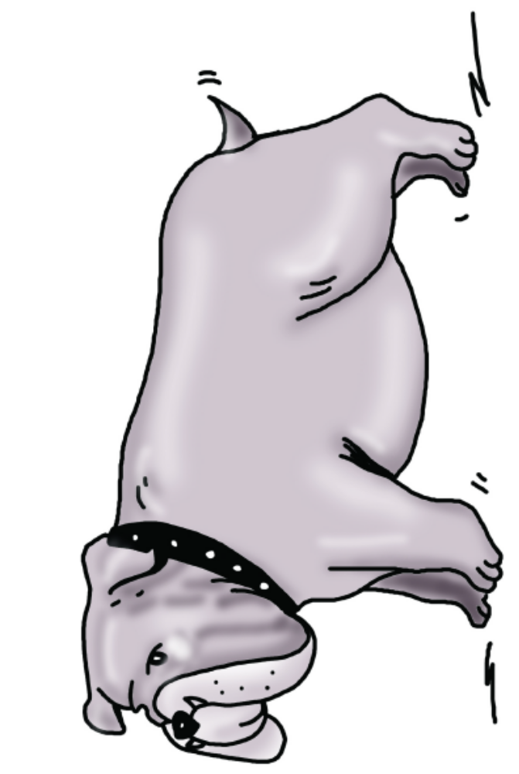
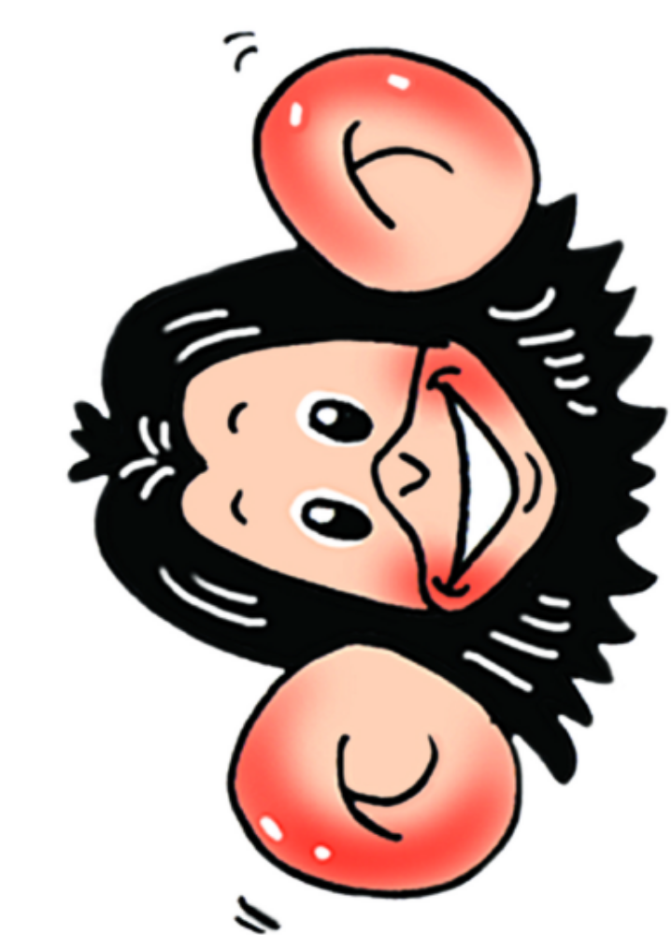

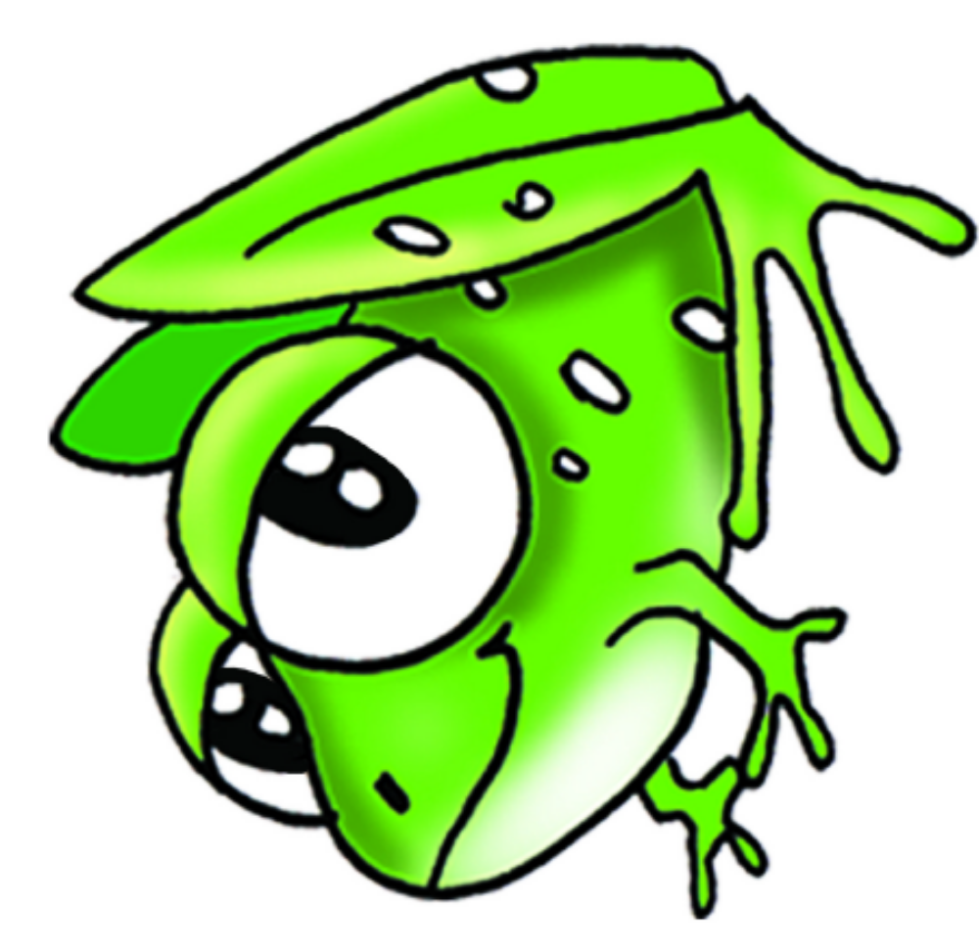

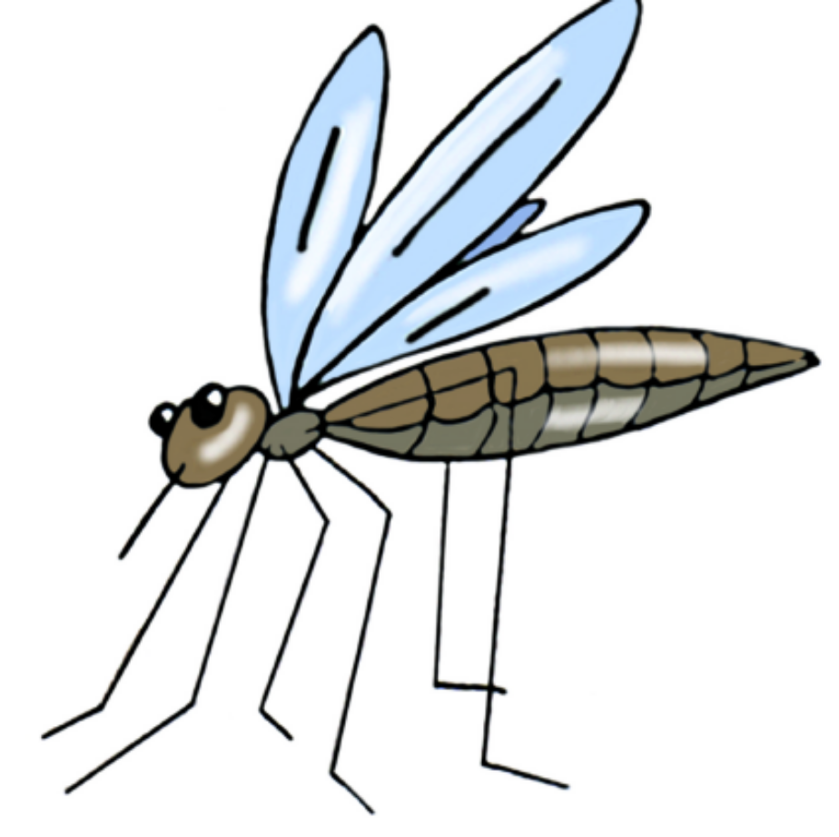

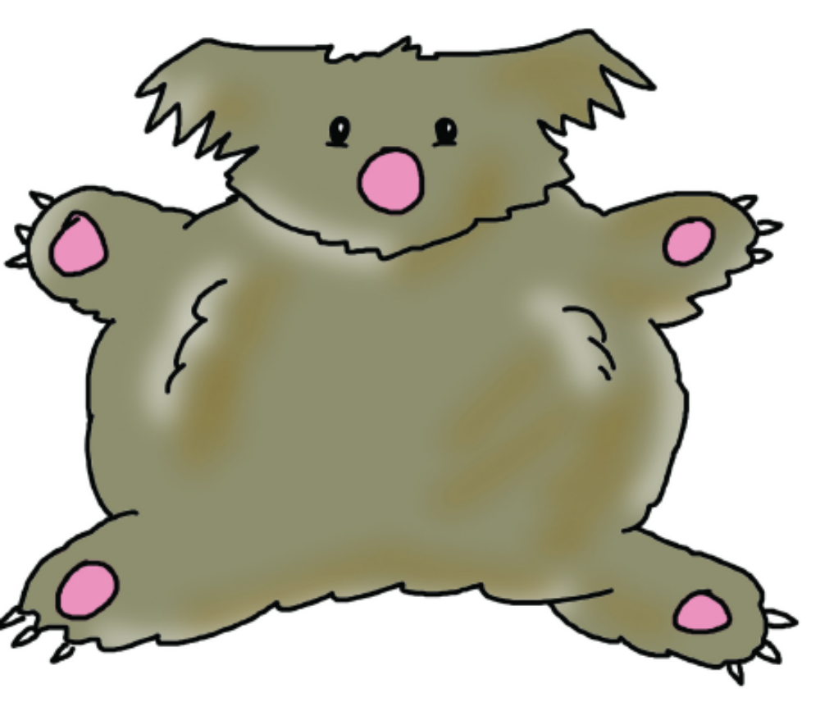

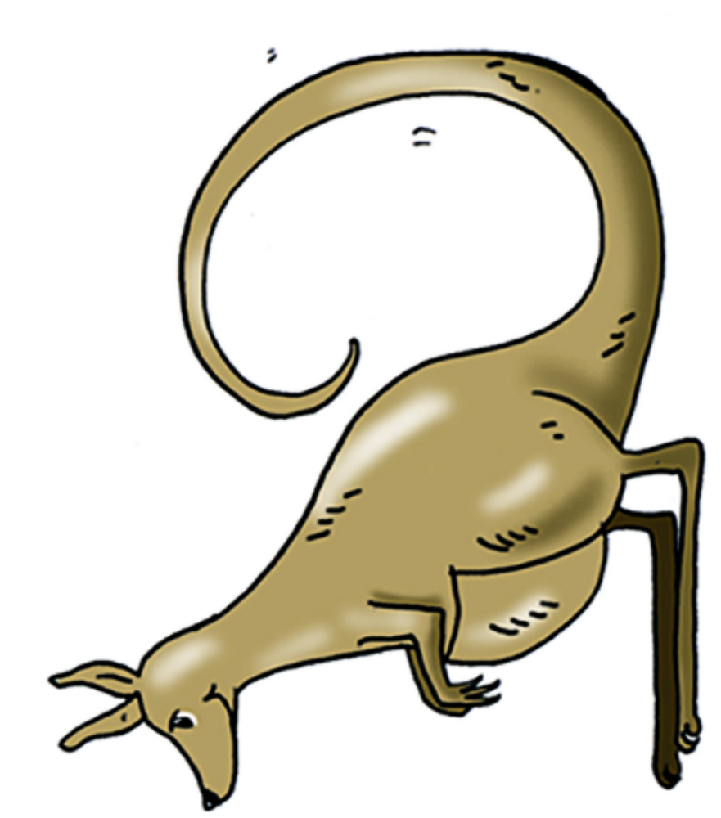

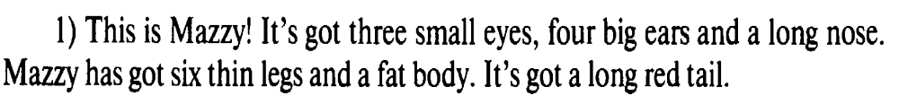

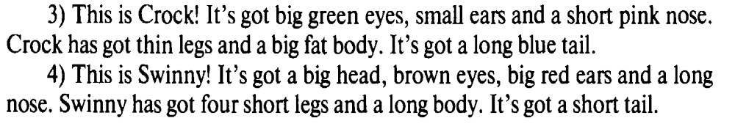

I have got | I have not got | Have I got? | I’ve got | I haven’t got
You have got | You have not got | Have you got? | You’ve got | You haven’t got
We have got | We have not got | Have we got? | We’ve got | We haven’t got
They have got | They have not got | Have they got? | They’ve got | They haven’t got
He has got | He has not got | Has he got? | He’s got | He hasn’t got
She has got | She has not got | Has she got? | She’s got | She hasn’t got
It has got | It has not got | Has it got? | It’s got | It hasn’t got
Yes/No, I(we, you, they) have/haven’t. Yes/No, he (she, it) has/hasn’t.
I have got | I have not got | Have I got? | I’ve got | I haven’t got
You have got | You have not got | Have you got? | You’ve got | You haven’t got
We have got | We have not got | Have we got? | We’ve got | We haven’t got
They have got | They have not got | Have they got? | They’ve got | They haven’t got
He has got | He has not got | Has he got? | He’s got | He hasn’t got
She has got | She has not got | Has she got? | She’s got | She hasn’t got
It has got | It has not got | Has it got? | It’s got | It hasn’t got
Yes/No, I(we, you, they) have/haven’t. Yes/No, he (she, it) has/hasn’t.
I have got | I have not got | Have I got? | I’ve got | I haven’t got
You have got | You have not got | Have you got? | You’ve got | You haven’t got
We have got | We have not got | Have we got? | We’ve got | We haven’t got
They have got | They have not got | Have they got? | They’ve got | They haven’t got
He has got | He has not got | Has he got? | He’s got | He hasn’t got
She has got | She has not got | Has she got? | She’s got | She hasn’t got
It has got | It has not got | Has it got? | It’s got | It hasn’t got
Yes/No, I(we, you, they) have/haven’t. Yes/No, he (she, it) has/hasn’t.
I have got | I have not got | Have I got? | I’ve got | I haven’t got
You have got | You have not got | Have you got? | You’ve got | You haven’t got
We have got | We have not got | Have we got? | We’ve got | We haven’t got
They have got | They have not got | Have they got? | They’ve got | They haven’t got
He has got | He has not got | Has he got? | He’s got | He hasn’t got
She has got | She has not got | Has she got? | She’s got | She hasn’t got
It has got | It has not got | Has it got? | It’s got | It hasn’t got
Yes/No, I(we, you, they) have/haven’t. Yes/No, he (she, it) has/hasn’t.
I have got | I have not got | Have I got? | I’ve got | I haven’t got
You have got | You have not got | Have you got? | You’ve got | You haven’t got
We have got | We have not got | Have we got? | We’ve got | We haven’t got
They have got | They have not got | Have they got? | They’ve got | They haven’t got
He has got | He has not got | Has he got? | He’s got | He hasn’t got
She has got | She has not got | Has she got? | She’s got | She hasn’t got
It has got | It has not got | Has it got? | It’s got | It hasn’t got
Yes/No, I(we, you, they) have/haven’t. Yes/No, he (she, it) has/hasn’t.
I have got | I have not got | Have I got? | I’ve got | I haven’t got
You have got | You have not got | Have you got? | You’ve got | You haven’t got
We have got | We have not got | Have we got? | We’ve got | We haven’t got
They have got | They have not got | Have they got? | They’ve got | They haven’t got
He has got | He has not got | Has he got? | He’s got | He hasn’t got
She has got | She has not got | Has she got? | She’s got | She hasn’t got
It has got | It has not got | Has it got? | It’s got | It hasn’t got
Yes/No, I(we, you, they) have/haven’t. Yes/No, he (she, it) has/hasn’t.
I have got | I have not got | Have I got? | I’ve got | I haven’t got
You have got | You have not got | Have you got? | You’ve got | You haven’t got
We have got | We have not got | Have we got? | We’ve got | We haven’t got
They have got | They have not got | Have they got? | They’ve got | They haven’t got
He has got | He has not got | Has he got? | He’s got | He hasn’t got
She has got | She has not got | Has she got? | She’s got | She hasn’t got
It has got | It has not got | Has it got? | It’s got | It hasn’t got
Yes/No, I(we, you, they) have/haven’t. Yes/No, he (she, it) has/hasn’t.
I have got | I have not got | Have I got? | I’ve got | I haven’t got
You have got | You have not got | Have you got? | You’ve got | You haven’t got
We have got | We have not got | Have we got? | We’ve got | We haven’t got
They have got | They have not got | Have they got? | They’ve got | They haven’t got
He has got | He has not got | Has he got? | He’s got | He hasn’t got
She has got | She has not got | Has she got? | She’s got | She hasn’t got
It has got | It has not got | Has it got? | It’s got | It hasn’t got
Yes/No, I(we, you, they) have/haven’t. Yes/No, he (she, it) has/hasn’t.
I have got | I have not got | Have I got? | I’ve got | I haven’t got
You have got | You have not got | Have you got? | You’ve got | You haven’t got
We have got | We have not got | Have we got? | We’ve got | We haven’t got
They have got | They have not got | Have they got? | They’ve got | They haven’t got
He has got | He has not got | Has he got? | He’s got | He hasn’t got
She has got | She has not got | Has she got? | She’s got | She hasn’t got
It has got | It has not got | Has it got? | It’s got | It hasn’t got
Yes/No, I(we, you, they) have/haven’t. Yes/No, he (she, it) has/hasn’t.
I have got | I have not got | Have I got? | I’ve got | I haven’t got
You have got | You have not got | Have you got? | You’ve got | You haven’t got
We have got | We have not got | Have we got? | We’ve got | We haven’t got
They have got | They have not got | Have they got? | They’ve got | They haven’t got
He has got | He has not got | Has he got? | He’s got | He hasn’t got
She has got | She has not got | Has she got? | She’s got | She hasn’t got
It has got | It has not got | Has it got? | It’s got | It hasn’t got
Yes/No, I(we, you, they) have/haven’t. Yes/No, he (she, it) has/hasn’t.
I have got | I have not got | Have I got? | I’ve got | I haven’t got
You have got | You have not got | Have you got? | You’ve got | You haven’t got
We have got | We have not got | Have we got? | We’ve got | We haven’t got
They have got | They have not got | Have they got? | They’ve got | They haven’t got
He has got | He has not got | Has he got? | He’s got | He hasn’t got
She has got | She has not got | Has she got? | She’s got | She hasn’t got
It has got | It has not got | Has it got? | It’s got | It hasn’t got
Yes/No, I(we, you, they) have/haven’t. Yes/No, he (she, it) has/hasn’t.
I have got | I have not got | Have I got? | I’ve got | I haven’t got
You have got | You have not got | Have you got? | You’ve got | You haven’t got
We have got | We have not got | Have we got? | We’ve got | We haven’t got
They have got | They have not got | Have they got? | They’ve got | They haven’t got
He has got | He has not got | Has he got? | He’s got | He hasn’t got
She has got | She has not got | Has she got? | She’s got | She hasn’t got
It has got | It has not got | Has it got? | It’s got | It hasn’t got
Yes/No, I(we, you, they) have/haven’t. Yes/No, he (she, it) has/hasn’t.

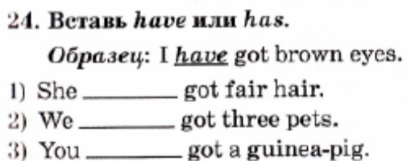

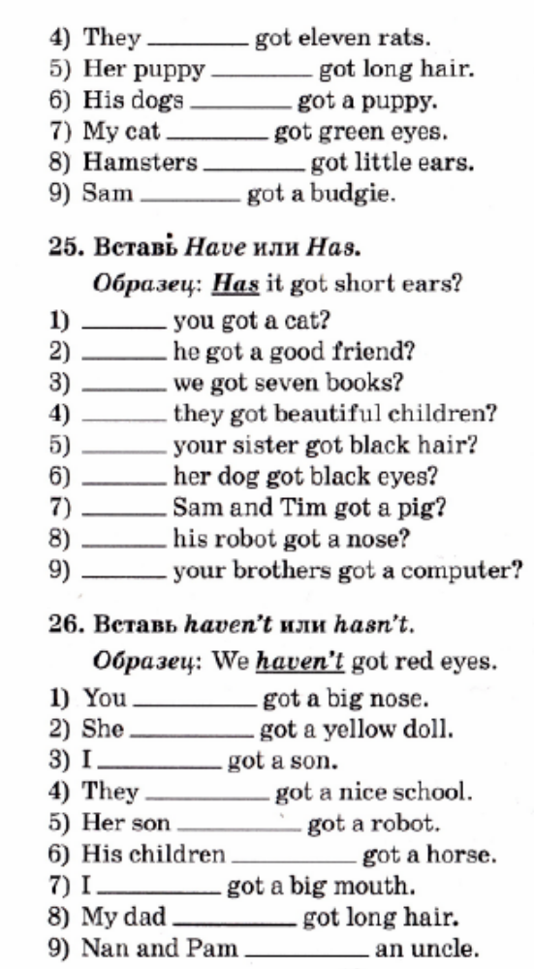

Thin | [ θɪn ] | Θин | Тонкий, худой | Thin | [ θɪn ] | Θин | Тонкий, худой
Leg | [ leɡ ] |  | нога | Leg | [ leɡ ] |  | нога
Fat | [ fæt ] | Фэт | Толстый, полный | Fat | [ fæt ] | Фэт | Толстый, полный
Body | [ ˈbɒdi ] | Бади | Тело | Body | [ ˈbɒdi ] | Бади | Тело
Tail | [ teɪl ] | Тэйл | Хвост | Tail | [ teɪl ] | Тэйл | Хвост
Short | [ ʃɔːt ] | Шоот | Короткий | Short | [ ʃɔːt ] | Шоот | Короткий
long | [ lɒŋ ] | Лон | Длинный | long | [ lɒŋ ] | Лон | Длинный
Cow | [ kaʊ ] | Кау | Корова | Cow | [ kaʊ ] | Кау | Корова
Track | [ træk ] | трэк | Дорога,путь | Track | [ træk ] | трэк | Дорога,путь
Man-men | [ mæn - men ] | Мæн-мен | Мужчина-мужчины | Man-men | [ mæn - men ] | Мæн-мен | Мужчина-мужчины
Woman-women | [ˈwʊmən -ˈwɪmɪn] | Вумæн-вимин | Женщина-женщины | Woman-women | [ˈwʊmən -ˈwɪmɪn] | Вумæн-вимин | Женщина-женщины
Child-children | [ tʃaɪld - ˈtʃɪldrən] | Чайлд-чилдрэн | Ребенок-дети | Child-children | [ tʃaɪld - ˈtʃɪldrən] | Чайлд-чилдрэн | Ребенок-дети
Tooth-teeth | [ tuːθ- tiːθ ] | Тууθ - тииθ | Зуб-зубы | Tooth-teeth | [ tuːθ- tiːθ ] | Тууθ - тииθ | Зуб-зубы
Foot-feet | [ fʊt - fiːt ] | Фуут-фиит | Ступня-ступни | Foot-feet | [ fʊt - fiːt ] | Фуут-фиит | Ступня-ступни
Mouse-mice | [ maʊs - maɪs] |  | Мышь-мыши | Mouse-mice | [ maʊs - maɪs] |  | Мышь-мыши
Sheep-sheep | [ ʃiːp ] |  | Овца-овцы | Sheep-sheep | [ ʃiːp ] |  | Овца-овцы
Fish-fish | [ fɪʃ ] |  | Рыба-рыбы | Fish-fish | [ fɪʃ ] |  | Рыба-рыбы
Thin | [ θɪn ] | Θин | Тонкий, худой | Thin | [ θɪn ] | Θин | Тонкий, худой
Leg | [ leɡ ] |  | нога | Leg | [ leɡ ] |  | нога
Fat | [ fæt ] | Фэт | Толстый, полный | Fat | [ fæt ] | Фэт | Толстый, полный
Body | [ ˈbɒdi ] | Бади | Тело | Body | [ ˈbɒdi ] | Бади | Тело
Tail | [ teɪl ] | Тэйл | Хвост | Tail | [ teɪl ] | Тэйл | Хвост
Short | [ ʃɔːt ] | Шоот | Короткий | Short | [ ʃɔːt ] | Шоот | Короткий
long | [ lɒŋ ] | Лон | Длинный | long | [ lɒŋ ] | Лон | Длинный
Cow | [ kaʊ ] | Кау | Корова | Cow | [ kaʊ ] | Кау | Корова
Track | [ træk ] | трэк | Дорога,путь | Track | [ træk ] | трэк | Дорога,путь
Man-men | [ mæn - men ] | Мæн-мен | Мужчина-мужчины | Man-men | [ mæn - men ] | Мæн-мен | Мужчина-мужчины
Woman-women | [ˈwʊmən -ˈwɪmɪn] | Вумæн-вимин | Женщина-женщины | Woman-women | [ˈwʊmən -ˈwɪmɪn] | Вумæн-вимин | Женщина-женщины
Child-children | [ tʃaɪld - ˈtʃɪldrən] | Чайлд-чилдрэн | Ребенок-дети | Child-children | [ tʃaɪld - ˈtʃɪldrən] | Чайлд-чилдрэн | Ребенок-дети
Tooth-teeth | [ tuːθ- tiːθ ] | Тууθ - тииθ | Зуб-зубы | Tooth-teeth | [ tuːθ- tiːθ ] | Тууθ - тииθ | Зуб-зубы
Foot-feet | [ fʊt - fiːt ] | Фуут-фиит | Ступня-ступни | Foot-feet | [ fʊt - fiːt ] | Фуут-фиит | Ступня-ступни
Mouse-mice | [ maʊs - maɪs] |  | Мышь-мыши | Mouse-mice | [ maʊs - maɪs] |  | Мышь-мыши
Sheep-sheep | [ ʃiːp ] |  | Овца-овцы | Sheep-sheep | [ ʃiːp ] |  | Овца-овцы
Fish-fish | [ fɪʃ ] |  | Рыба-рыбы | Fish-fish | [ fɪʃ ] |  | Рыба-рыбы

