Home task - People around the world
Ex. 1 Put the word in the columns
Mike, red, fish, bike, she, bed, Kim, white, Steve, pink, like, he, melon, pig, pet, kite, big, see
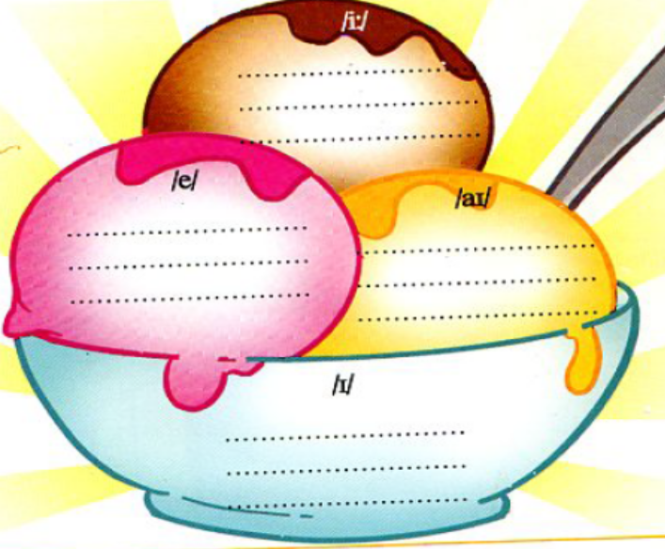
Ex. 2 Complete the list of nationality
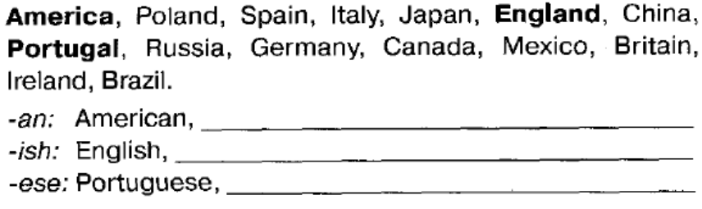
Ex. 3 Answer the questions
- He is from Italy. Who is he? __________
- She is Irish. Where is she from? _______________________
- We are from Poland. Who are we? ____________________
- They are Peruvian. Where are they from? __________________
- We are from Mexico. Who are we? ______________________
- I am English. Where am I from? _________________________
- It is from Brazil. What is it? _________________
- He is Russian. Where is he from? _________________
- She is from the USA. Who is she? _________________
- You are Argentinian. Where are you from? ___________________
- They are from Ireland. Who are they? _____________________
- We are Italian. Where are we from? ___________________
- She is from Russia. Who is she? _________________
- It is Mexican. Where is it from? _______________________
- He is from England. Who is he? _________________
- You are Brazilian. Where are you from? ___________________
- I am from Peru. Who am I? ______________________
- She is American. Where is she from? _________________
- They are from Argentina. Who are they? __________________
- We are Polish. Where are we from? __________________

