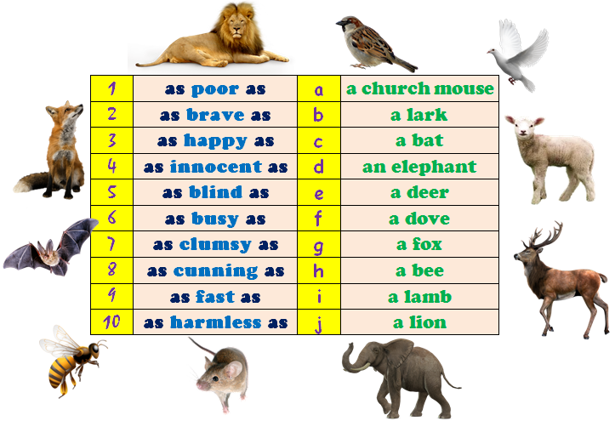
Контрольная работа по английскому языку для 5 класса за II четверть
I. Заполни пропуски will или be going to
1. I___to swim in an hour.
2. They___come next week.
3. She____to a supermarket tomorrow in the evening.
4. We___ski next Sunday.
5. My friends___return in the evening.
II. Напиши предложения, используя конструкцию as…as
Образец: Rome is hot. Madrid is hot too. – Rome is as hot as Madrid.
- She sings well and I sing well too.
- He and his father swim fast.
- I and my brother worked hard.
- Jane and Kate are beautiful girls.
- Moscow is big city, and London is a big city too.
III. Напиши предложения, используя конструкцию not as…as
1. Olga run faster than Natasha.
2. This home is bigger than that one.
3. My room is cosier than my sister’s room
4. Hotels in London are better than in Oxford.
5. Sam is smarter than Tom.
IV. Напиши наречие, образованное от прилагательного
1. calm
2. clear
3. bad
4. perfect
5. polite
6. merry
7. rude
8. simple
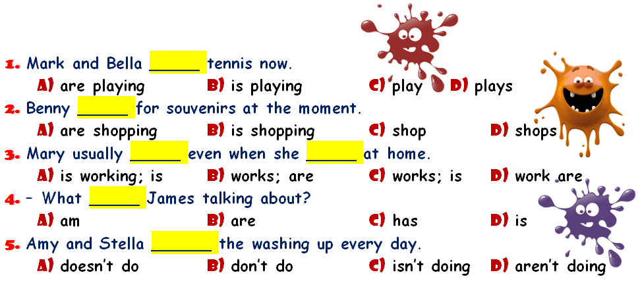
9. loyal
10.quiet
V. Choose the right variant.

VI. Make up correct word-combinations.

