Date:
Form:1
Theme: Let`s play
The aims of the lesson:
a)educational: to teach pupils about seasons and to correct their pronunciation.
b)up-bringing : to teach pupils like English.
c)developing: to develop pupils oral speech,listening and speaking skills.
The type:mixed
The equipments: book,card,picture,slide,flashcards,colour papers,glue,bricks.
The procedure of the lesson.
I The beginning of the lesson.
a)Greeting
b)Checking up homework
I.org moment:greeting:
-Good morning children
-How are you?
-What`s the weather like today?
II.Checking up homework:
1.Game “Who is he or she?” .
Objective:To give information and to develop pupils speaking skills.
Pupils should find parts of body and they should say what part of body is it.Last pupil should describe the picture.
For example: This is a nose.This is an eye.
This is a mouth. This is an ear.
This is a boy.This is a girl. This is her nose.This is his nose.
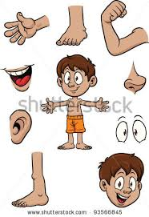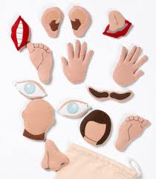
2.Jigsaw game.Find” What toy is it?”
Objective:To develop pupils skills.
Pupils should find different parts of the picture and collect different parts,the toys appears.
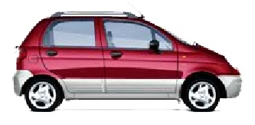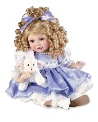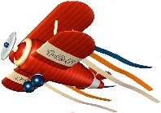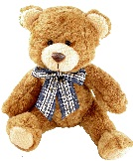

3.”Magic tree”game.
Objective: With the help of pictures ,to improve pupils listening skill.
Pupils should find the picture and say about it.Pupils should say what can they do.
They take one of the picture from the tree and describe this picture.If they can find and describe the picture they get present.
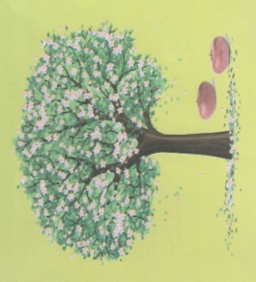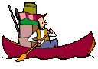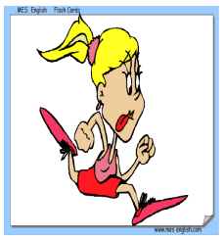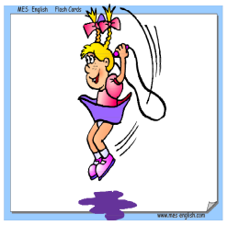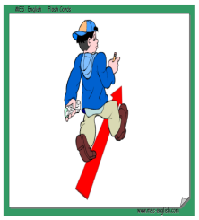

4.Puzzle. “What season is it?
Objective: To help them to pronounce words correctly.
Teacher gives the paper and colour shapes of the paper (leaves,fruits,vegetables, rain,sun snow,cloud)to pupils and they should find what season is it and describe it.
For example: It is spring.It is warm,windy and rainy in spring.It is green.
It is winter.It is cold,snowy and cloudy in winter.It is white.
5.Game “Which animals tail (brush) is it?.
Objective: To increase pupils memory.
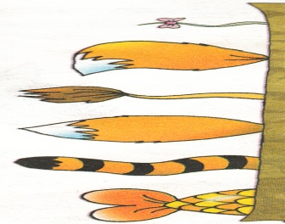
Pupils should find which animals tail is it. F-ex: It is fox`s brush.It is tiger`s tail.
6.Game “Vocabluary box”.
Objective:To develop pupils speaking skills.
Pupils should take one picture and say what is it.What colour is it? What animal (toy,season,number) is it?
Look at the picture and tell about it?
For example : It is a frog. It is small. It has got 4 legs. It has got 2 eyes. It has got a mouth.
It is a wild animal.It is a ….. .
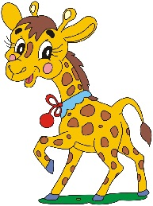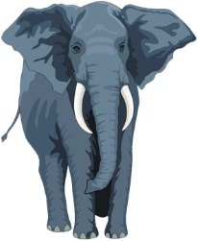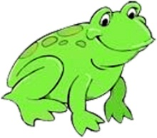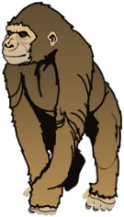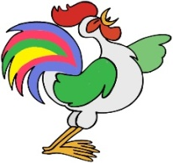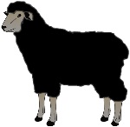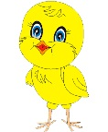

III.New theme.
1.To explain the lesson .
How we use have got and have you got .
I have got a carrot.
Have you got a carrot?
2.Game: “Spider`s thread”.
Objective: With the help of visual method to improve pupils skills.
Pupils should find the different colourful threads and putting in these threads kinds of vegetables.

3.Make up sentences looking at the picture.
Objective:To develop pupils oral speech.
F-ex:I have got a carrot.It is orange. I have got 2 carrots. They are orange. I like it.
4.Make up dialogue.
Objective:To develop their speaking skill.
-Hello
-Hello.How are you?
-I am great.Thank you.
-Is it a potato?
Yes,it is.
-What colour is potato?
-It`s brown or red.
5.Game “Put the vegatables in order”.
Objective:To increase their memory and speaking,listening skills.
Pupils should find which vegetable is big and which vegetable is small.
F-ex: Pumpkin,cabbage,eggplant,beet,cucumber,potato,tomato,onion,garlic.
6.Brick game.
Objective:
First pupils divided into 2 groups.Pupils find the vegetables. Who will be first that`s the winner.
7.Game “Sing songs”.
Pupils divided into 2 groups and each group should sing different songs.Who sings many songs that’s winner.
8.Play “At the market”
One of the pupil should be a seller,others are customers.
-Good morning
-Good morning
-Have you got a tomato?
-Yes,I have got
-How much?
-Thirty(twenty,forty,fifty).
9.Play “What word I think?”
One pupil think one vegetable and others should find what vegetable is it.
F-ex:Pupil 1-carrot.
Pupil 2-cabbage
Pupil 3-pumpkin
Pupil 4-onion
Pupil 5-tomato
Pupil 6-carrot.
IV.Homework
Put marks and give them presents.
To learn new words by heart.

