New theme: Everyday English 8 d | School №23
Date: 17.04.20 | Teacher’s name: Kemelbaeva S.A  Omarova A.B
Grade: 8 «b» | Number present: 15 Absent:0
Learning objective is that this lesson is contributing to | 8.2.6.1 deduce meaning from context with little or no support in extended talk on a growing range of general and curricular topics  8.3.6.1 link comments with some flexibility to what others say at sentence and discourse level in pair, group and whole class exchanges  8.4.6.1 recognise the attitude or opinion of the writer on a growing range of unfamiliar general and curricular topics, including some extended texts
Lesson objectives | All learners will be able to: understand the exercises  Most learners will be able to: understand the text, answer the question  Some learners will be able to: do exercises with somebody`s help
Assessment criteria | Understand the main idea of the theme  Ask and answer simple questions
Value link | Respect each other, learn each other
Intercultural awareness | Kazakh
Level of thinking skills | Understand the theme, answer the question, do exercises
Previous learning | Several, plenty of, amount/number
Planned timings | Planned activities | Resources
Beginning  10-min | Greeting  T: Good morning, students!  S: Good morning teacher.  T: How are you?  S: I am very well, thanks!  T: I`ll teach you today. My name is Omarova Asylzhan.  T: What date is it today?  T: What day is it today?  S: Today is Wednesday  T: What season is it now?  S: It is Spring now.  T: Thank you, take your seat.  Checking up the home task  -What was your home task for today?  Phonetic task  How many cookies could a good cook cook  If a good cook could cook cookies?  A good cook could cook as much cookies  as a good cook who could cook cookies. | A3 paper with tongue twister
Middle  25-min | Video material  « Ordering breakfast »  https://www.youtube.com/watch?v=QJNLsG3LtYs  Questions about video:  - What can you say about this video?  - How do you start your day?  - What gives you energy for the first part of the day?  - How do you think what will be about today's our new theme?  - What do you think people around the world have for breakfast?  Vocabulary  Order - [ˈɔːdə(r)]- тапсырыс  Offer- [ˈɒfə(r)]- ұсыныс  Light- [laɪt]- жарық  Omelette - [ˈɒm.lət]- омлет  Plain- [pleɪn] - жазық  filling - [ˈfɪl.ɪŋ]- толтыру  Exercise 1  Read the dialogue and translate  Waiter: Good morning .What can I get you ?  Martha: Hi . Is it too late to order breakfast ?  Waiter: No , not at all . We serve breakfast until noon . And ,we've got a special offer today - our full English breakfast is just £ 6.  Martha: Oh , I think I 'd prefer something lighter . Can i have an omelette , please ?  Waiter: Yes, of course .Would you like it plain or with a filling?  Martha: Hmm. could you make it with cheese and tomato ?  Waiter: No problem at all! Would you like some toast with that?  Martha: Yes , please ,and some butter , too .  Waiter: What would you like to drink ?  Martha: I 'd like some coffee , please .  Waiter: OK. Can I get you anything else?  Martha: no , thanks .  Waiter: OK .I'll bring your order in a moment .  Даяшы: Қайырлы таң. Мен сізге не ұсына аламын?  Марта: Сәлем. Таңғы асқа тапсырыс беру кеш емес пе?  Даяшы: Жоқ, мүлде емес. Түскі асқа дейін таңғы ас ішеміз. Ал бүгін бізде арнайы ұсыныс бар - біздің толық ағылшын тіліндегі таңғы ас 6 фунт.  Марта: О, мен жеңілірек нәрсені қалаймын. Маған омлет бере аласыз ба?  Даяшы: Ия, әрине. Оның қарапайым немесе салмасы қалайсыз ба?  Марта: Хм. мұны ірімшік пен қызанақпен жасай аласыз ба?  Даяшы: ешқандай қиындығы жоқ! Сіз осыған тост алғыңыз келеді ме?  Марта: Ия, өтінемін, май да беріңіз.  Даяшы: Сіз не ішкіңіз келеді?  Марта: Маған кофе керек.  Даяшы: Жарайды. Сізге тағы бір нәрсе ұсына аламын ба?  Марта: рақмет жоқ.  Даяшы: Жарайды. Мен сіздің тапсырысыңызды бір минут ішінде жеткіземін.  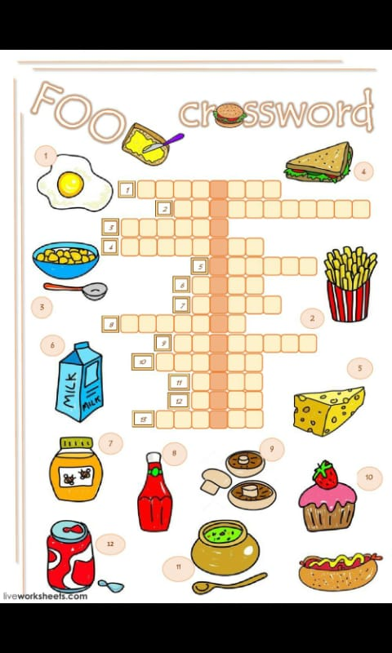  Exercise 2  https://i.pinimg.com/originals/cb/22/38/cb2238e6d82325a3883f197a2b4d1632.jpg  Exercise 4  Pronunciation ou  Listen and repeat  About, house, sound, count  Course, fourth  You, could, group ,would  Cousin, double |  | Video material about  ordering breakfast  Student’s book  Page, 94  https://hitfile.net/A79FMDl  Student’s book  Page, 94  https://hitfile.net/A79FMDl  A3 paper with crossword  Student’s book  Page, 94  https://hitfile.net/A79FMDl
End | Giving the hometask  Exercise 3  Look at the menu. In pairs, act out a dialogue similar to the one in Ex.1.  Reflection “OREO”    O- (opinion about lesson)  R-(recommendation for the next lesson)  E-(their emotions after lesson)  O-(own opinion about teacher) |  | Student’s book  Page, 94  https://hitfile.net/A79FMDl  A3 paper with reflection

School Teacher: Baizhukenova G.G

College Methodist: Torybaeva G.N
Student: Omarova A.B





