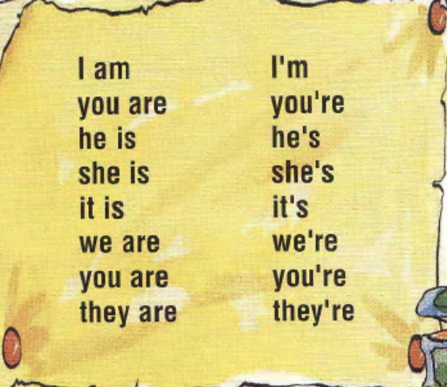

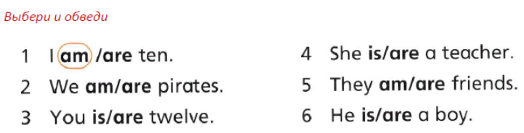

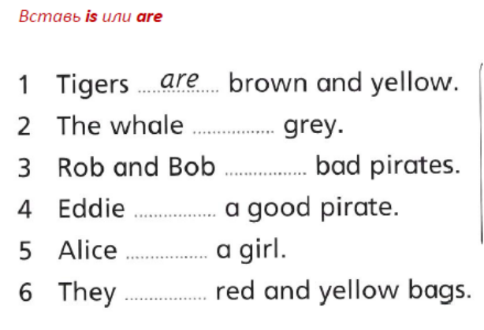

am, is, are  - I ________________ ten. | am, is, are  - I ________________ ten.
- You ______________ six. | - You ______________ six.
- He _______________three. | - He _______________three.
- She _______________nine. | - She _______________nine.
- We _______________ happy. | - We _______________ happy.
- They ______________ sad. | - They ______________ sad.
- Tom and Nick ________________ brave. | - Tom and Nick ________________ brave.
- Nick ________________ small. | - Nick ________________ small.
- I ___________________ a good sportsman. | - I ___________________ a good sportsman.
- My book ___________________ red. | - My book ___________________ red.
- My boots ___________________ black. | - My boots ___________________ black.
- I _______________ from Russia. | - I _______________ from Russia.
- You ________________ a good pupil. | - You ________________ a good pupil.
- You ________________ good pupils. | - You ________________ good pupils.
- Alex ________________ a good friend. | - Alex ________________ a good friend.
- I __________________ in the house. | - I __________________ in the house.
- My sister _______________ a doctor. | - My sister _______________ a doctor.
- The streets in the city ___________________ long. | - The streets in the city ___________________ long.
- The streets in the country ________________ short. | - The streets in the country ________________ short.
- My street ___________________ green. | - My street ___________________ green.
- His garden ___________________ beautiful. | - His garden ___________________ beautiful.
- Russia __________________ big. | - Russia __________________ big.
- His dad _________________ a driver. | - His dad _________________ a driver.
- How _____________you? | - How _____________you?
- We _________________ in the forest. | - We _________________ in the forest.
- They ______________ from Africa. | - They ______________ from Africa.
- My family _______________ not big. | - My family _______________ not big.
- How old _________________ you? | - How old _________________ you?
- How old _________________ his mum? | - How old _________________ his mum?
- His car ___________________ yellow. | - His car ___________________ yellow.
- My brother _______________ five. | - My brother _______________ five.
- I _______________ in the street. | - I _______________ in the street.
- My telephone number _____________ +7 918 345 21 60. | - My telephone number _____________ +7 918 345 21 60.

