-
Short term plan  Unit 2: Living things |  |  | School: #56 U.Gagarin
Date: |  |  | Teacher’s name: Begzhanova I.B.
CLASS: 5 |  |  | Number present: |  |  | absent:
Lesson title |  | Describing people and families
Learning objectives(s) that this lesson is contributing to |  | 5.L3 understand an increasing range of unsupported basic questions on general and curricular topics ( Ex. 1 - 2 p.43)  5.R2 understand with little support specific information and detail in short, simple texts on a limited range of general and curricular topics  5.W3 write with support factual descriptions at text level which describe people and their possessions  5.W7 use with some support appropriate layout at text level for a limited range of written genres on familiar general topics and some curricular topics  5.W8 spell most high-frequency words accurately for a limited range of general topics ( ex. 1-2 p.44)  5.UE3 use a growing variety of adjectives on a limited range of familiar general and curricular topics  5.C5use feedback to set personal learning objectives
Lesson objectives
All learners will be able to:
Match the pictures with sentences,
 |  | Most learners will be able to: distwingish the countable and uncountable
 |  | Some learners will be able to: Students will write parts of the body (singular and plural form)
Assessment criteria |  | Give basic information about themselves and others at sentence level.  Write topic related words correctly  Identify and apply countable and uncountable nouns in the given sentences correctly.  Express ideas clearly
Values links |  | successful development of the national education system, health care and culture
Cross-curricular links |  | Biology,
Plan
Planned timings | Planned activities (replace the notes below with your planned activities) |  |  |  |  |  | Resources
2 min  5 min | Greeting .  T: Good morning, students! I am glad to see you. How are you today? I hope you are well.  Introduction of new theme: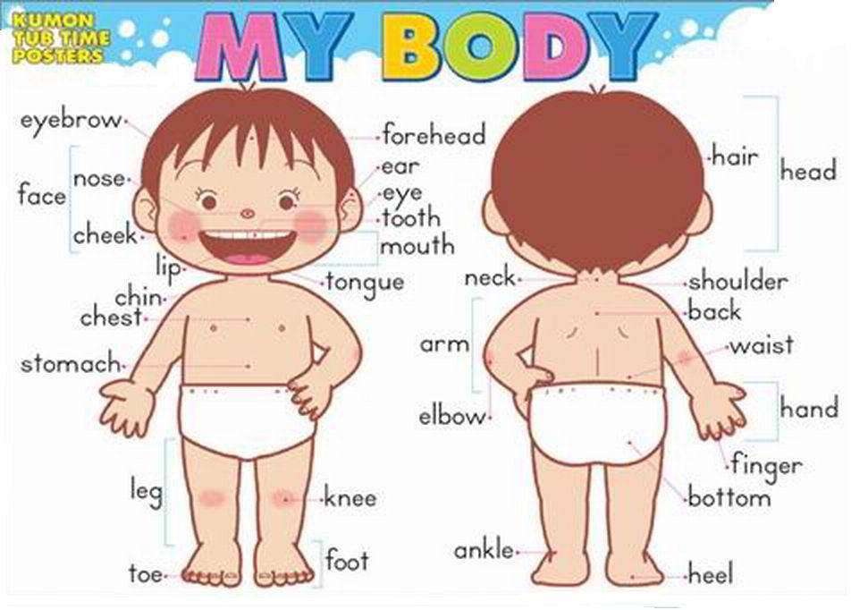  S1Task:1 Match the pictures with their names and say.  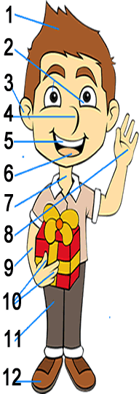  Descripter a learner  -Matches the pictures (a-1) with their names  -says them |  |  |  |  |  | https://www.youtube.com/watch?v=j6g_OPGdblU  Body Parts for Kids - English Vocabulary - Kids Learning Videos  Pictures  Explain new vocabulary Showing the video  https://www.youtube.com/watch?v=j6g_OPGdblU
  1 | 
  2
  3
  4
  5
  6
  7
  8
  9
  10
  11
  12
Middle  5 min  20 min  3 min | C6 Task:2 peir work  Fill in the gap, put necessary verbs with group  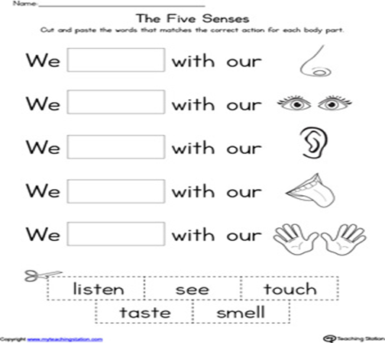  Descriptor learners  • Choose a righte verb  • Read the sentences  UE1.New theme. Grammar:  A noun can be countable and uncountable.  Countable noun You can use one/two/three……countable noun (you can count them)  for example:  an eye- two eyes , a face-two faces, an ear –ears, an arm –two arms, a shoulder- two shoulders leg,  Uncountable noun  for example: nose , mouth, hair , neck ,  You can`t say one/ two/thee……..+ this things:  Irregular noun: foot-feet, tooth-teeth  Ph. Training  Learners listen to the song about parts of the body and dance a little.  W8. Task 2 group work  Students will write parts of the body (singular and plural form)  Descriptor a learner:  Write names of parts of the body (singular and plural) |  |  |  |  |  | Flashcards, active board  Worksheet 1  Flashcards, active board  blackboard  Worksheet 2  Flashcards, active board
End  5 min | All learners put stickers into three groups according their understanding of the lesson  Home task: Tasks from WORKBOOK |  |  |  |  |  | stickers
  I know and understand   | I can speak   | I need a help
Additional information
All learners will be able to: Match the pictures with sentences,  Most learners will be able to: distinguish the countable and uncountable  Some learners will be able to: Write short story about your friend use new words |  |  |  | -by giving feedback  - by observing  - by smiling  I`ll give 3 different picture  -by fingers | Lesson is connected with Biology,
Summary evaluation
1:What two things went really well (consider both teaching and learning)?
2:What two things would have improved the lesson (consider both teaching and learning)?
3:What have I learned from this lesson about the class or individuals that will inform my next lesson?

