1.

NUMBERS- WORDSEARCH

FIND THE HIDDEN NUMBERS.
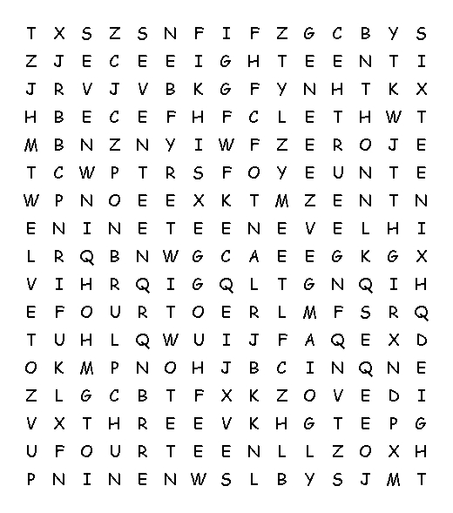

zero one two three four five six seven eight nine ten eleven
twelve thirteen fourteen fifteen sixteen seventeen nineteen

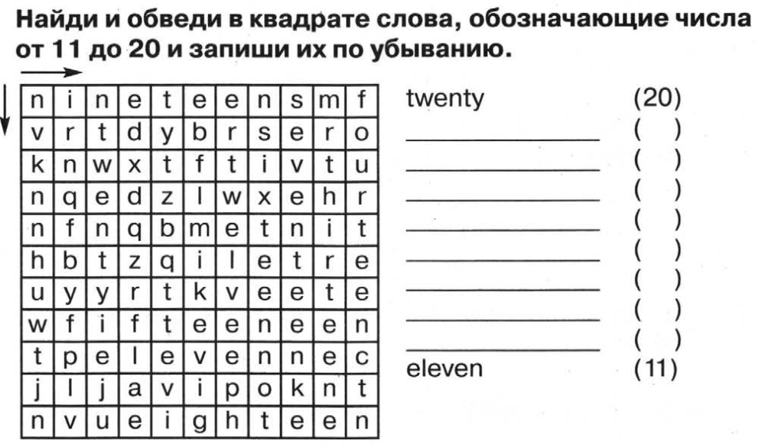
2.

1.
KEY

