1a. Guess what the song is it about.
1. Look at the pictures. What do you see? What do they depict?
9 lesson
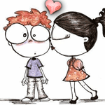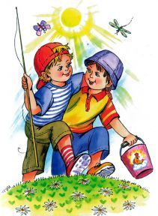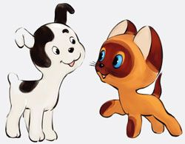
_____________________________________________________________________________
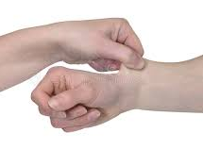
Zero Conditional:
If/when + Present Simple, …Present Simple
First Conditional:
If+ present, …will + Infinitive
Note:
Pinch
_____________________________________________________________________________
2a. Listen to the song and fill in the gaps.
scared, wake, perfect, smile
There are days
I 1)______ up and I pinch myself
You're with me, not someone else
And I'm 2) __________, yeah, I'm still scared
That it's all a dream
'Cause you still look 3)________ as days go by
Even the worst ones, you make me 4)________
I'd stop the world if it gave us time
2b. Number the sentences in the correct order.
__a) 'Cause when you love someone
__b) You open up your heart
__c) You probably never loved someone like I do
__d) When you love someone
__e) If you love someone
__f) You make room
__g) And you're not afraid to lose 'em
__h) You probably never loved someone like I do


Note:
Vibe – настрой
Bond – связь

3a. Listen to the song and write the missing words.
It's been a long day without you, my ________
And I'll tell you all about it when I _____ you again
We've come a long _______ from where we began
Oh, I'll tell you all about it when I see you _______
When I see you again

3b. Match the lines.
First, you both go out your way and get lost
And what's small turned to a friendship, a friendship turned to a bond
And that bond will never be broken, the love will never get lost
The love will never the vibe is feeling strong

4. Do you understand the ideas of the songs? Which song do you like? Do you have friends? (Since childhood)
5. Can you name the title of the first song, the second one?
Lukas Graham - Love Someone
Wiz Khalifa - See You Again ft. Charlie Puth

6. Find and write the examples of Zero Conditional and First Conditional.
_____________________________________________________________________________________________________________________________________________________________________________________________________________________________________________________________________________________________7. Make your own sentences with Zero/First Conditionals.
____________________________________________________________________________________________________________________________________________________________________________________________________________________________________

9. Make a poster about gadgets (warning signs, weather, work etc.) and make descriptions using Conditionals.
8a) What gadgets do you have? Will you use them in the future? Will they be important for you? Why?
8b) In pairs. Discuss your future plans for tomorrow/next week/month using Conditionals.

