1a. Look at the pictures. Describe what you see.
10 lesson
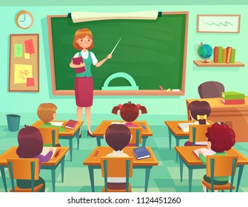
1b. Guess what picture is related to the song.
1c. Look at the title. What do you think this song is about? Listen, read and check your answers.
Boyinaband
“Don't Stay in School”
2. Listen to the song and fill in the gaps.
Job, loads, taught, defining, vote, cell
I wasn't taught how to get a ______
But I can remember dissecting a frog
I wasn't ________ how to pay tax
But I know _______ about Shakespeare's classics
I was never taught how to _______
They devoted that time to ___________ isotopes
I wasn't taught how to look after my health
But mitochondria is the powerhouse of the _______

Note:
dissecting - рассечение
tax - налог
loads – многое
vote - голосовать
сell- клетка
isotopes [ˈaɪsətəʊps] - изотопы
mitochondria [ˌmaɪtə(ʊ)ˈkɒndrɪə]митохондрии

5. What are your impressions of the song? Do you like it?
Do you support the singer? Why?
3. Match the lines
Never spent a lesson on current events
Instead I studied what laws there are
I was never taught what laws there are
I was never taught The Old American West

6. Discuss in groups necessity of school. Do we need distance learning or learning in class? Would you like to study online? Give the reasons.
4. Number the sentences in the correct order
__ But I know how Henry the VIII killed his women
__ Glad that's in my head instead of financial advice
__ Let me repeat, I was not taught the laws for the country I live in
__ Divorced, beheaded, died, divorced, beheaded, survived

8. Translate the first stanza in written form.
9. Read with expression a part of the song (or sing)
7. Do you agree that computers will replace teachers in the future or teachers will never stop teaching children? Why? Write an opinion essay.

