План-конспект учебного занятия по английскому языку в 5 «А» классе
Дата проведения: 26.02.2020
Учитель: Усова Екатерина Ивановна, первая квалификационная категория
Тема: «In the city»
Коммуникативная ситуация: «Trip around the town»
Цель: способствовать формированию коммуникативной компетенции в рамках заданной темы
Прогнозируемый результат: предполагается, что к концу учебного занятия учащиеся смогут составить высказывания о родном городе, рассказать о любимом месте.
Задачи:
- развитие грамматических навыков употребления модальных глаголов must/mustn’t, развитие лексических навыков по теме «In the city»
- развитие логики, творческого мышления и памяти в рамках заданной коммуникативной ситуации
- воспитание любви к родному городу
Формы работы:
- фронтальная
- групповая
- индивидуальная
Оборудование: компьютер, мультимедийный проектор, интерактивная доска, наглядный материал, раздаточный материал

I.Организационно-мотивационный этап
T: Good morning, my dear students! Good morning our dear guests! We are glad to see you at our lesson. We are going to make a trip around the town. But first of all I want to say that I got a letter yesterday. It’s from my friend. Her name’s Amelia. She’s 12 and she lives in Australia. Let’s read the letter (презентация Smart Notebook, слайд 1, приложение 1).
II. Основной этап
- Актуализация пройденного лексического материала (здания)
T: Let’s remember what buildings we can see in town (интернет-сервис LearningApps, https://learningapps.org/display?v=phcya03jj20). Your task is to match the definitions of the buildings with the pictures.
- Актуализация предлогов места
T: And now let’s make a map of the town. You will read the instructions and place the buildings as it is written in the instruction (презентация Smart Notebook, слайд 2, приложение 2)
- Актуализация предлогов направления
T: We have made the map (учитель размещает карту города на доске, приложение 3). Let’s remember how we can give directions. You should divide into two teams (учащиеся вытягивают карточки с буквами, слаживают названия городов Minsk и Brest (приложение 4) и делятся на две команды).
T: Your task is to make a rout for a tourist from the other team. Start is at the bus station (учащиеся получают конечную точку маршрута, участник из команды соперников должен дойти до нужного здания в соответствии с инструкцией, которую дают учащиеся из другой команды).
- Физкультминутка
T: Amelia is interested in astrology. She has made some predictions for you. But I hid the box with the predictions. I will you give you the instructions where to go and you’ll find the box (учащиеся идут на старт, учитель дает направление движения. После того, как коробочка с предсказаниями найдена, учащиеся зачитывают их (приложение 5).
- Восприятие и понимание иноязычной речи на слух
T: Before we’ll on a trip let’s remember safety rules. We are going to watch a video about safety rules. But first we should look through the unknown words (презентация Smart Notebook, слайд 3, приложение 6). Let’s look the video (презентация Smart Notebook, слайд 4).
T: Let’s check how well you know safety rules. We are going to do some exercises (приложение 7).
- Чтение
T: Oh, I some photos for you. Tell me please, do you know these places (размещает на доске фотографии различных мест Солигорска, учащиеся называбт их, приложение 8). We’ll read the text about Soligorsk. You should insert the words from the box into the text (приложение 9).
II. Заключительный этап
- Рефлексия
T: We have little time and we should to write a letter to Amelia (учитель раздает учащимся бланки для писем, приложение 10). Let-‘s read your letters. They are very interesting. Let’s put your letters into an envelope and I will send them to Amelia.
- Подведение итогов
T: You worked had today! Your marks are …
Thank you for your work. The lesson is over. Good-bye.

Приложение 1
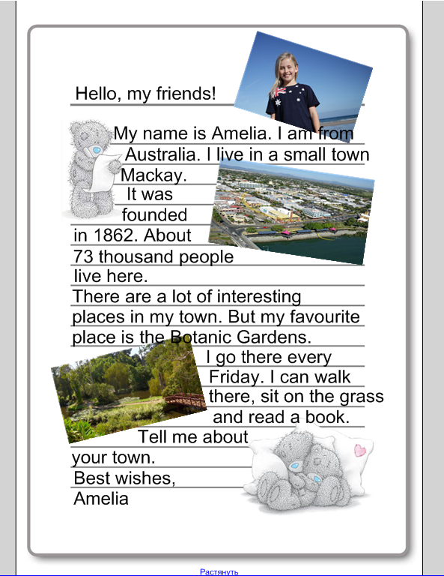

Приложение 2
1. A bus stop is in front of the theatre
2. The cinema is opposite a swimming-pool
3. A bank is behind the cinema
4. A school is between the swimming-pool and a library
5. A bookshop is next to the church
6. The post-office is opposite the bookshop
7. A supermarket is behind the church
8. A hospital is behind the café opposite the supermarket
9. A pet shop is next to the café in front of the hospital
10. A museum is next to the pet shop

Приложение 3
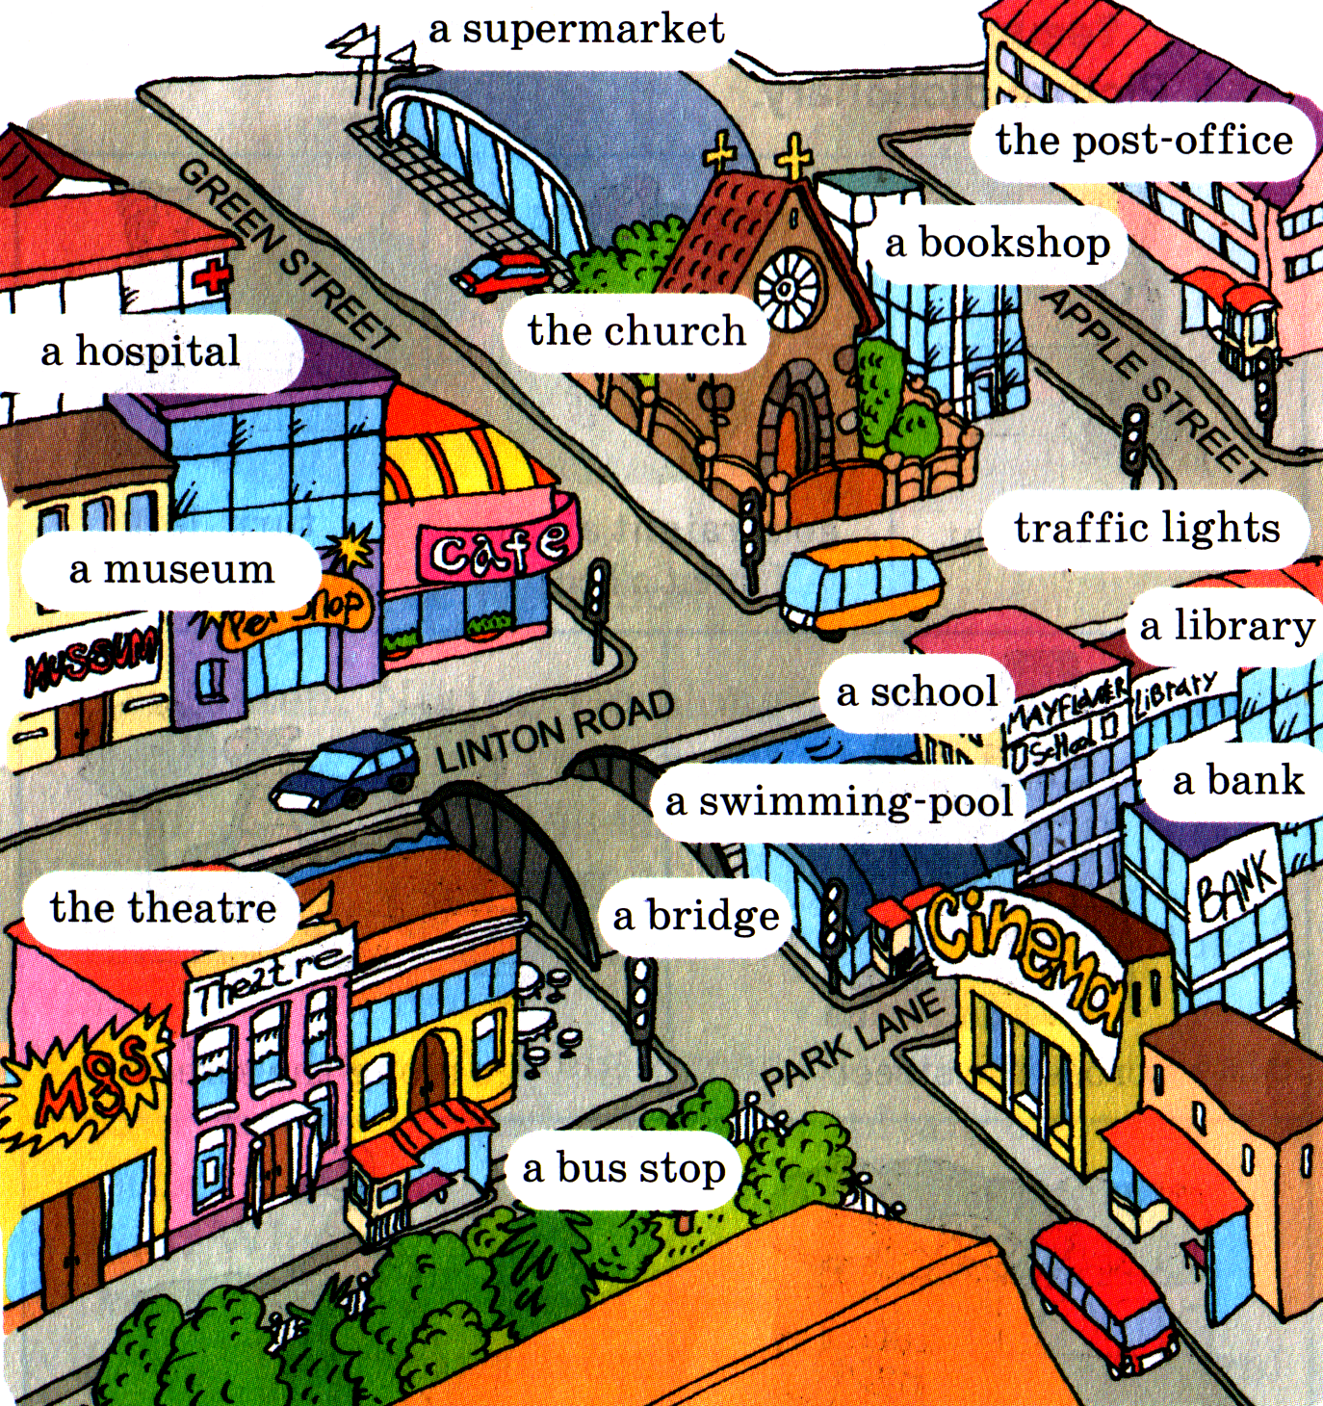

Приложение 4
B | M
R | I
E | N
S | S
T | K

Приложение 5
You’ll get something sweet
Don’t run at school. You can break your phone
Go for a walk after school and you’ll find some money
Be careful! You can get 2 on Math
You’ll go to the seaside in summer
You will go to the café at the weekend
You will get a present
You’ll meet a new friend
You will to the cinema on Sunday
Your mum will buy an ice-cream for you

Приложение 6
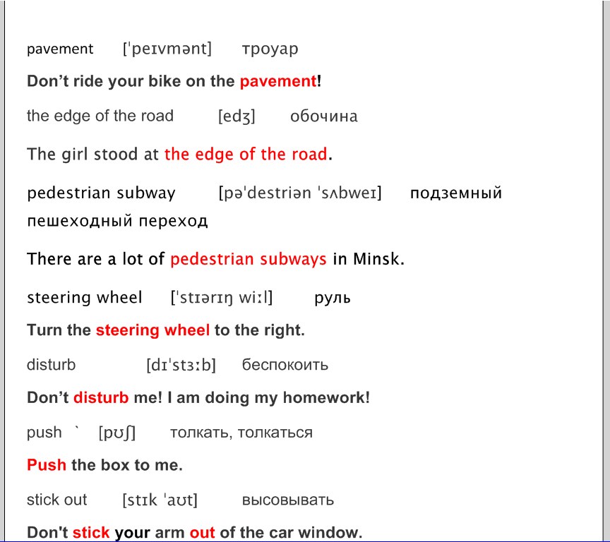

Приложение 7
True/False
1. You must cross the road when the traffic lights are red.
2. You must wait when the traffic lights are yellow.
3. You mustn’t play on the road.
4. You must walk on the pavement.
5. You mustn’t cross the road at a Zebra Crossing.
6. You must disturb a driver.
7. You must play with a steering wheel.
8. You must sit properly in your sit.
9. You mustn’t stick your head out of the window.
10. You must jump up and down on your sit.

Match the beginning with the end

1. Red signals cars to stop …
2. Cross the road at a Zebra Crossing …
3. Do not cross the railway crossing …
4. Do not push others …
5. Look to your left …
6. Do not disturb the driver …
7. Sit properly in your sit …

a. … when getting on or out of the bus.
b. … then right and then to your left.
c. … green to go.
d. … so the person sitting next to you, is comfortable.
e. .. when the gate is closed.
f. … by talking to him.
g. … or use a pedestrian subway.

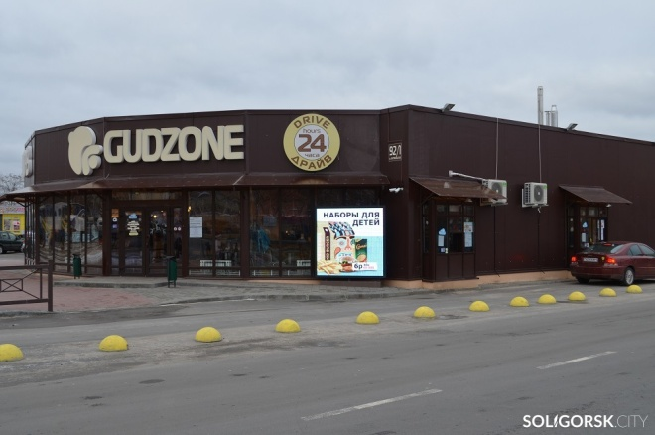
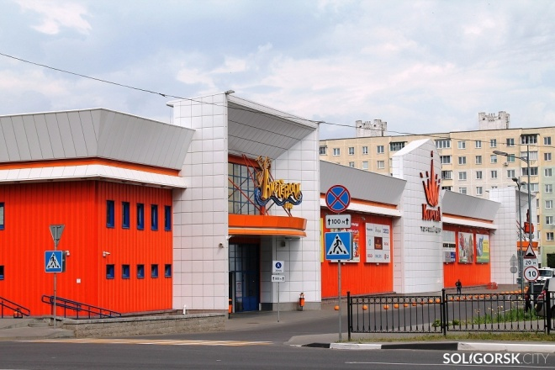
Приложение 8

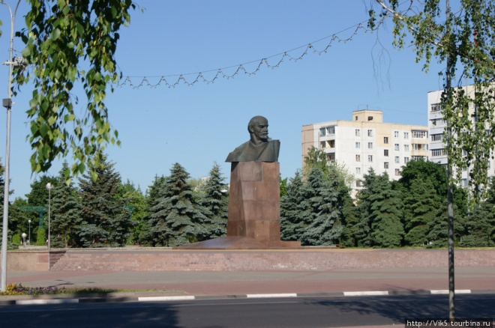

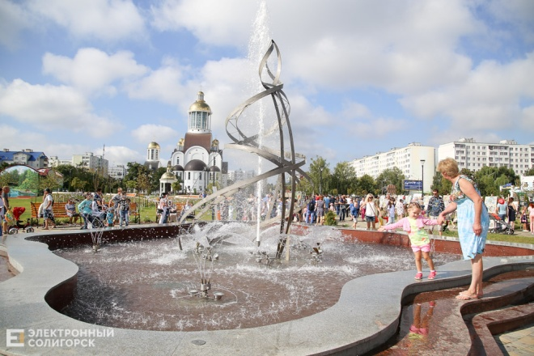

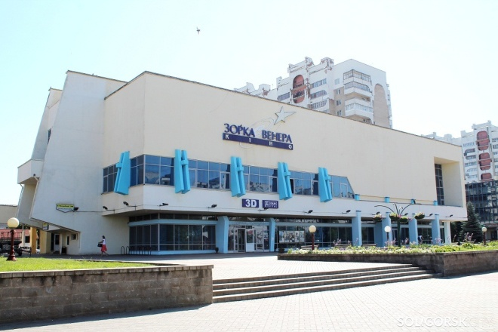

Приложение 9
Fill in the words

big roller-skating 100 thousand town

the cinema a museum 1958 sport centre

the fountains happy

Soligorsk is a beautiful 1)_______________. It was founded in 2)_______________. More than 3)______________ people live here. Soligorsk is not very 4)______________. There are a lot of shops and cafes in it.
If you want to watch a new film go to 5)_______________ “Zorka Venera”. If you like sport there is a big 6)_______________ for you.
One of the most beautiful places is Lenin Square. Children like 7)_______________ there. We also have 8)_______________ and two wonderful parks. In summer people walk there and enjoy 9)_______________. Come to Soligorsk and you will have 10)_______________ time.

Приложение 10
Hello, Amelia!
My name is __________________. I live in Soligorsk. I live at_____________ (house) ___________________ Street, flat ____________. There area lot of places in my town, but my favourite is _____________________________. I go there __________________________ (how often). I can ___________________________________________ there. Come to my town.
Best wishes,
_______________________.

