Test
Name/Surname_______________________________________

- Listen to the recording. Which genres do the British teens prefer? Choose the right answers:

Speaker 1:
- Romance
- Historical novel
- Detective story
- Non-fiction
- (Auto-)biography
Speaker 2:
- Romance
- Historical novel
- Detective story
- Non-fiction
- (Auto-)biography
Speaker 3:
- Romance
- Historical novel
- Detective story
- Non-fiction
- (Auto-)biography
Speaker 4:
- Romance
- Historical novel
- Detective story
- Non-fiction
- (Auto-)biography

- Fill in the table with the missing words using the suffixes below:
Verb | Noun | Noun (person) | Adjective
1 remark | - | -
2 - | interest |  | 1)  2)
3 inform
4 succeed |  | -
5 - | power | -
6 describe |  | -
7 - | suspense | -
8 imagine |  | -
  - Fill in the gaps with words in the correct form:
Philip Pullman is a ____________ (1) writer. His novels are so ____________ (2) and _______________ (3) to read. He achieved ______________ (4) with the fantasy trilogy “His Dark Materials”. Also, Philip wrote ______________ (5) short stories where he gave realistic _______________ (6) of the fantasy world.

- Use the verbs in brackets in the right tense and voice: the Present/ Past Simple Active; the Past Progressive/ Perfect Active; the Past Simple Passive:
William Shakespeare was born in April 1564. His father ___________ (to make) and sold leather gloves. His mother ___________ (to be) a daughter of an important farmer.
By the time, Shakespeare ______________ (to leave) Stratford-on-Avon, he ___________ (to marry) a farmer’s daughter, Anne, and _________ (to become) a father of three children. Shakespeare _________ (to leave) them in 1587 to work in London. He __________ (to take) by a company of actors to the capital where he acted and wrote 37 plays. After the playwright and his friends _____________ (to spare) enough money, they _ (to build) their own theatre, the Globe, at the end of the 16th century.
In England and other countries, Shakespeare’s plays ________ (to put) on the stage in our days, too. Actors who __________(to invite) to play in his comedy or tragedy consider it the highest honour.

- Read the text and choose the right answer (True, False, Not stated):
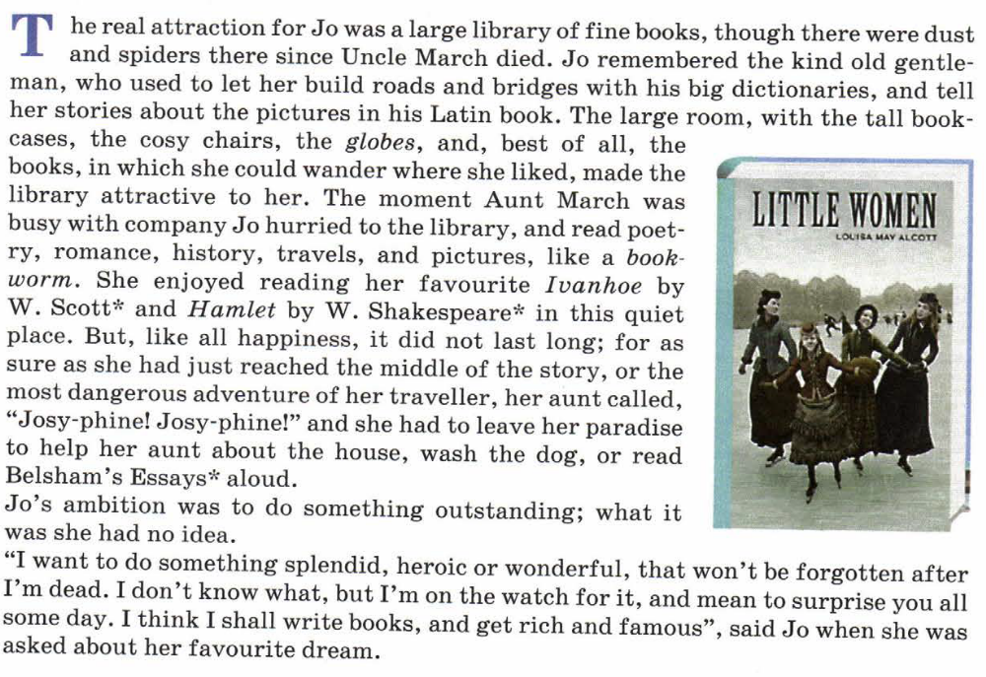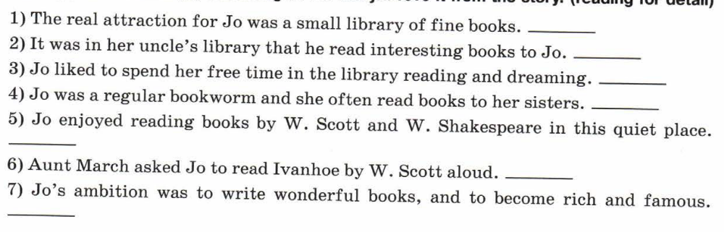
- You are going to give a talk about reading books. Answer the questions:
- What is your attitude to reading?
- what kind of books do you like to read?
- Who is your favourite author? Why?
- What book have you read recently, and what was it about?
- What do you prefer: reading a book or watching a film? Why?

