SCHOOL LESSONS
№ 1. Look at the pictures and write.
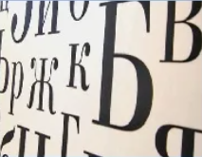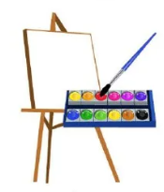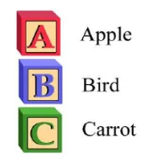
_______________ ____________________ _______________ _________________
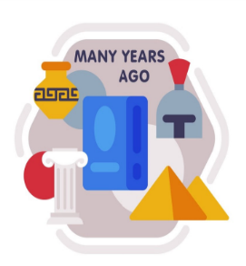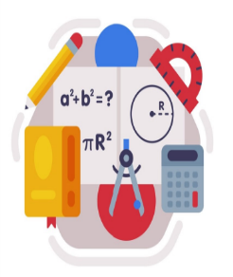
_______________ _______________ ________________ ________________ _______________
№ 2. Find 9 lessons.
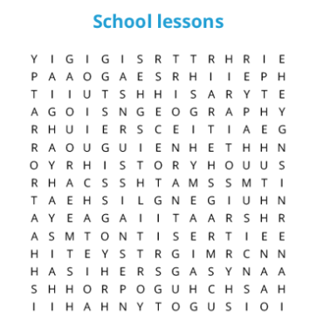

№ 3. Complete the sentences
I like ____________________________________________ .
I don’t like _______________________________________ .
№ 4. What lesson are the children doing?
- 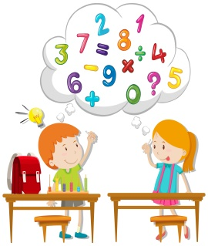_________________________________________
-  _________________________________________
-  _________________________________________
-  _________________________________________
№ 5. Choose and write
Geography Art PE History English Maths Music

- Pupils sing songs in _______________ .
- We count in _____________ .
- I write the alphabet in ______________ .
- Children play football in _______________ .
- We paint and draw pictures in ____________ .
- Pupils read about mountains and rivers in ________________ .
- I read about old castles, queens and kings in ______________ .

