Класс: 10
Учитель: Сокол Ирина Михайловна
Дата: 19.12.2024
Тема: Молодежь и общество.
Коммуникативная ситуация урока: Международный день молодежи
Оборудование урока: УМК для 10 класса, телефоны, мультимедиапроектор и экран
Цель: Развитие коммуникативной компетенции учащихся в рамках коммуникативной ситуации урока «Международный день молодежи»
Прогнозируемый результат урока: предполагается, что к окончанию учебного занятия учащиеся смогут самостоятельно, опираясь на прочитанную информацию, составить и презентовать план празднования международного дня молодежи в своeм городе (не менее 12 фраз)
Задачи:
•способствовать развитию коммуникативной компетенции учащихся в рамках заданной темы;
•способствовать развитию умения извлекать необходимую информацию из текста;
•способствовать развитию логики и памяти учащихся, овладению основными способами мыслительной деятельности (сравнение, анализ, обобщение);
•способствовать формированию следующих качеств индивидуальности: ответственность, добросовестность, патриотизм
Формы работы: фронтальная, парная, групповая

Ход учебного занятия

I этап – организационно – мотивационный
Good morning! Nice to see you! I think everybody is ready and we can start our lesson. I’d like to begin with a video about International Youth Day, but before watching let’s answer some questions: Do you know
1. How many young people are there in the world? (1,2 billion, 15%)
2. What kind of people can we call youth? (15-24 years old)
3. When is it celebrated? (On August 12) (выбирают из предложенных)

Let’s watch a video.

7.Were we right?
Cross wrong information.

As you see today we are going to speak about International Youth Day, learn some interesting information and even make a plan for celebration International Youth Day in Soligorsk.

II этап – операционно – познавательный

Работа над текстом (ex.1a, p.156)
1) предтекстовый этап
Do you celebrate International Youth Day?
How do you think young people celebrate it?
Look on the desks. You have some variants. Choose some of them.
Begin your answer with the words:
People can take part in ...
Young people choose ...
Youth get in on ...

2) текстовый этап

Let’s read and check your guesses.
Were your guesses write?
What information was surprising to you?

3) послетекстовый этап

ex.1b, p.157 Use the text and write questions to the answers. Work in pairs.

1. When is The United Nations’ International Youth Day celebrated?
2. What is this holiday aimed at?
3. On what issues can youth conferences be held on this day?
4. How many young people are there in the world today?
5. Where do many young women and men live?
6. Where was the idea of the International Youth Day proposed?
7. When was the idea of holding an International Youth Day proposed?
When was the resolution adopted proclaiming August 12 as International Youth Day?
When was the International Youth Day first celebrated?
8. What awards have eight youth organisations in Latin American and The Caribbean received?
9. What is depicted on the UN logo?
10. What does the UN logo symbolize?

Физкультминутка
Let’s play “TRUE/ FALSE”
If the statement is true, come to this corner (TRUE)
If the statement is false, come to that corner (FALSE)

1. The United Nations’ (UN) International Youth Day is celebrated on August 18. (False, 12)
2. According to the UN’s definition, the world’s youth are the age group between 15 and 24 years old. (true)
3. Today, there are 1.2 billion young people, making up 24 per cent of the global population. (False, 16)
4. The idea for International Youth Day was proposed in 1981. (False, 1991)
5. International Youth Day was first observed in 2000. (true)
6. The olive branches symbolize friendship. (False, peace)
7. The world map represents all the people of the world. (true)
8. Many activities and events that take place around the world on International Youth Day promote the benefits that young people bring into the world. (true)

Change your papers and check your classmate’s questions.
How many mistakes have they got?

III этап – организационно – деятельностный
ex.1c, p. 157
Split into two teams and have a competition. Close the books. Ask and answer your questions to the opposite team. You get a point for each correct question and answer.

ex.2a, p.157-158 Complete the International Youth Day 2020 Quotes.

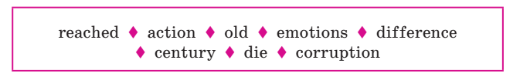
1. “The duty of the youth is to change ... .” – Aristotle (corruption)
2. “Dream, Dream, Dream. Dreams transform into thoughts and thoughts result in ....” – APJ Abdul Kalam (action)
3. “Youth is not a time of life; it is a state of mind; it is a matter of the will, quality of the imagination, a vigour (energy) of the ... .” – Samuel Ullman (emotions)
4. “A few heart-whole, sincere, and energetic men and women can do more in a year than a mob (crowd) in a ... .” – Swami Vivekananda (century)
5. “Arise! Awake! and stop not until the goal is ... .” – Swami Vivekananda (reached)
6. “Youth is happy because it has the capacity (ability) to see beauty. Anyone who keeps the ability to see beauty never grows ... .” – Franz Kafka (old)
7. “Older men declare war. But it is the youth that must fight and ... .” – Herbert Hoover (die)
8. “Good Habits formed at youth make all the ... .” – Aristotle (difference)

ex.2b, p.158 Work in pairs. Choose three quotes you agree with. Explain why.

ex.2b, p.158
Surf the Internet to discover this year’s International Youth Day Quotes.
Discuss their messages in small groups. Then tell other groups.

By the way, do you want to celebrate this holiday in our town? I think “yes”.

ex.3a, p.158 Work in small groups. Make a plan for celebration International Youth Day in Soligorsk. Write the date and the time off your activities. You can use the cards with the activities.

IV этап – рефлексивно – оценочный

ex.3b,158
Present your plan to the other groups. (выходят к доске вешают план на доску, презентуют его)
Take the magnet and vote for the most interesting plan, which we are going to send to our local authorities. (каждый учащийся под понравившимся планом размещает смайл)
The winner is ...
Thank you for your work.
Your marks for the lesson are …
Your hometask is to make a story about celebration International Youth Day in your town.

1,2 billion
young people in the world

2 billion
young people in the world
1,8 billion
young people in the world

3 billion
young people in the world
16 per cent of the global population.

24 per cent of the global population.
7 per cent of the global population.

30 per cent of the global population.
between
15 and 24 years old

between
18 and 35 years old
between
14 and 21 years old

between
15 and 31 years old
On August 12

On July 3

On August 20
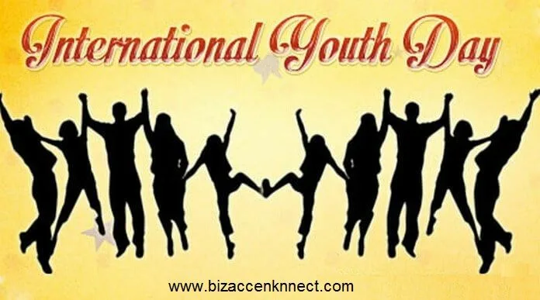
_____________________________________________________________________________________
___________________________________________________________________________________
_____________________________________________________________________________________
_____________________________________________________________________________________
_____________________________________________________________________________________
_____________________________________________________________________________________
_____________________________________________________________________________________
_____________________________________________________________________________________
_____________________________________________________________________________________
_____________________________________________________________________________________
_____________________________________________________________________________________
_____________________________________________________________________________________
_____________________________________________________________________________________
_____________________________________________________________________________________
_____________________________________________________________________________________
_____________________________________________________________________________________
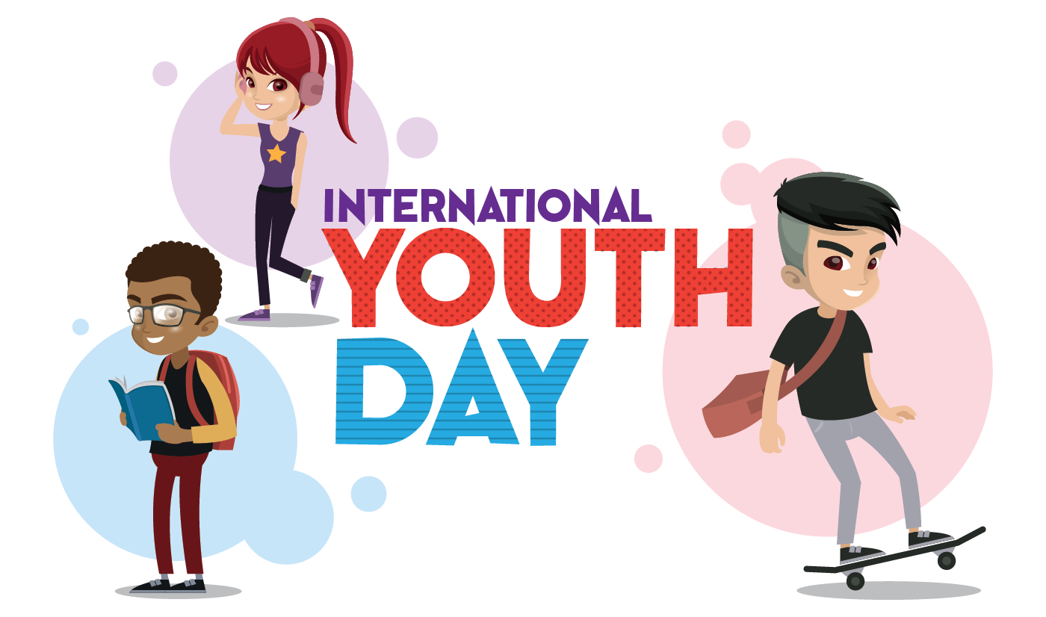

_____________________________________________________________________________________
___________________________________________________________________________________
_____________________________________________________________________________________
_____________________________________________________________________________________
_____________________________________________________________________________________
_____________________________________________________________________________________
_____________________________________________________________________________________
_____________________________________________________________________________________
_____________________________________________________________________________________
_____________________________________________________________________________________
_____________________________________________________________________________________
_____________________________________________________________________________________
_____________________________________________________________________________________
_____________________________________________________________________________________
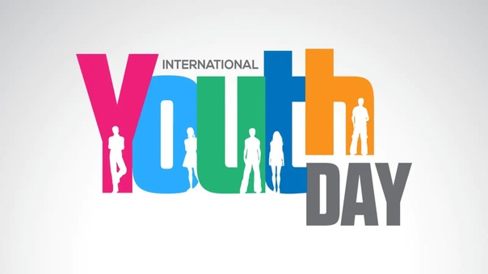
_____________________________________________________________________________________
_____________________________________________________________________________________
_____________________________________________________________________________________
_____________________________________________________________________________________
_____________________________________________________________________________________
_____________________________________________________________________________________
_____________________________________________________________________________________
_____________________________________________________________________________________
_____________________________________________________________________________________
_____________________________________________________________________________________
_____________________________________________________________________________________
_____________________________________________________________________________________
_____________________________________________________________________________________
_____________________________________________________________________________________
_____________________________________________________________________________________
____________________________________________________________________________________
Town picnic in the park | Charity market with hand-made crafts
Conferences on ecological problems | Conferences on youth problems
Meetings on healthy lifestyle | Charity event “help homeless animals”
Talent show | Concerts of Belarusian youth bands
Toys workshops | Sports competitions
Bicycle race | Fashion show of youth designers
Motorbike show | Parade of rarity cars

Youth marathon | Exposition of pets
Conferences on youth organisations | Kites show
Videoconferences with foreign youth groups | Festival of national cuisine
Dance competitions | Photo sessions with the leader of local youth organisation
Fireworks show | Open dialogue with youth bloggers

