7 класс. Контрольная работа №1. ________________________
ФИ
Reading (Чтение)
Read the text and answer the questions.
My friend Karen is a very busy person. When she’s not doing her homework or studying, she is out having fun.
On Tuesdays, she goes swimming after school. She practices a lot because she’s in the school team. Then, on Wednesdays, she goes to music club. On Thursdays, she meets her friends for a coffee in town. Then, on Fridays, she goes to the cinema or plays scrabble with her sister.
At the weekend, Karen always spends time with her family. She usually helps her mum around the house and sometimes her dad takes her windsurfing.

- What school team does Karen belong to?
……………………………………………………………………………………

- What does she do on Wednesdays?
……………………………………………………………………………………

- When does she meet her friends? ……………………………………………………………………………………

- Which board game does Karen like to play? ……………………………………………………………………………………

- Who does she spend her weekends with?
……………………………………………………………………………………

- What activity does Karen do with her dad?
……………………………………………………………………………………

7 класс. Контрольная работа №1. ________________________
ФИ
Listening (Аудирование)

1.What was Jenny scared of?
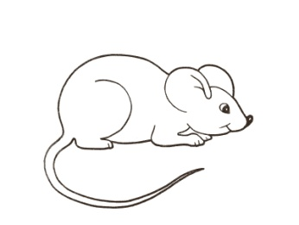 |  |  |  | 
A |  | B |  | C
2.What did he do last night?
 |  |  |  | 
A |  | B |  | C
3. What time did she finish school today?
2:30 |  | 3:30 |  | 2:45
A |  | B |  | C
4. Who are they describing?
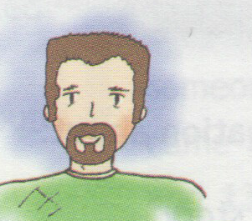 |  | 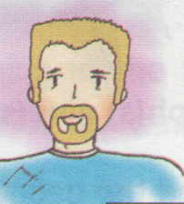 |  | 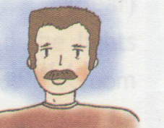
A |  | B |  | C

7 класс. Контрольная работа №1. ________________________
ФИ
Writing (Письмо)

You have received a letter from your English-speaking pen friend Martin.

…My best friend had a birthday party last weekend. We went on a picnic. There were many guests and it was great. And when is your birthday? How do you usually celebrate it? What present would you like to get for your next birthday?

Write him a letter and answer his 3 questions. Write70- 80 words. Remember the rules of letter writing.
______________________________________________________________________________________________________________________________________________________________________________________________________________________________________________________________________________________________________________________________________________________________________________________________________________________________________________________________________________________________________________________________________________________________________________________________________________________________________________________________________________________________________________________________________________________________________________________________________________________________________________________________________________________________________________________________________________________________________________________________________________________________________________________________________________________________________________________________________________________________________________________________________________________________________________________________________________________________________________________________________________________________________________________________________________________________________________________________________________________________________________________________________________________________________________________________________________________________________________________________________________________________________________________________________________________________________________

Speaking (Говорение)
You are going to give a talk about your hometown. You will have to start in 1.5 minutes and speak for not more than 2 minutes
Remember to say:
· Where your town is located, what you like most about your hometown, where you would like to go with your guest
You have to talk continuously.

КЛЮЧИ
Reading (Чтение)
Ответ:
1 | swimming team
2 | She goes to music club.
3 | On Thursdays.
4 | Scrabble
5 | with her family
6 | windsurfing

Listening (Аудирование) 1 a 2 c 3 a 4 c
Текст из РТ с. 13 №2
1. What was Jenny scared of?
A: Poor Jenny she had a real shock the other day.
B: Why was there a storm? I know she hates lightning.
A: No, there wasn’t a storm.
B: OK! Did she see a snake?
A: No, silly! There was a mouse under her bed!
She was so frightened!

2. What did he do last night?
A: Did you finish your homework last night?
B: No, I didn’t, I decided to have the night off.
A: Did you play games on your computer?
B: No, I went to the cinema with my sister.

3. What time did she finish school today?
A: When did you get home, Alison?
B: Quarter to three.
A: But I thought school finished at three thirty.
B: Yes, but they let us go home early today, so the bell went at two thirty.

4 .Who are they describing?
A: So what did the thief look like?
B: Well, he had a moustache, but not a beard.
A: Did he have blond hair?
B: No. It was brown.

