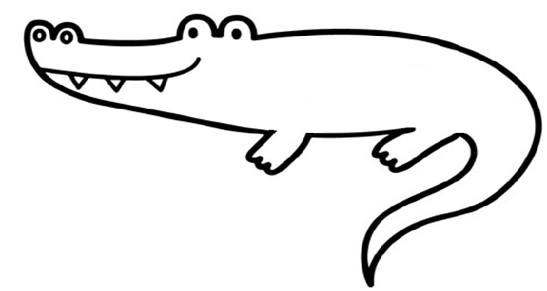
am/is
was
быть
are
were
быть
become
became
становиться
buy
bought
покупать
come
came
приходить
do
did
делать
drink
drank
пить
eat
ate
есть
give
gave
come
давать
go
went
идти, ехать
have got
had
иметь
make
made
делать
pay
paid
платить
read
read
читать
ride
rode
кататься
run
ran
бегать
say
said
сказать
see
saw
видеть
take
took
брать
think
thought
думать
wear
wore
носить
get
got
получать
write
wrote
писать
swim
swam
плавать

